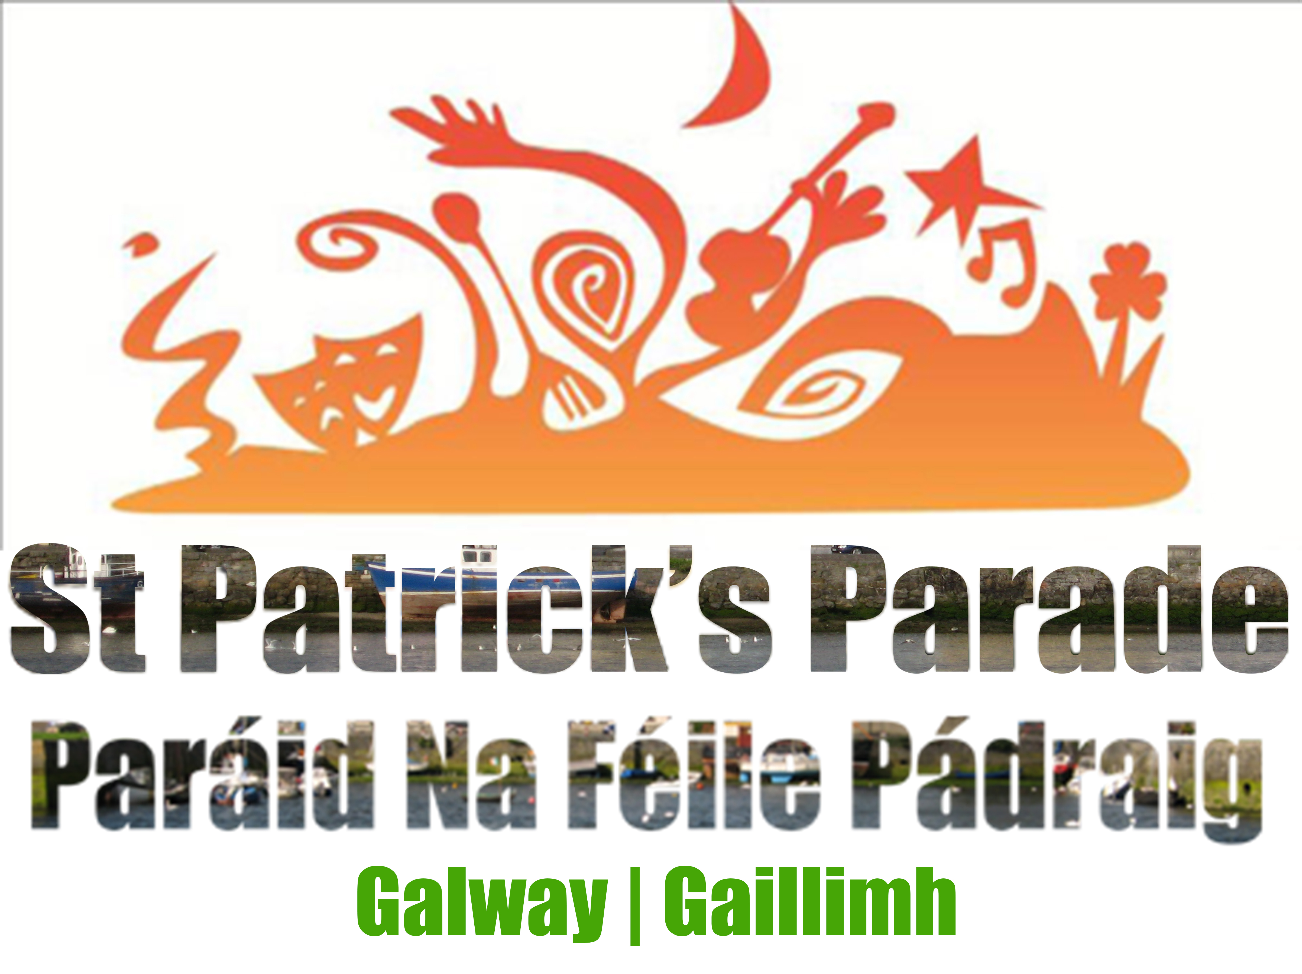

Parade Expression of Interest 2025

The St. Patrick’s Day parade will take place on Monday 17th of March 2025. The parade is proposed to start at 11.00am and usually finishes at 1.00pm. The starting point will be at University of Galway and the collection point is the Black Box Car Park.

The below form is an application to participate in the parade. The final line up and details of the parade are announced in the days leading up to the parade but will be subject to change.

The parade is organised and funded by Galway City Council and is free to participate.

Parade Information:
- Set up area is in front of the Quadrangle, NUI Galway, University Road / Dispersal is at the Black Box Theatre, Dyke Road.
- The parade route is usually -University Road, Cathedral, Salmon Weir Bridge, Courthouse Square, Eglinton Street, Williamsgate Street, Eyre Square, Prospect Hill.
- Timetable
  - 09:00 - Set Up Area Open
  - 10:00 - All participants on site
  - 11:00 - All Groups in position
  - 11:30 - Parade Starts The total parade route should take approximately 45 minutes to walk

- There will be toilets at the set up area and again at the Black Box Theatre.
- If your group is arriving by coach, please drop off on University Road prior to 10:00.
- We recommend parking at the Dyke Road Car Park. Rate is €6.50 per day.
- There will be a cloakroom van parked at the Set Up area where groups can leave coats, umbrellas etc. This van will be waiting at the Black Box Theatre for coat collection following the Parade.
- If your pageant features a float, it can be collected from the yard to the rear of the Black Box Theatre after the Parade.
- In order to minimise litter, we would ask your group to refrain from handing out flyers or using confetti /streamers.
- The weather can be mixed, so please wrap up warm under your costumes/uniforms. Please ensure that your participants have enough water to last to the end of the Parade.
- We may need to refuse an application if it is felt that the applicant’s entry is not suitable for participation.
- The parade must not be used to make political statements or promote any lobby group or campaign.
- Groups need to observe the instructions of the parade stewards to ensure the smooth and safe running of the event.
- Once the parade starts it will not stop until it reaches the finishing point, there are no planned stops along the parade route.
- Accessible Areas will be announced closer to the time.
All details are subject to change.

Contact details of person responsible for group.
Please sign to indicate you have read the rules and considerations.

Name:
Address:
Contact No:
Email:
Name of Entry:

Entry Classification:
Band / School/ Performers/ Other:
Total Number in Group:

To Be Completed by Bands Only:
Band Category:

Name of Director:

Information on Entry: If you are using a float, music, power i.e. a generator or batteries etc., approval from the organisers will be required for health and safety reasons. If you require creative assistance let us know.

