**Galway City Council Arts Newsletter Early January**

Welcome to the Arts Office Newsletter for early January 2025.

Below you will find opportunities, news, listings and events for creative practitioners and people interested and involved in arts and Culture in Galway City.

Happy new year, from the Galway City Arts Office team.

**_____________________________________________________________**

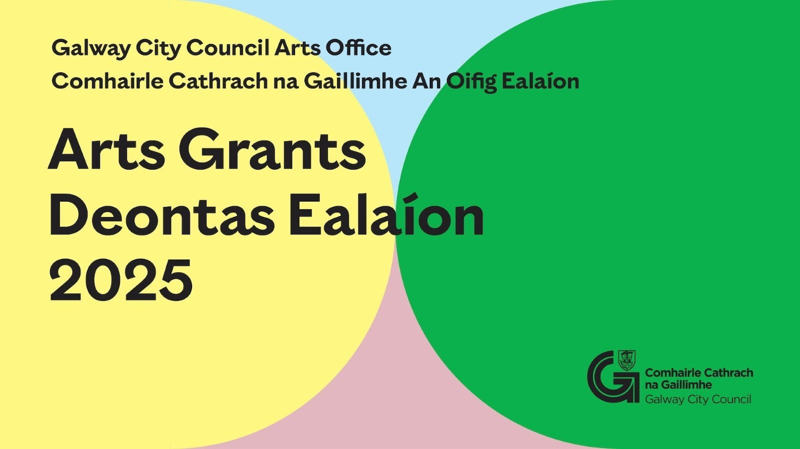

**Arts Organisation Grants applications close soon!**

The deadline for receipt of applications for Galway City Council Arts Organisation Grants 2025 is next Tuesday the 14th of January.

Arts Grants for organisations are managed in two strands:

1) Arts Grant Professional Strand

2) Arts Grant Community, Voluntary and Amateur Strand

For the Arts Grants 2025 online application and guideline go to

[www.GalwayCity.ie/ArtsGrants](https://www.galwaycity.ie/ArtsGrants)

**_____________________________________________________________**

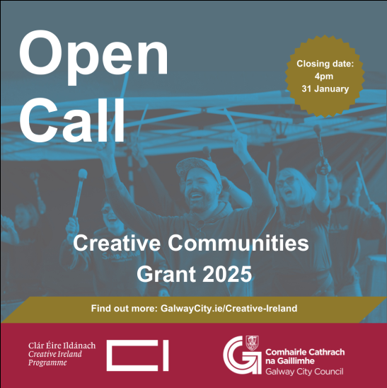

**Information Sessions for Creative Communities Grants**

Applications for the Creative Communities Grant closes on January the 31st

Information sessions will be held in-person at the following days and times ahead of this closing date:

Ballybane Community Resource Centre

* 10am, Tuesday 14 January

Galway City Library

* 2.30pm, Wednesday 15 January

Westside Resource Centre

* 7pm, Thursday 16 January

Register your attendance: [CandC@GalwayCity.ie](mailto:CandC@GalwayCity.ie).

For more information about these funding opportunities visit: [GalwayCity.ie/Creative-Ireland](https://www.galwaycity.ie/services/community/community-services/creative-ireland)

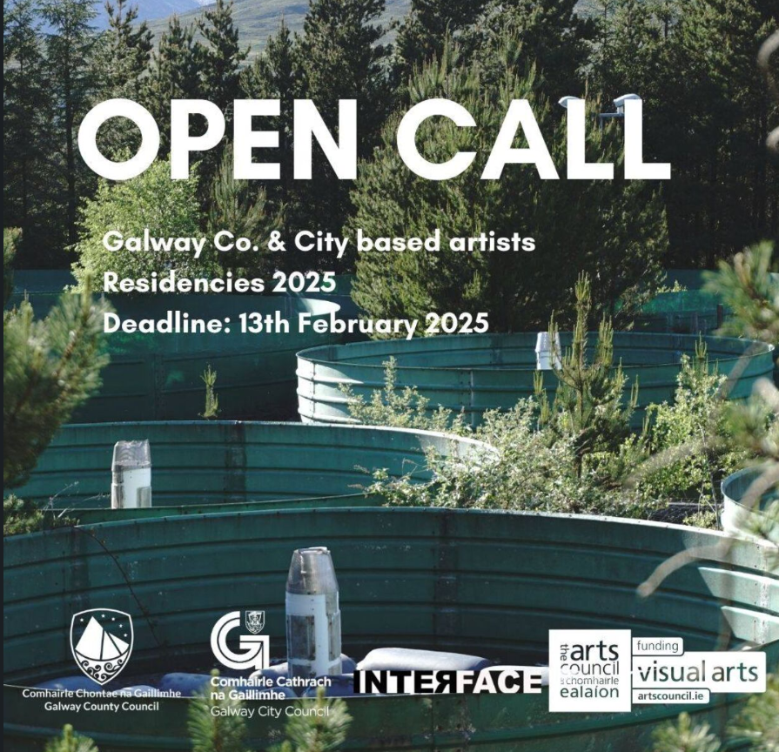

**Artist in Residence Opportunity; Galway City Arts Office X Interface Inagh**

Interface Inagh have launched 2025 artist-in-residence opportunities, with applications being received up to February 13th 2025.   
  
Proposals are invited from practicing artists, writers, and musicians whose work explores intersections between scientific research, environmental concerns and the arts. Interface Inagh allows artists to engage with a unique environment and be inspired by the exciting research taking place in a spectacular landscape.  
  
Ní neart go cur le chéile; Galway City Council Arts Office is proudly supporting two residency places for artists currently living in Galway City.   
These residences must take place in May and June 2025.   
  
How to apply: Send one pdf including your proposal, CV, artist’s statement and six samples of recent work or links to work to [interfaceinagh@gmail.com](mailto:interfaceinagh@gmail.com)Please put Galway City/County Council residency in the subject line.  
  
The awarded artists will receive access to a studio space, accommodation and stipend of €1,100 for each artist for residency periods of two weeks.   
  
Artists will be responsible for their own food, materials and travel costs.  
A driver’s license and a car are essential for this residency for which the artist is entirely responsible

______________________________________________________________________

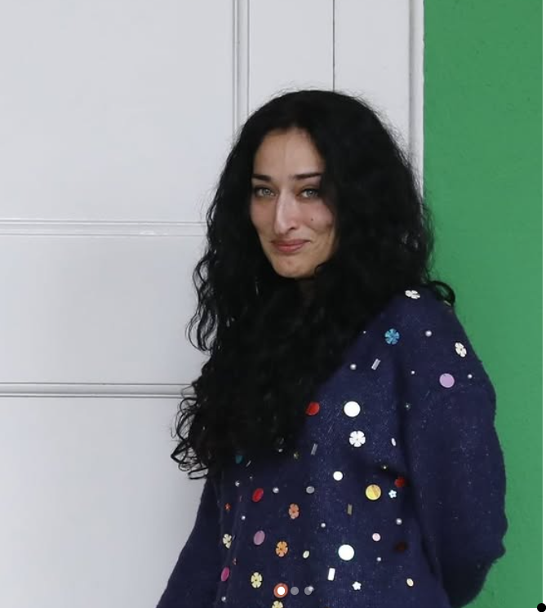

**Galway City Council X Galway Arts Centre ATU graduate AIR award**

Galway Arts Centre have announced Taim Haimet as the recipient of the Galway Arts Centre ATU graduate artist in residence award 2024, supported by Galway City Council Arts Office.  
  
Taim Haimet is a multidisciplinary artist based in Galway. Born in France of Syrian parents, her work delves into the complexities of a Middle Eastern identity marked by a history of colonialism, ongoing conflict, and loss.  
  
Her practice centres on the question of where we place the notion of the ‘Sacred’_on what is lost or on what remains, both individually and collectively. drawing from Arab folklore, history, poetry and mysticism, she creates symbolic ‘sacred spaces’ where these narratives can be honoured and resonate within the Western world. With a background in theatre, her work often integrates the staging of space, spoken narrative, and the human voice as a powerful medium. Her narrative-driven installations are expressed through sculpture, video and sound.  
  
Taim completed an Honours degree in Contemporary Art in 2023 and is currently pursuing an MA in Creative Practice at ATU Galway. She was awarded the 126 Gallery artist residency and the RDS Visual Arts Awards 2023.  
  
This residency aims to support and nurture emerging artistic talent in our local community.

**_____________________________________________________________**

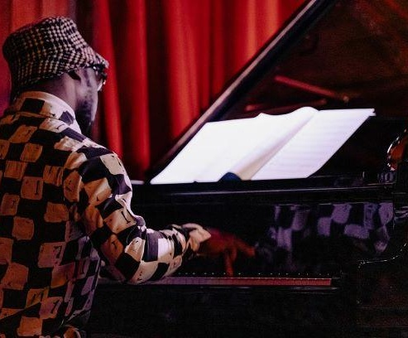

**Music Capital Scheme 2024 Piano Award**

Applications are now open for the Music Capital Scheme 2024 Piano Award to support the purchase/refurbishment of concert standard grand pianos by arts venues and music presenters.

The Music Capital Scheme is supported by the Department of Tourism, Culture, Arts, Gaeltacht, Sport and Media and provides funding for musical instruments.

Deadline for applications: 2pm, Wednesday 19 February 2025.

[More Information here](https://www.musicnetwork.ie/whats-on/the-music-network-piano-award).

**_____________________________________________________________**

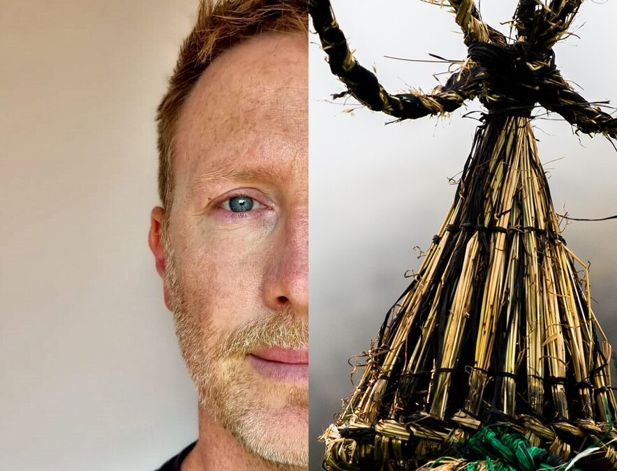

**Applications Open: Galway Dance's International Residency Initiative Scheme**

Galway Dance has secured funding from the International Residency Initiative Scheme from the Arts Council to work in partnership with Glasgow Life and Theatre Gu Leòr to bring four artists together into a studio (two based in Ireland and two based in Scotland). Dance artist Rob Heaslip will facilitate the studio time, creating a space for artists to explore and exchange.

Closing date January 17th 2025

[More information here](https://galwaydance.ie/galway-dances-international-residency-initiative-scheme-2025/).

**_____________________________________________________________**

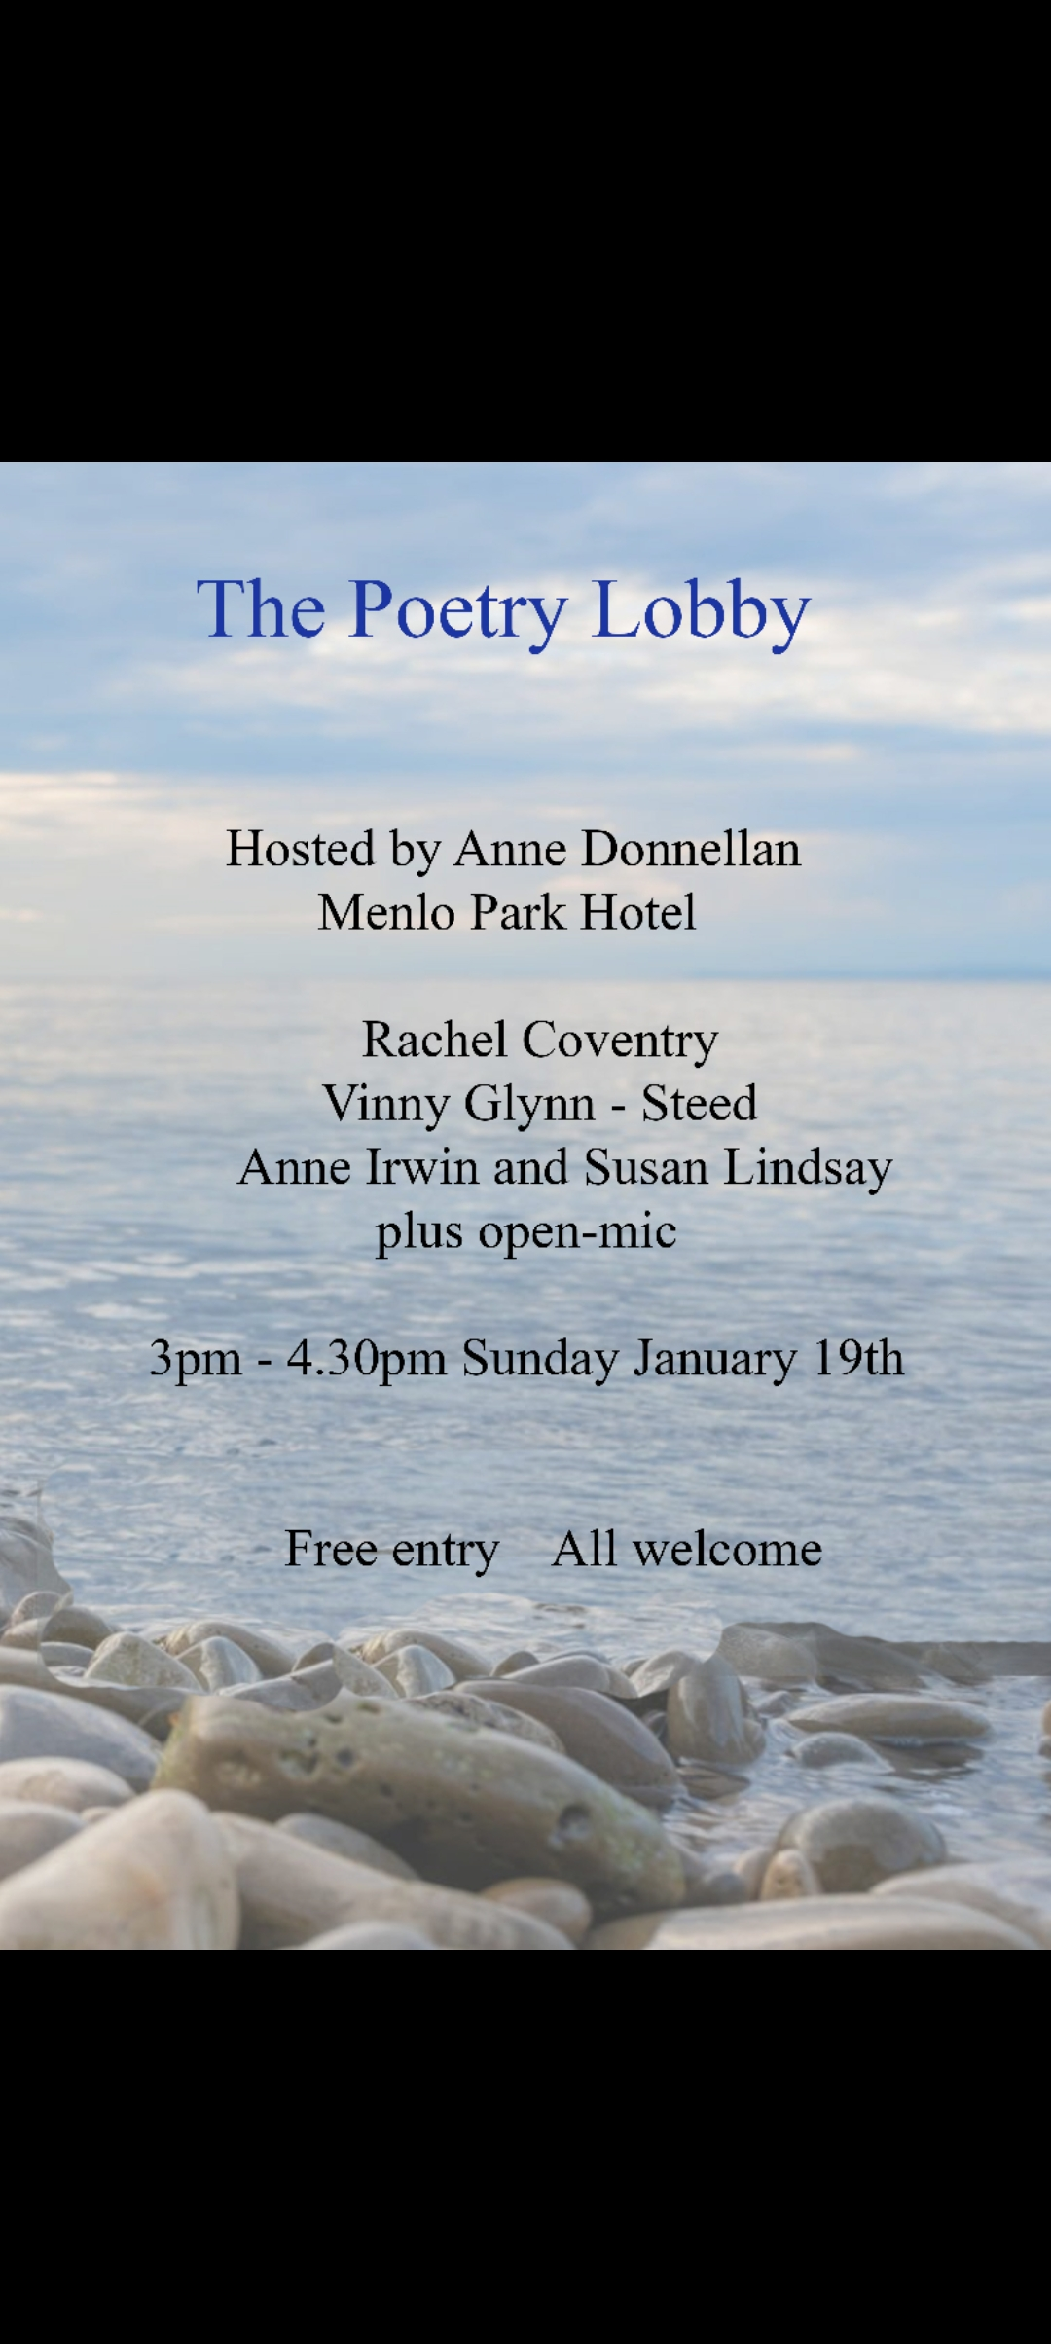

**Poetry Lobby January Reading in the Menlo Park Hotel**

The featured readers for the next Poetry Lobby reading in the Menlo Park Hotel are Rachel Coventry, Anne Irwin, Vinny Glynn Steed and Susan Lindsay. It will take place on Sunday January 19that from 3pm to 4.30pm hosted by local poet Anne Donnellan, followed by an open-mic session.

All are welcome.

**_____________________________________________________________**

**_________________________________________________________**

**Send us your Listings & News**

We can share your posts! Email up to 50 words to [arts@galwaycity.ie](mailto:arts@galwaycity.ie) with a high-resolution landscape image. Images and text may be edited to fit.

**___________________________________________________________________**

**GCC Arts Office Social Media**

Facebook: [www.facebook.com/ArtsOfficeGalwayCity](https://scanner.topsec.com/?d=1122&r=show&u=https%3A%2F%2Fwww.facebook.com%2FArtsOfficeGalwayCity&t=a6b33347cd65717d4a93047cc8b1c9f7c5d8a4c9)

Instagram: [@artsofficegalwaycity](https://www.instagram.com/artsofficegalwaycity?utm_source=ig_web_button_share_sheet&igsh=ZDNlZDc0MzIxNw==)

X: [@cityartsgalway](https://x.com/CityArtsGalway?s=20)

**___________________________________________________________________**

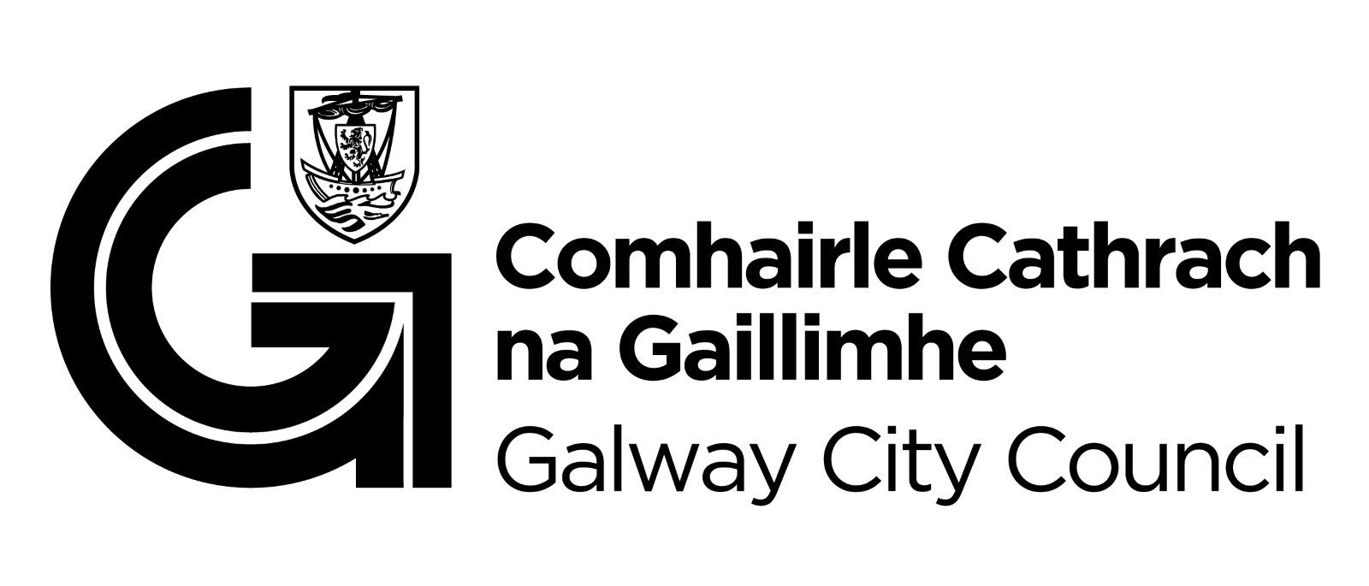

You are getting this email because you are on the Galway City Council Arts Office mailing list. Unsubscribe by emailing [arts@galwaycity.ie](mailto:arts@galwaycity.ie) and ask to be removed.