Galway City Council Arts Newsletter Late April
The newsletter highlights the work of our funded arts organisations in Galway City and also includes opportunities and news for anyone interested and involved in arts and culture in Galway City.
GCC Arts Office Social Media
Facebook: www.facebook.com/ArtsOfficeGalwayCity
Instagram: @artsofficegalwaycity
X: @cityartsgalway
_____________________________________________________________

An Taibhdhearc: Dathanna Geala Amháin
Dráma dúghrinn is ea ‘Dathanna Geala Amháin’, a chuaigh ar camchuairt ó Bhéal Feirste go dtí An Bhrasaíl i gcóiste marbh! Suite i dteach faire, níl an dráma seo ach feiliúnach dóibh siúd atá beo beithíoch.
This legendary Irish wake show has toured from Belfast to Brazil in a hearse! This show is only suitable for those dying to live!
Tuilleadh eolais ┐ ticéid | More information & tickets at antaibhdhearc.com
_____________________________________________________________


WRAP: Bradford/ West of Ireland 2025 Screen Producer Exchange Callout
Bradford 2025, in partnership with Ardán, the WRAP Commission, and Screen Yorkshire, are seeking applications from producers to take part in a Bradford/West of Ireland Screen Producer Exchange programme.

The intention of the exchange is to develop international relationships and opportunities between the Irish and UK producing community via learning and networking opportunities in Bradford and the West of Ireland.

The WRAP Commission is managed and administered by Ardán in partnership with Galway City Council Arts Office and regional authorities.

The deadline for applications is 12pm on Tuesday 29 April, 2025 ardan.ie

_____________________________________________________________

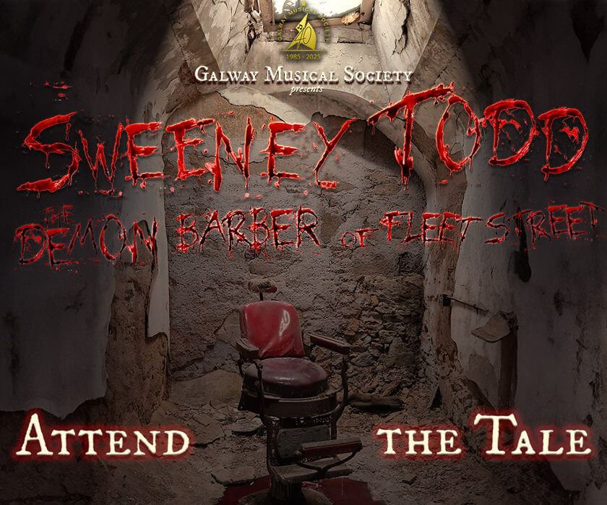
Galway Musical Society presents Sweeney Todd: The Demon Barber of Fleet Street - A Musical Thriller
Fresh off the success of their award-winning 2024 production, Galway Musical Society returns to the Town Hall Theatre stage from April 30 to May 4 with a thrilling new production of Stephen Sondheim’s Sweeney Todd: The Demon Barber of Fleet Street.

Galway City Council Arts Office are proud supporters of Galway Musical Society.

More information and tickets at tht.ie/4469/sweeney-todd
_________________________________________________________________

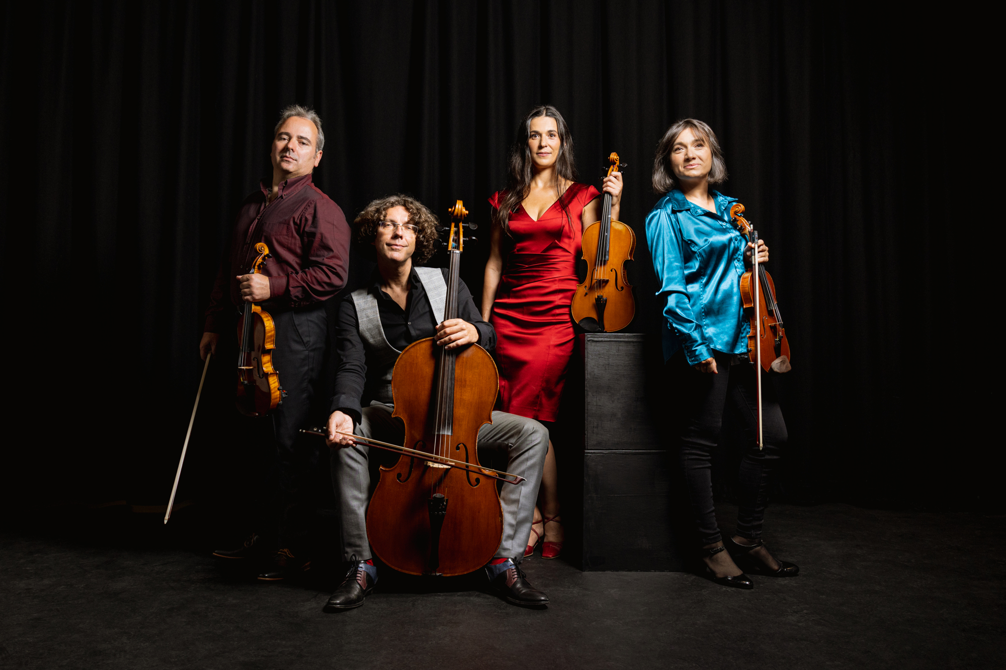
Galway Music Residency lunchtime Concert
As part of its Nature & Ecology theme for 2025, Galway Music Residency is exploring the beauty and mystery of birds. This May ConTempo Quartet, Galway’s Ensemble-in-Residence, will perform works celebrating various birds, from their song to their mesmerising flight.

Galway City Council Arts Office are proud supporters of Galway Musical Society through the Cultural Partnership program and the Arts Organisation Grant.

The concert will take place in St.Nicholas’ Collegiate Church on Tuesday 6 May at 1.10pm.

Entrance is free.

More information at galwaymusicresidency.ie
______________________________________________________
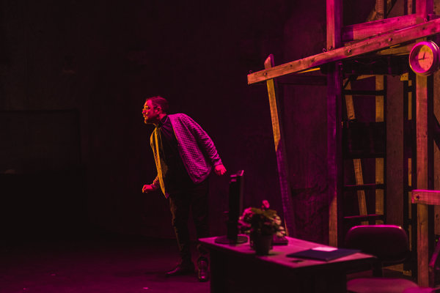
Blas - Pilot Artist Development Programme
The Town Hall Theatre, in partnership with Theatre Artist James Riordan and Galway Theatre Festival, are inviting applications for Blas, a pilot Artist Development programme to take place over 7 months during 2025.

The programme will involve bespoke mentorship, masterclasses, rehearsal space, technical support, and a €3,000 stipend.

Deadline for applications: Thursday May 15 at 5pm

Galway City Council Arts Office proudly supports Galway Theatre Festival through the Arts Organisation Grant.

More information here: tht.ie
_________________________________________________________________

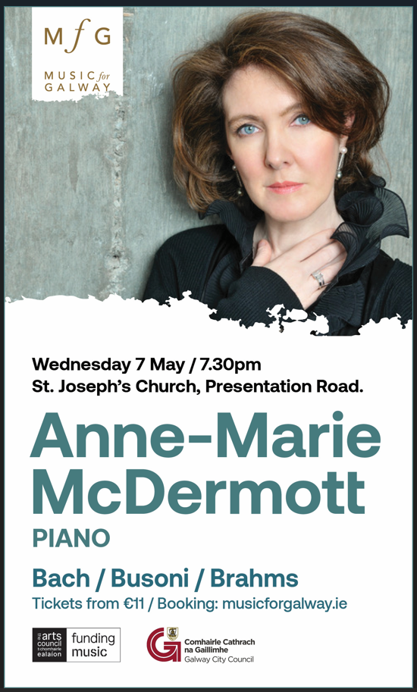

Music for Galway Concert
One of the most dazzling pianists on the American scene today, Anne-Marie McDermott is a true force of nature. Performance on Wednesday, May 7th at 7.30pm in St. Joseph’s Church on Presentation Road. Please note that this is a different venue than previously announced.

More information at musicforgalway.ie
______________________________________________________

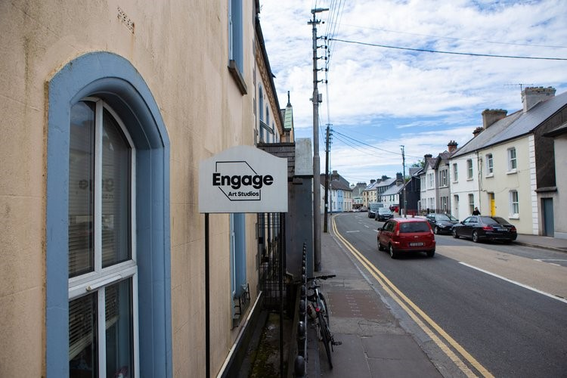
Engage Studios offering space to rent in Galway City
Engage Art Studios has two studios available: Churchfields (short-term, until Sept 2025) and Francis St (2-year renewable lease).

To apply, submit a single PDF with your chosen studio, practice info (max 250 words), CV (2 pages), and 5 work samples to engageartstudios@gmail.com by 17:00, Friday May 2nd.

More information here: engagestuidos.com

_____________________________________________________________
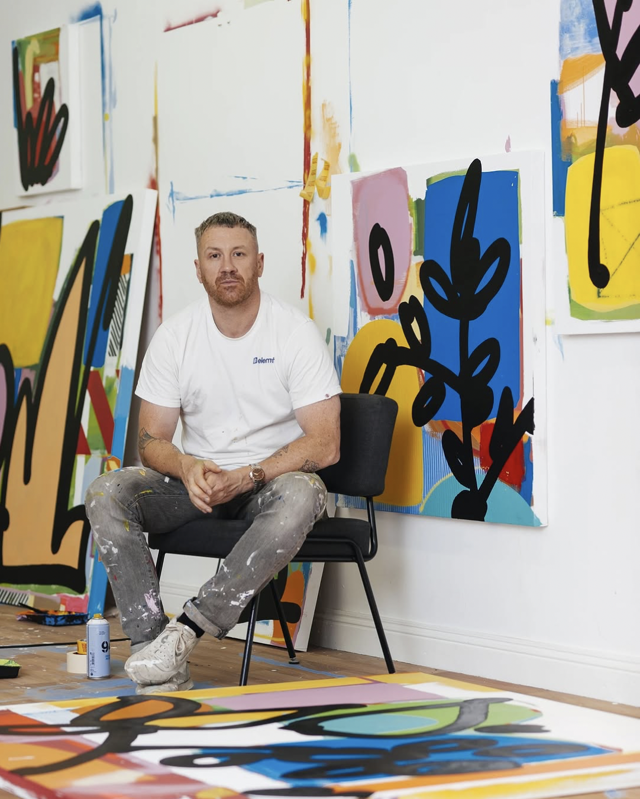
Create Through Collage: Urban Explorations Workshop with Maser
Join renowned visual artist Maser for an immersive, hands-on workshop at Outset Gallery, exploring collage as a powerful medium for visual storytelling and artistic play. Rooted in the same methods that inform his dynamic painting and installation work, this full-day session invites participants to engage deeply with the creative process, from urban observation to abstract composition.
Saturday, April 26 · 11am - 4pm at Outset Gallery
Tickets are €85
More information and tickets here.

_________________________________________________________



Calling all young poets & storytellers in Galway City (14-18)! – Please share within your networks.
Unleash your voice with Youth Lates Spoken Word workshops led by Mars Duignan & Liam McBrearty. 6 sessions, culminating in a #CruinniúnanÓg performance! Ready to find your voice and share your story? For more information: https://thisisgalway.ie/unleash-your-voice-with-youth-lates-spoken-word/

This opportunity is brought to you by Youth Lates, Galway City Council Night-Time Economy and Creative Ireland Programmes, Youth Work Ireland Galway, Galway City Comhairle na nÓg. Funded by Creative Ireland through the Department of Arts, Culture, Communications, Media and Sport.

_____________________________________________________________

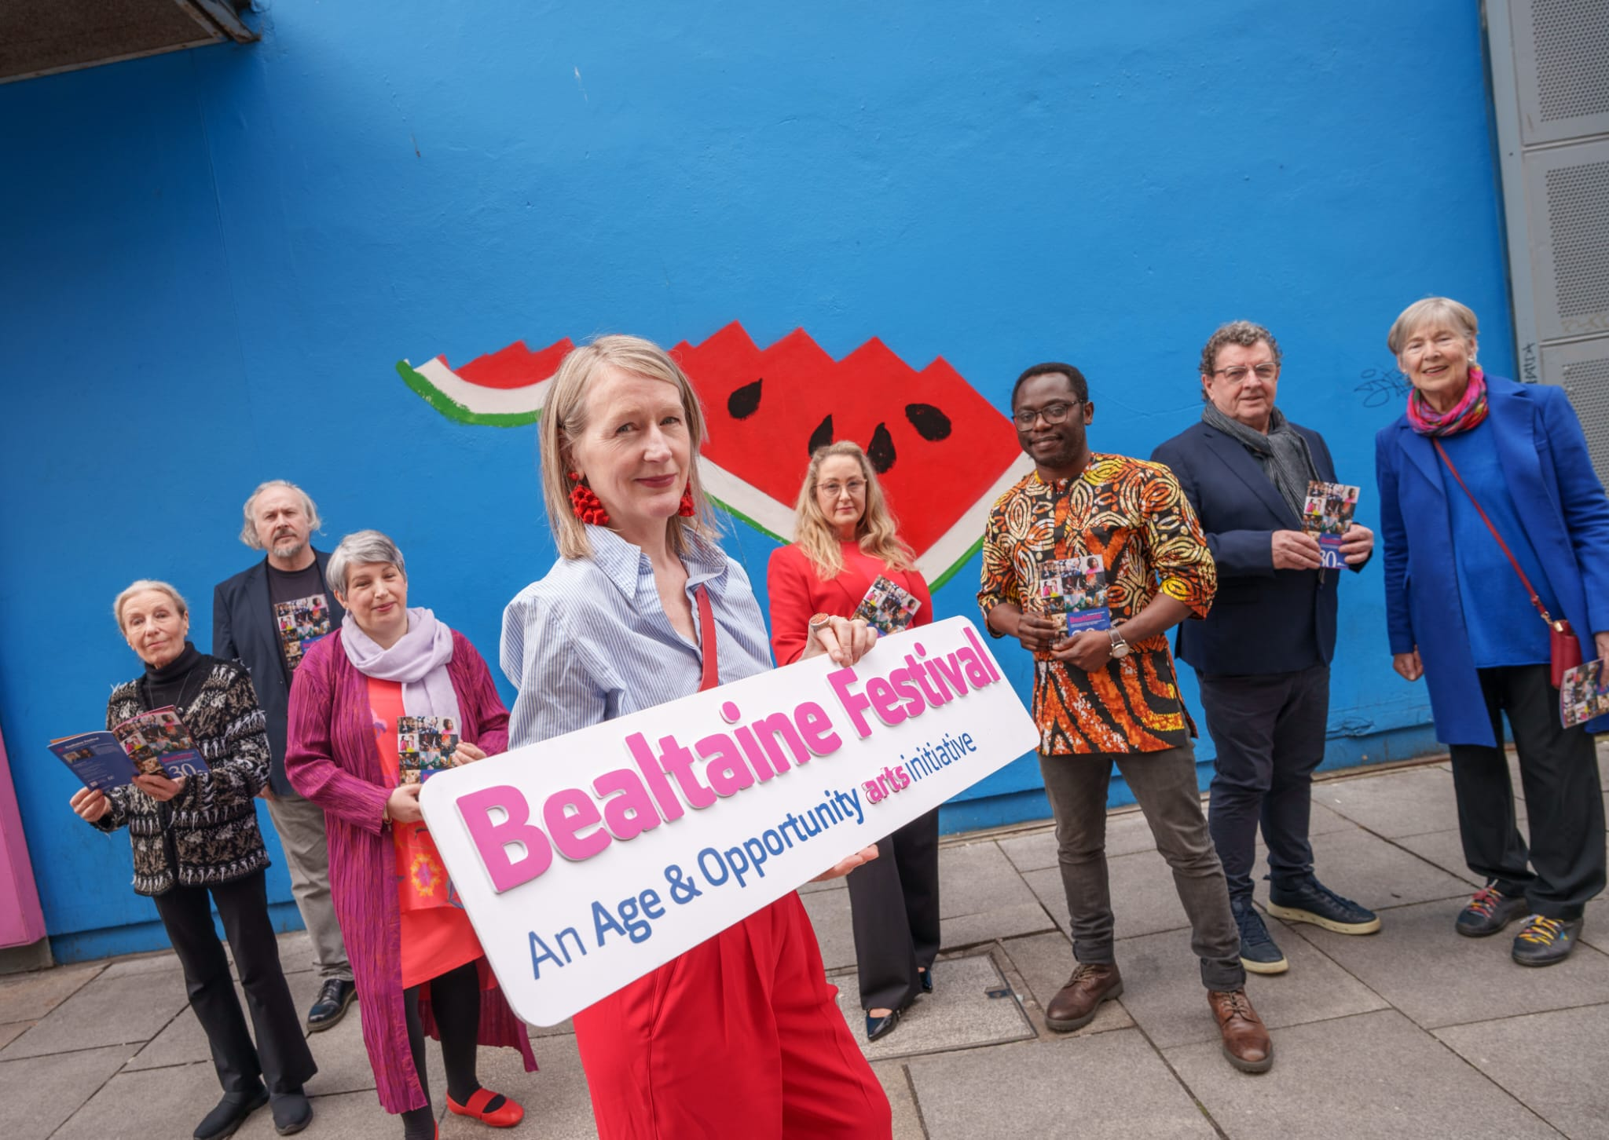
Galway City Council celebrates Bealtaine Festival with Night-Time Economy events
Experience Jazz Night on the 2nd of May, and a Night of Creative Connections on the 14th of May at Dangan House Café as part of the Café Lates initiative, offering music, craft, light bites and garden views.

Join Elena Santos for two evenings of artists' talks featuring Sioban Piercy and Brian Bourke at Just Art It in Galway's Westend. These free, ticketed events on the 16th and 30th of May offer insights into the artistic profession.

Visit Galway Arts Centre until 9 PM on Thursdays to experience the Alice Rekab exhibition, Clann Miotlantach / Mythlantics, exploring family, place, and belonging. Free guided tours are available.

For more information visit: https://thisisgalway.ie/celebrating-bealtaine-festival-in-galway-by-night/
__________________________________________________________
Send us your Listings & News
To be included in our newsletter, please email up to 40 words to arts@galwaycity.ie with a high-resolution landscape image. Images and text may be edited to fit.
___________________________________________________________________

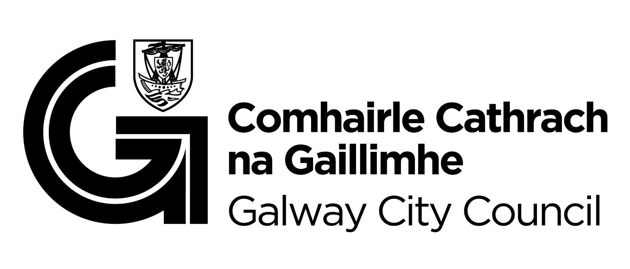
You are getting this email because you are on the Galway City Council Arts Office mailing list. Unsubscribe by emailing arts@galwaycity.ie and ask to be removed.

