Galway City Council Arts Newsletter Early June
The newsletter highlights the work of our funded arts organisations in Galway City and also includes opportunities and news for anyone interested and involved in arts and culture in Galway City.
GCC Arts Office Social Media
Facebook: www.facebook.com/ArtsOfficeGalwayCity
Instagram: @artsofficegalwaycity
_____________________________________________________________
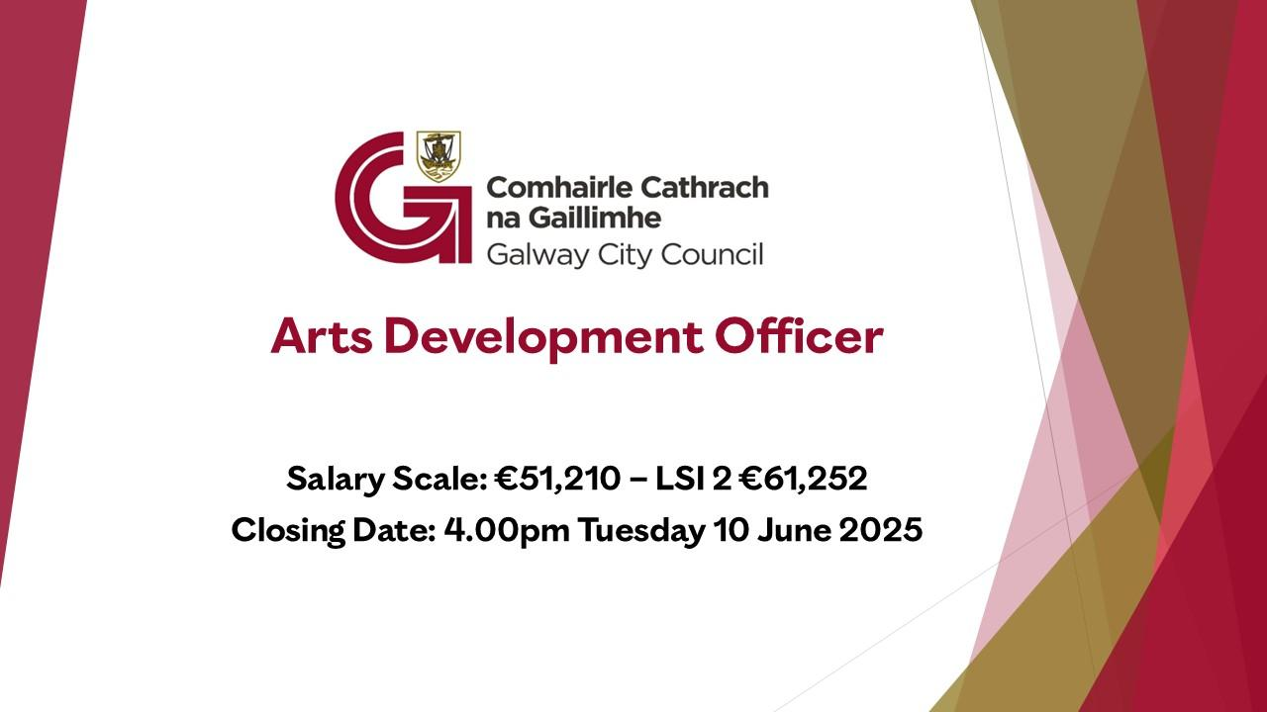
Arts Development Officer
Galway City Council is pleased to invite suitably qualified applicants for the following position: Arts Development Officer.
The closing date for receipt of fully completed application forms for this position is no later than 4.00pm on Tuesday 10 June 2025 . All fully completed application forms must reach the Human Resources Department by this date.
More information here.
_____________________________________________________________
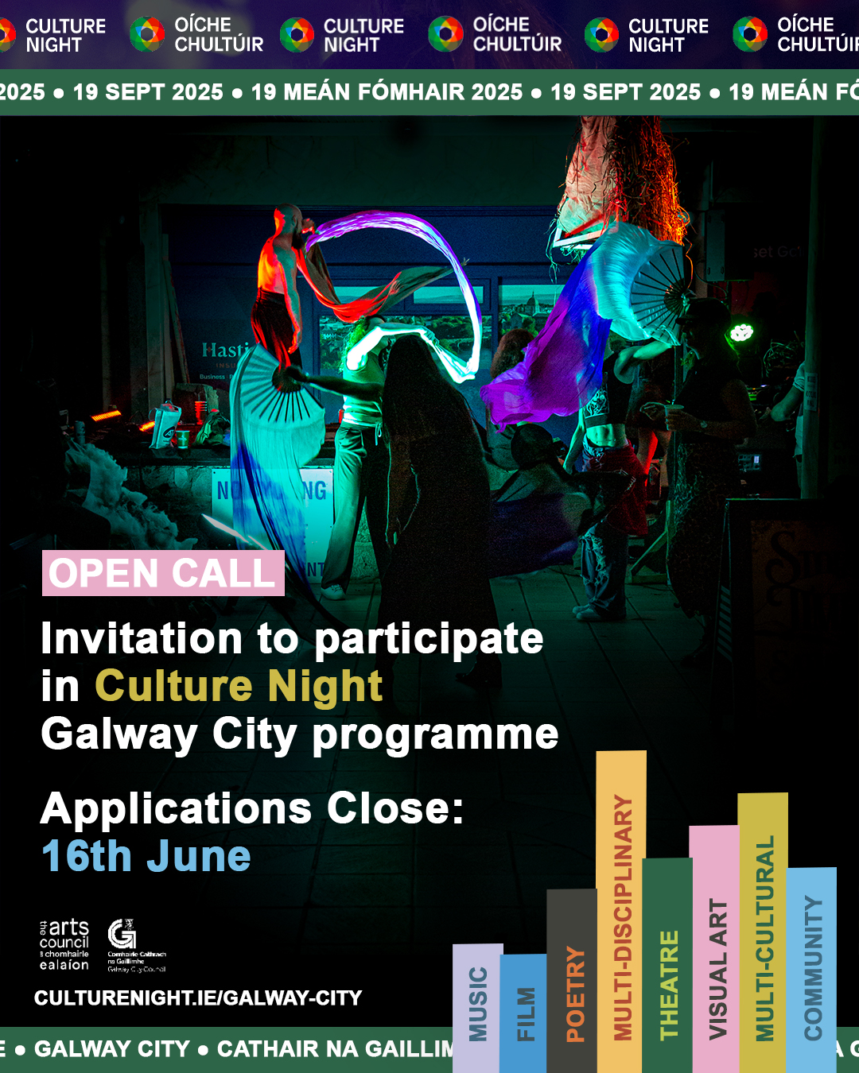
Applications for Galway City Culture Night Program close 16th June
The twentieth edition of Culture Night will take place on Friday 19 September 2025. Culture Night / Oíche Chultúir is brought to you by the Arts Council; it is a national moment, celebrating culture, creativity and the arts and seeks to actively promote the belief that this rich and varied culture is alive, treasured and nurtured in people’s lives, today and every day. It is delivered nationwide in cities, towns, villages and rural locations as well as online and through our media partners.
Galway City Council Arts Office aims to support events across Galway City and its neighbourhoods.
We also aim to support events that encourage and support diversity as well as events that ensure late-night offerings become a feature of the evening time culture and economy of Galway City.
Begin your application here.
_____________________________________________________________
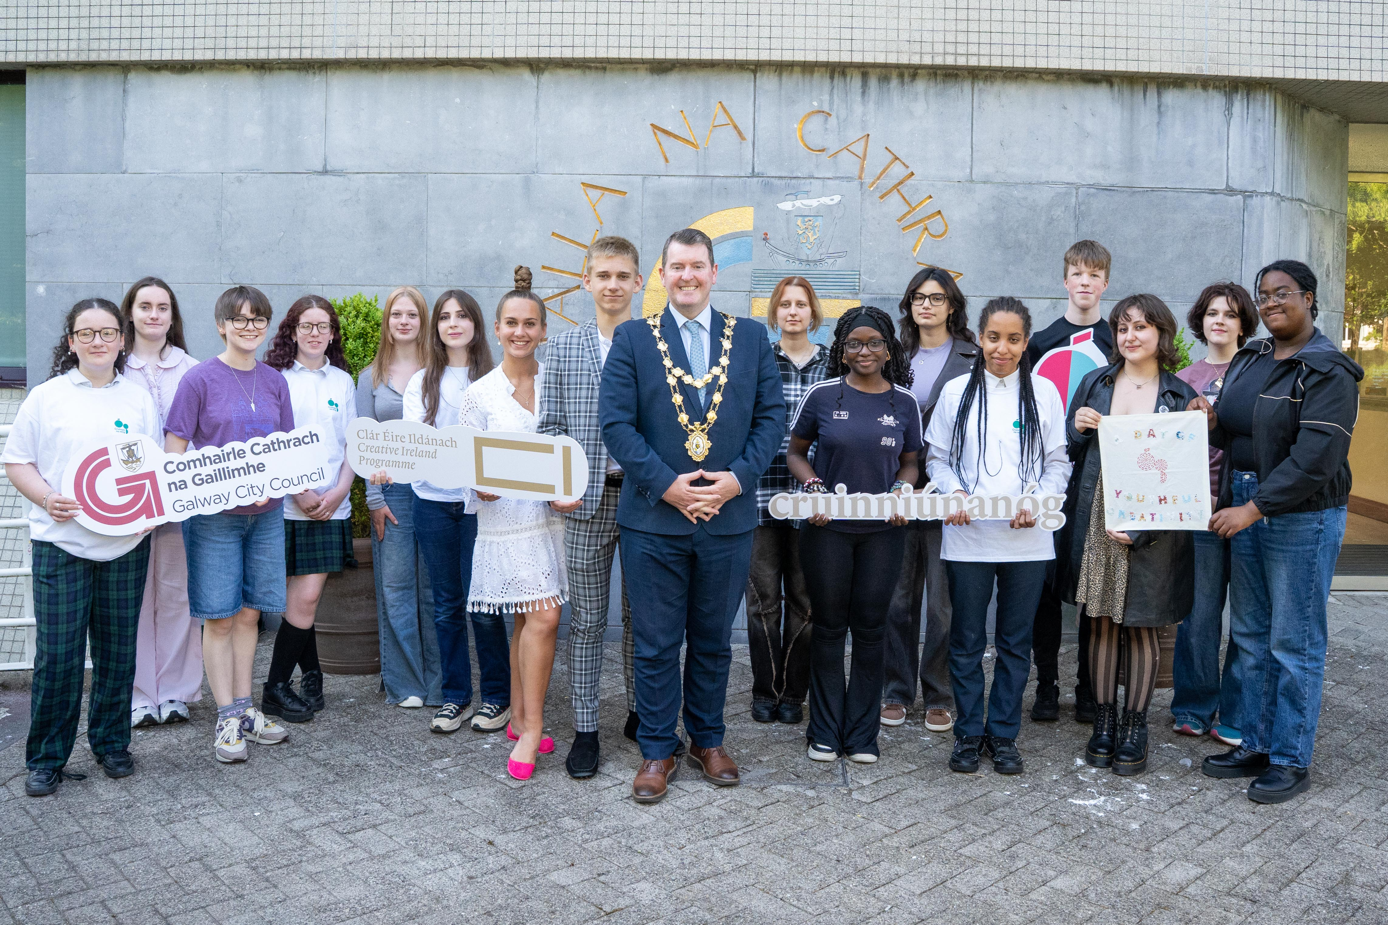
Cruinniú na nÓg in Fr Burke Park this Saturday!
Taking place on Saturday, June 7 from 12-9pm at Fr. Burke Park, this celebration will host over 40 free events, workshops, and performances, celebrating creativity through music, art, circus, storytelling, and more.

This year Cruinniú na nÓg promises an exciting and inclusive programme - from circus workshops, spoken word performances to sensory art.
More information here.
_____________________________________________________________
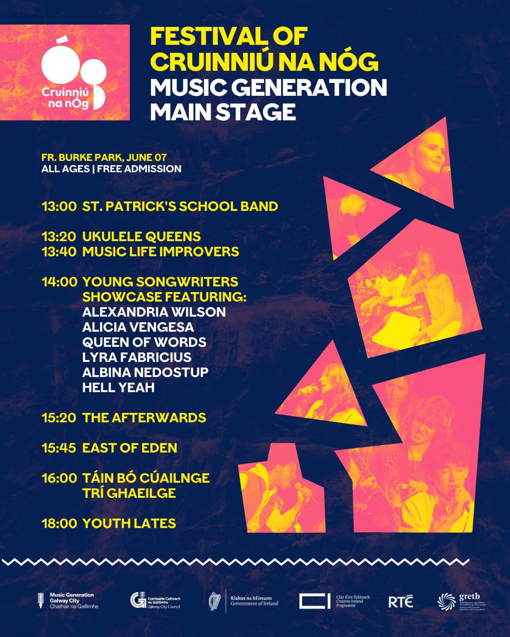
Music Generation Galway City Takes Over Main Stage at Cruinniú na nÓg Festival Galway
Music Generation Galway City is set to take over the main stage at Fr. Burke Park for this year’s Cruinniú na nÓg festival on Saturday, June 7th, with a vibrant celebration of youth creativity and music. The day-long showcase will feature an electric mix of young songwriters, musicians, bands, and ensembles from across the city’s music programmes.

More information about Cruinniu na nÓg here.

More information about Music generation here: www.musicgenerationgalwaycity.ie

_____________________________________________________________
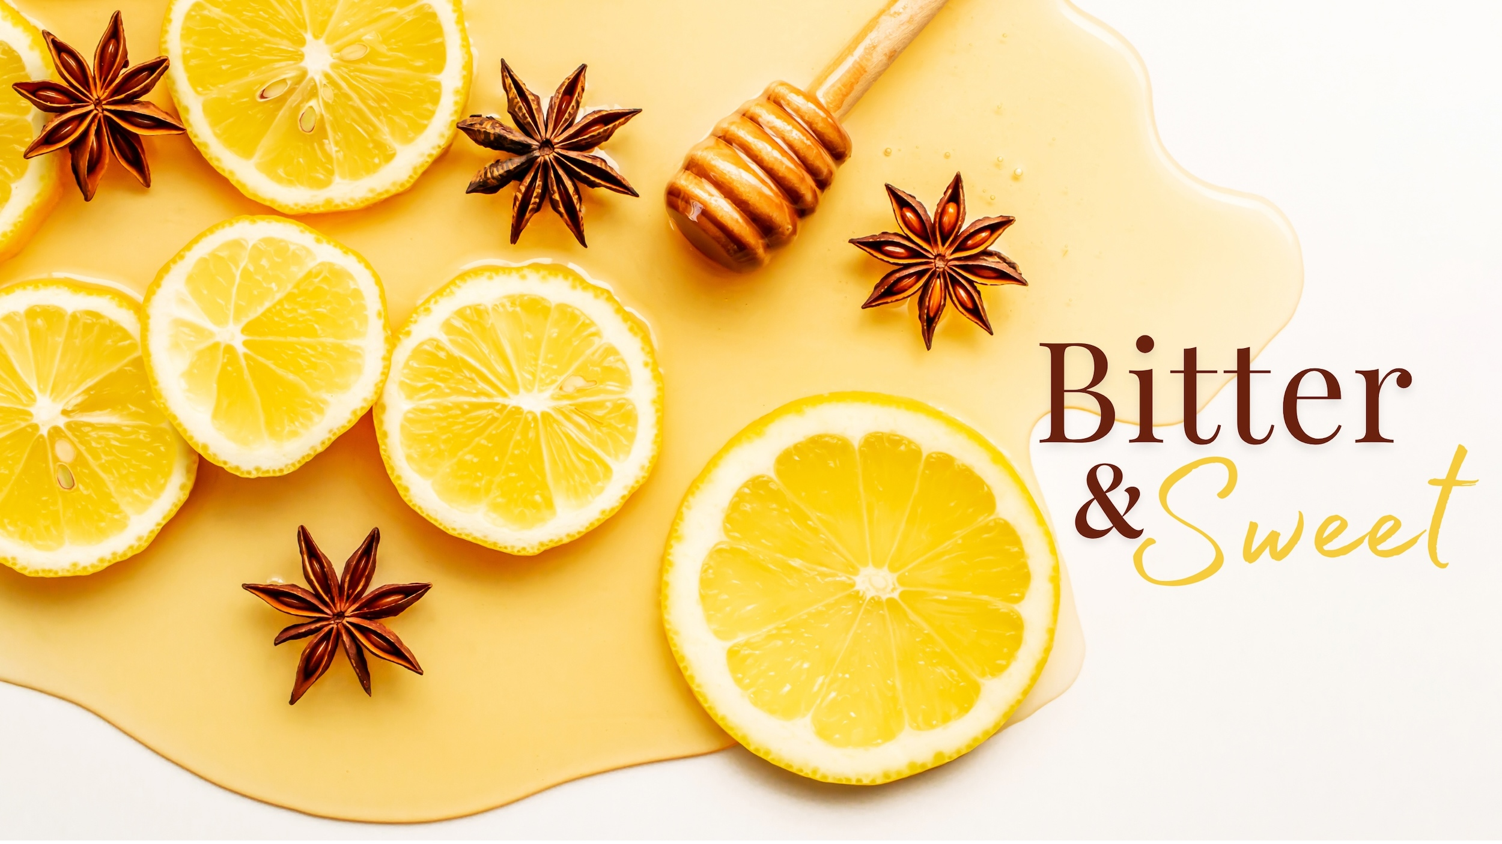
Moth and Butterfly Present Bitter and Sweet Storytelling Evening
Moth & Butterfly present a special night of storytelling and improvisation featuring local & international performers, held in the atmospheric location of Rouge Restaurant in the heart of Galway City on Monday 16 June.
Galway City Arts Office proudly supports Moth and Butterfly through the Arts Organisation Grant.
More information here and tickets here.
_________________________________________________________

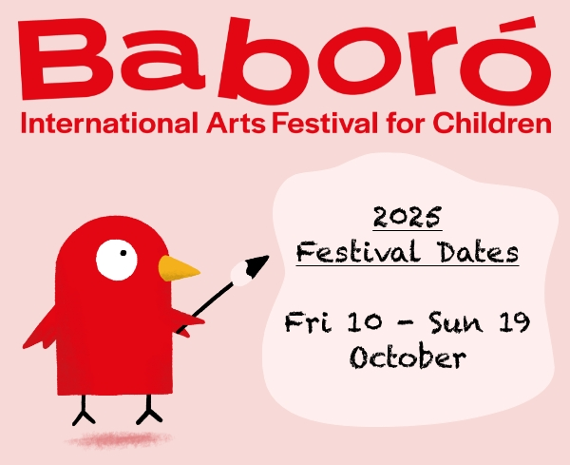
Baboró announce Internation Arts Festival for Children dates
Mark your calendars! Baboró recently announced their 2025 festival dates and are looking forward to welcoming children, families, schools, and artists to Galway this October for 10 days full of wonder.

The dates are Friday 10th October to Sunday the 19th of October.

Galway City Council proudly funds Baboró through the Arts Organisation Grant.

More information here.

_____________________________________________________________
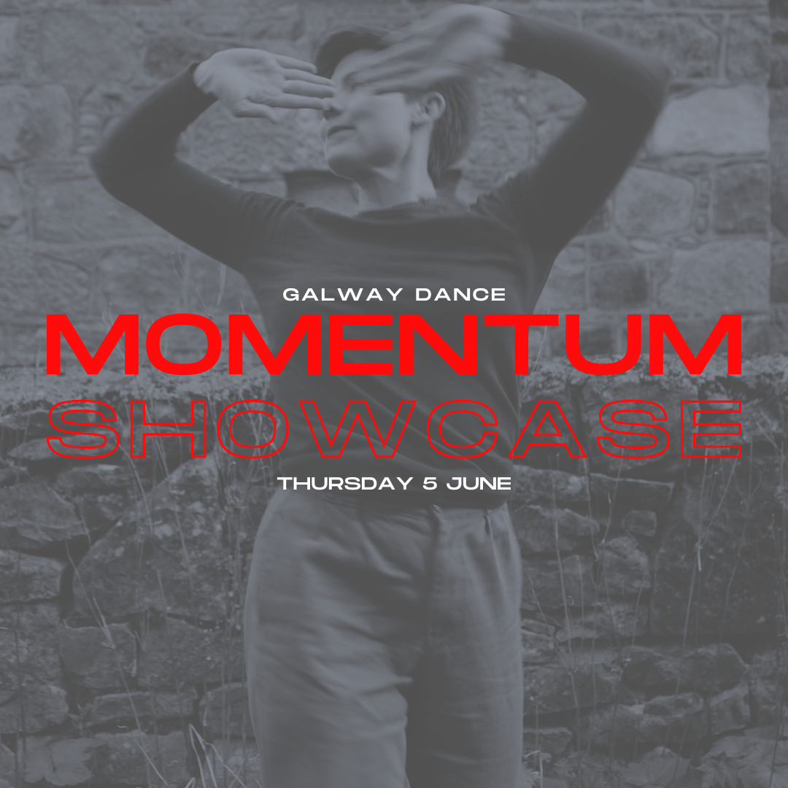
Upcoming Galway Dance MOMENTUM 2025 Showcase in Nuns Island Theatre
Join Galway Dance next Thursday, 5 June at Nuns Island Theatre for a showcase of three dance performances and work in progress showings. The showcase begins at 7pm and will run until approximately 8:30pm, including a Q&A session after the performances.

Galway City Council proudly funds Galway Dance through the Arts Organisation Grant.

More information and tickets here.

_____________________________________________________________
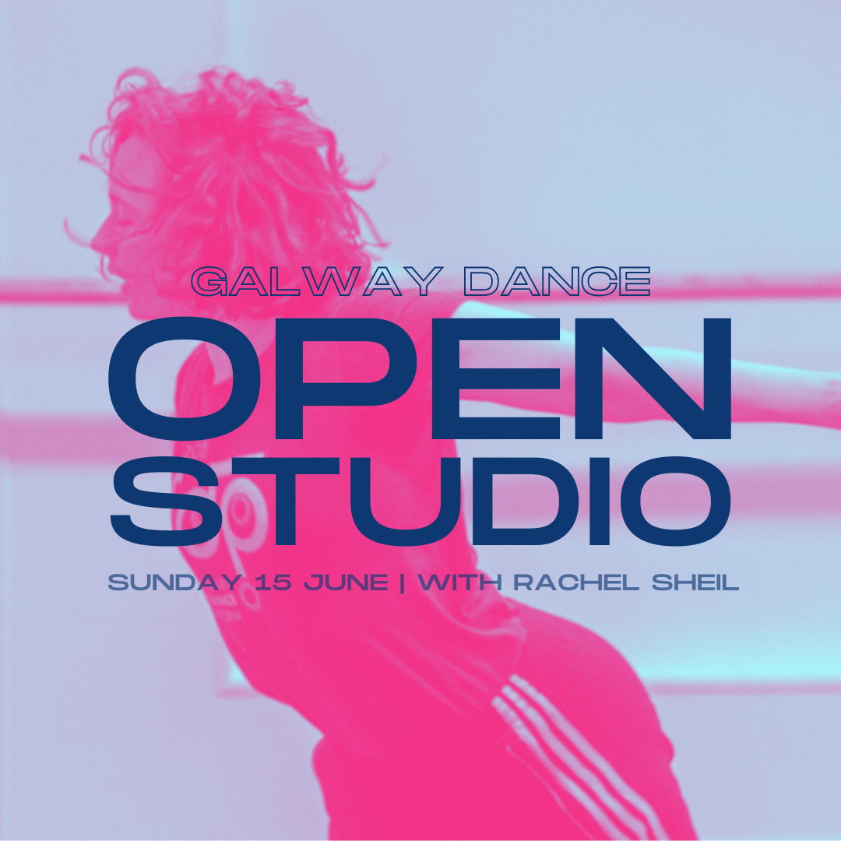
Open Studio with Rachel Sheil
After the success of Galway Dance’s Open Studio events last year, they are once again opening the doors of the Galway Dance studio for another Open Studio for dancers, movers, and anyone with a physical movement practice, hosted by Rachel Sheil.

The Open Studio is free of charge. No need to RSVP or register in advance, just show up on the day! All levels of experience are welcome.

More information here.

_____________________________________________________________

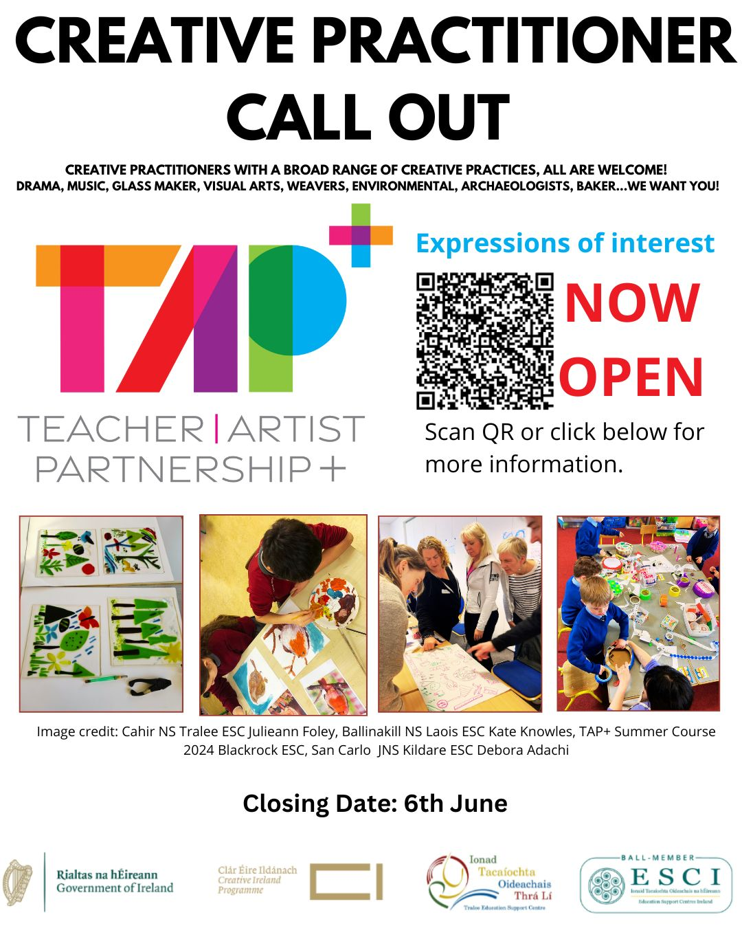
Creative Practitioner Call Out with TAP+
Galway Education Support Centre are inviting expressions of interest through the Teacher Artist Partnership+ scheme for creative practitioners of all disciplines to broaden their practice through professional development and in-school residency program.
Deadline for applications 6 June at 5pm.
More information here.
_________________________________________________________

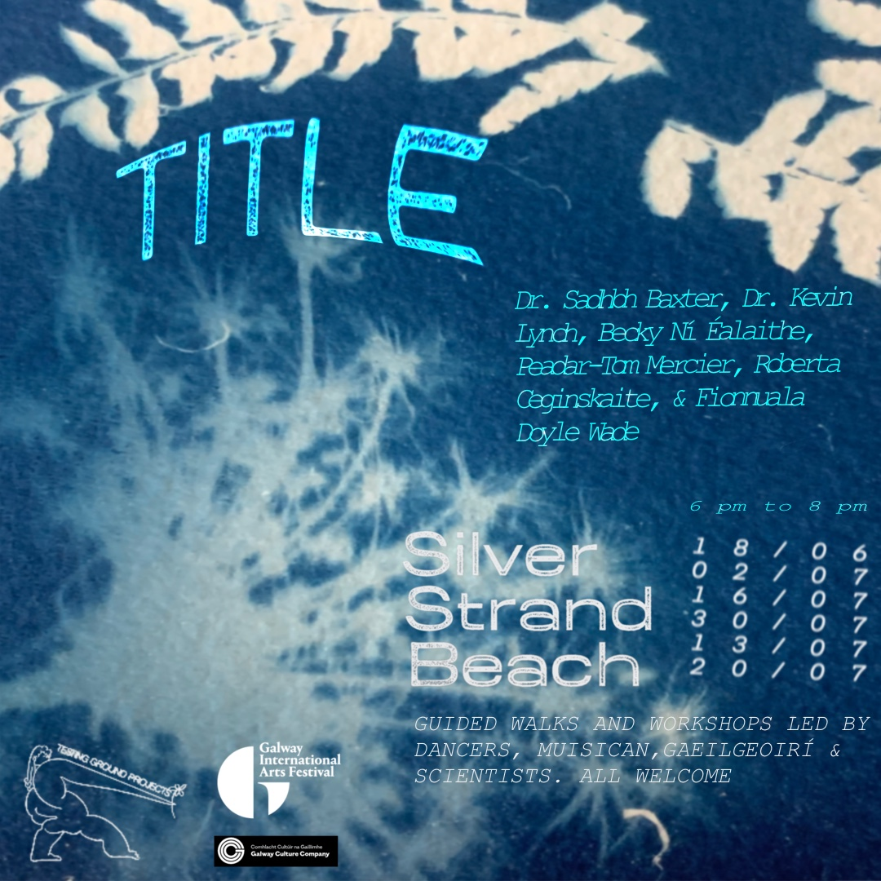
Galway Dancers present ‘TITLE’
Join Galway city-based dance artists Roberta Ceginskaite & Fionnuala Doyle Wade (testing ground projects) for 'TITLE'. Guided walks & workshops led by dancers, musicians, gaeilgeoirí & scientists. All are welcome.

TITLE is funded by a Galway International Arts Festival & Galway Culture Company Elevate Bursary.

More information and free registration here.

_____________________________________________________________

‘Janey Mac is Hot (Blame the Hormones)’: Perimenopause-Inspired, Improvised Comedy comes to Galway
After a sell-out debut at Tinderbox Theatre's Incubate Festival at The MAC Belfast, 'Janey Mac is Hot (Blame the Hormones)' is coming to Galway's Town Hall Theatre on 20 June 2025.
More information here and tickets here.
_________________________________________________________

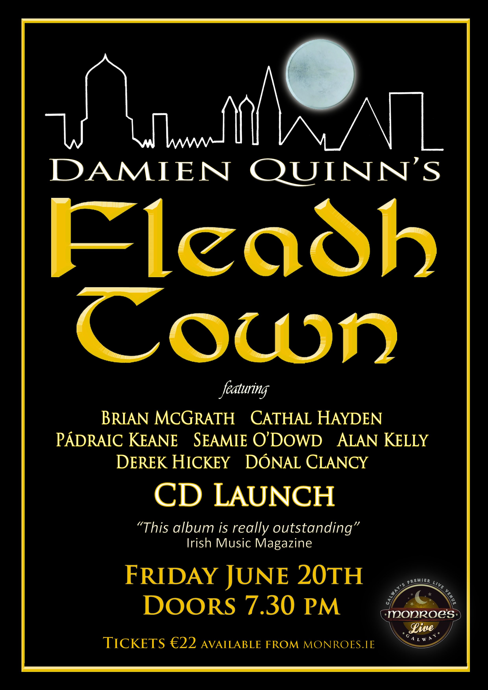
Damien Quinn’s Fleadh Town CD launch Monroe’s Live Galway June 20th
Friday June 20th Monroe’s live Galway presents the launch of “Damien Quinn’s Fleadh Town”, featuring a super group of traditional Irish Musicians, Cathal Hayden, Seamie O’ Dowd, Brian McGrath, Alan Kelly, Derek Hickey, Pádraic Keane, Michael McCague and Damien Quinn. Doors open at 7.30pm gig starts at 8.00pm sharp in what promises to be a night to remember
More information here and tickets here.
_________________________________________________________

Send us your Listings & News
We can share your posts! Email up to 50 words to arts@galwaycity.ie with a high-resolution landscape image. Images and text may be edited to fit.
___________________________________________________________________
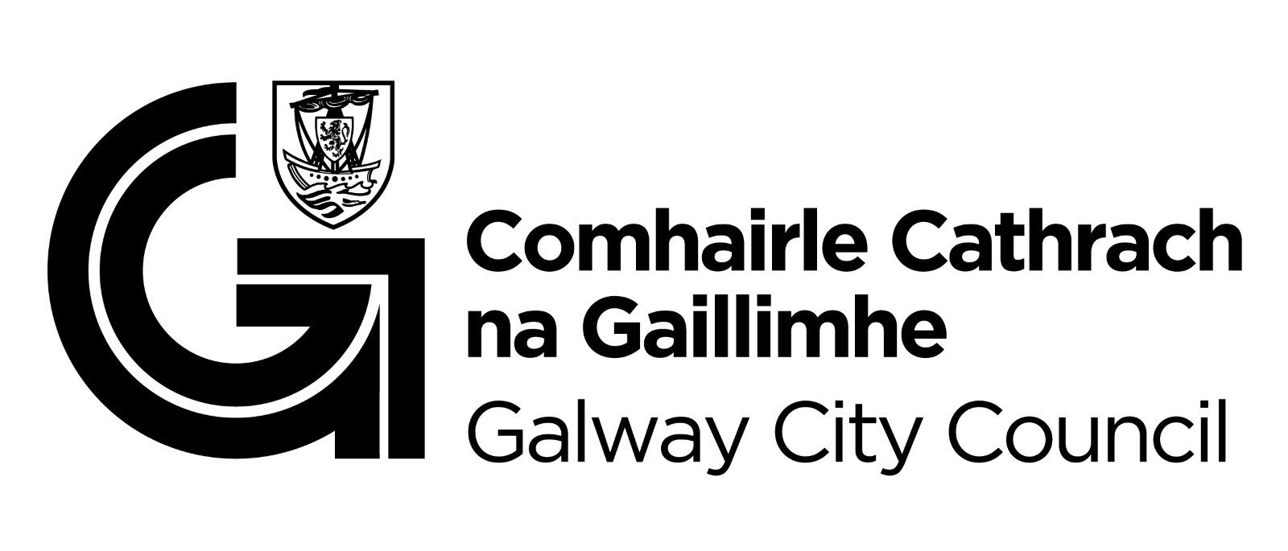
You are getting this email because you are on the Galway City Council Arts Office mailing list. Unsubscribe by emailing arts@galwaycity.ie and ask to be removed.

