Galway City Council Arts Newsletter Late May
The newsletter highlights the work of our funded arts organisations in Galway City and also includes opportunities and news for anyone interested and involved in arts and culture in Galway City.
GCC Arts Office Social Media
Facebook: www.facebook.com/ArtsOfficeGalwayCity
Instagram: @artsofficegalwaycity
_____________________________________________________________
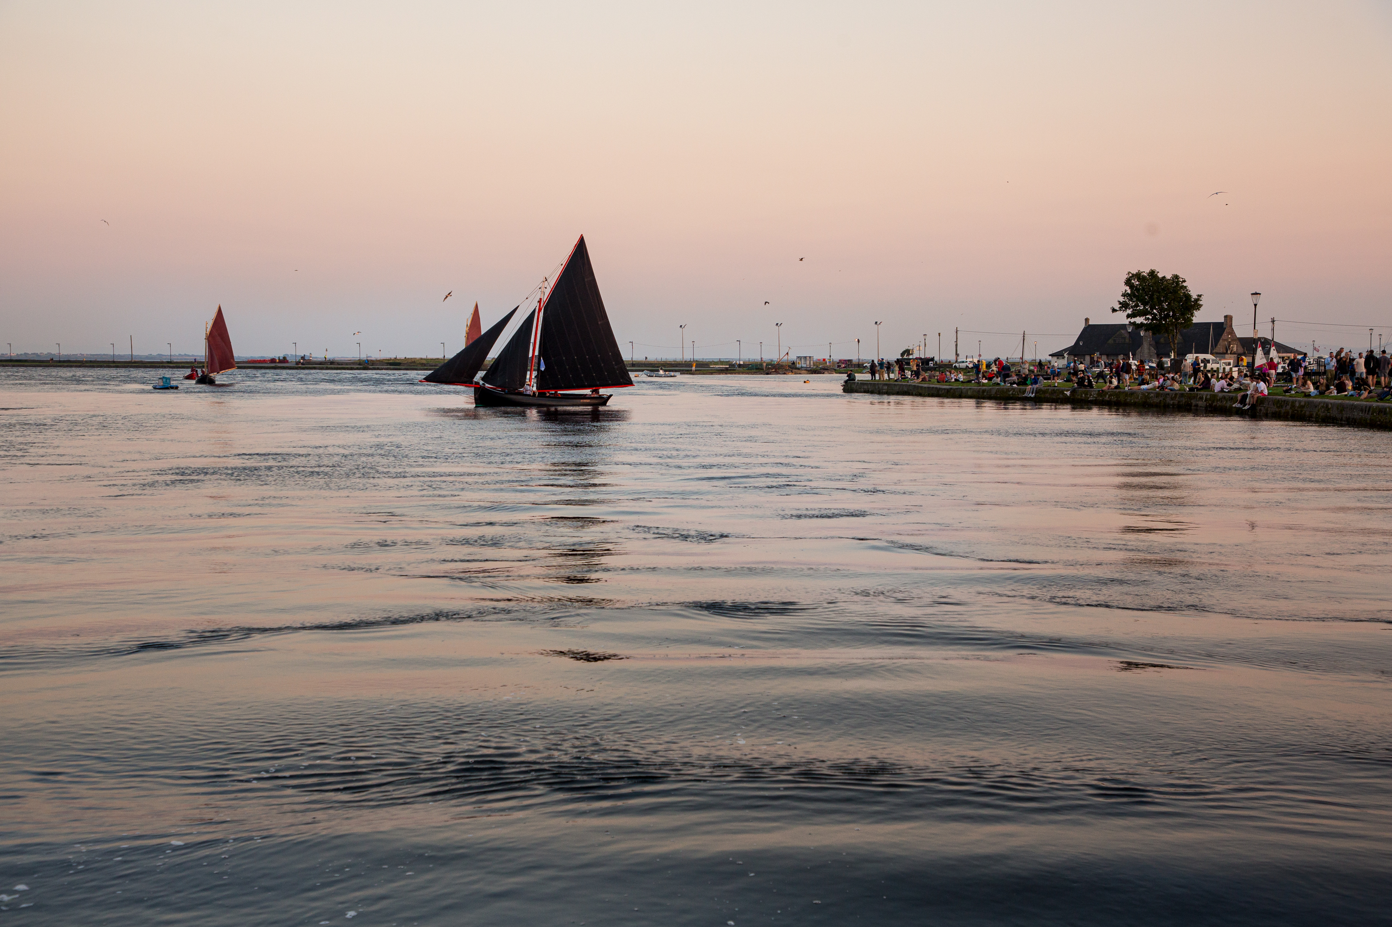
Galway City Culture Night Open Call
Galway City Council Arts Office are inviting applications to participate in this year’s Culture Night programme.

The twentieth edition of Culture Night will take place on Friday 19th September 2025. Culture Night / Oíche Chultúir is brought to you by the Arts Council; and managed and delivered locally by Galway City Arts Office. Galway City Council Arts Office aims to support events across Galway city centre and its neighbourhoods.
We encourage a range of events that celebrate all artforms as well as events that support or showcase diversity or events that ensure late-night offerings become a sustainable feature of the evening time culture and economy of Galway City.

- Events must be free of charge.
- Event organisers can apply to pay for artist fees and production costs for in-person events.
- The deadline for applications is 16th June 2025.
- Apply online at Galway City Council via Submit

More information and applications here.

_____________________________________________________________

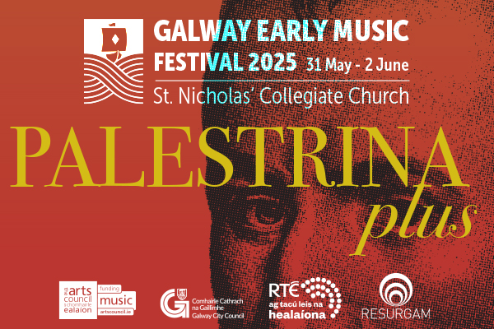
Galway Early Music Festival 2025
From 31st May to 2nd June, Galway Early Music Festival brings the medieval city to life with Italian-inspired performances by Palestrina, Carissimi, and more. Enjoy concerts at St. Nicholas’ Collegiate Church featuring Resurgam, the English Cornett and Sackbut Ensemble (ECSE) and international artists. With six events over three days this is a festival not to be missed.

Galway City Council Arts Office are proud funders of the festival organisers, Resurgam, through the Arts Organisation Grant 2025.

More information and tickets here: https://www.resurgam.ie/galway-early-music-festival.

_____________________________________________________________
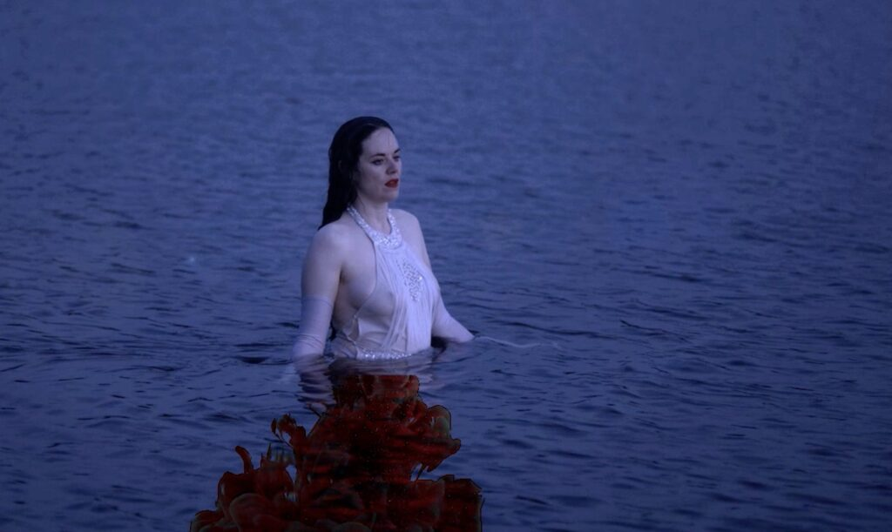
Love, Rage, and Solidarity at Galway City Arts Centre
Love, Rage & Solidarity is a solo exhibition by Treasa O’Brien, featuring a selection of works spanning her practice as an artist and filmmaker that focus on cultures and communities of resistance. Using documentary and narrative forms, essay film, sci-fi, and DIY tactics, O’Brien investigates the potential of video and filmmaking as both an artist and an activist.

The exhibition is open from 24 May to 29 June.

Galway City Arts Centre is supported by Galway City Council Arts Office through the Arts Organisation Grant 2025.

More information here: galwayartscentre.ie

_____________________________________________________________
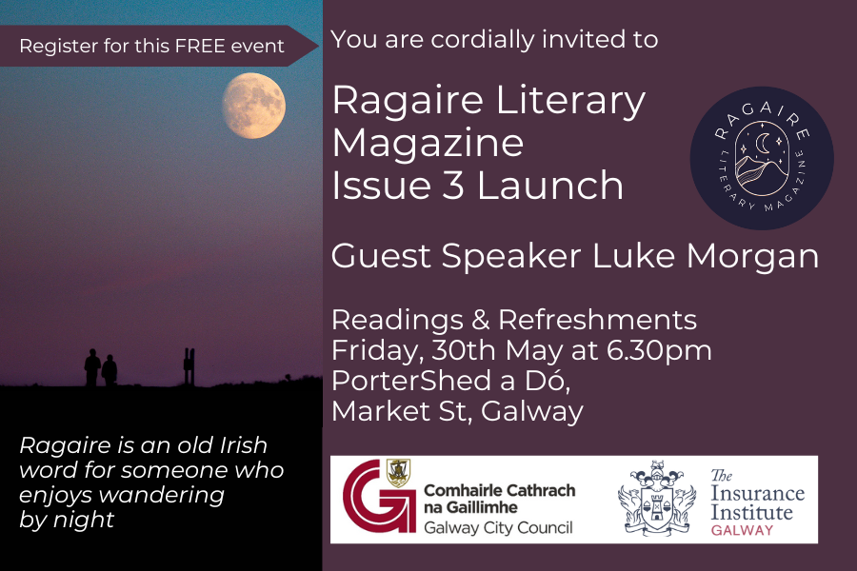
Ragaire to launch Issue 3 in May
Ragaire are delighted to invite the public to the launch of Issue 3 on Friday 30 May. Poet and Filmmaker Luke Morgan will be the guest speaker at the launch, and there will be readings and refreshments. Whether you have an appreciation for language, love a good story, or are simply curious, this promises to be an exciting event.

Ragaire Literary Magazine is supported by Galway City Council Arts Office through the Arts Organisation Grant 2025.

More information here: ragairemagazine.com
_____________________________________________________________

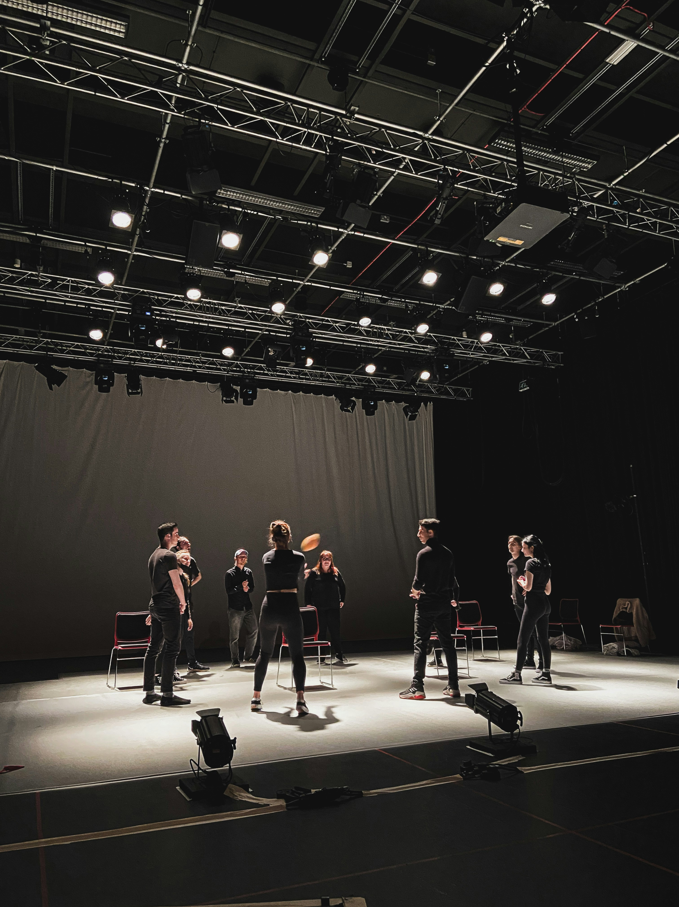
Arts Council Theatre Bursary Award Round 2 now open
The Arts Council have opened funding applications for the Theatre Bursary Award Round 2. The Bursary Award supports individual artists to develop their artistic practice.

It focuses on providing artists with the time and resources they need to think, research, reflect, and deeply engage with their artistic practice.

Application window closed 19 June at 5.30pm

There will be an information clinic for theatre artists interested in applying for funding through the Bursary Award on Thursday 29 May at 11:00 AM

More information here: artscouncil.ie/funding-opportunities

_____________________________________________________________
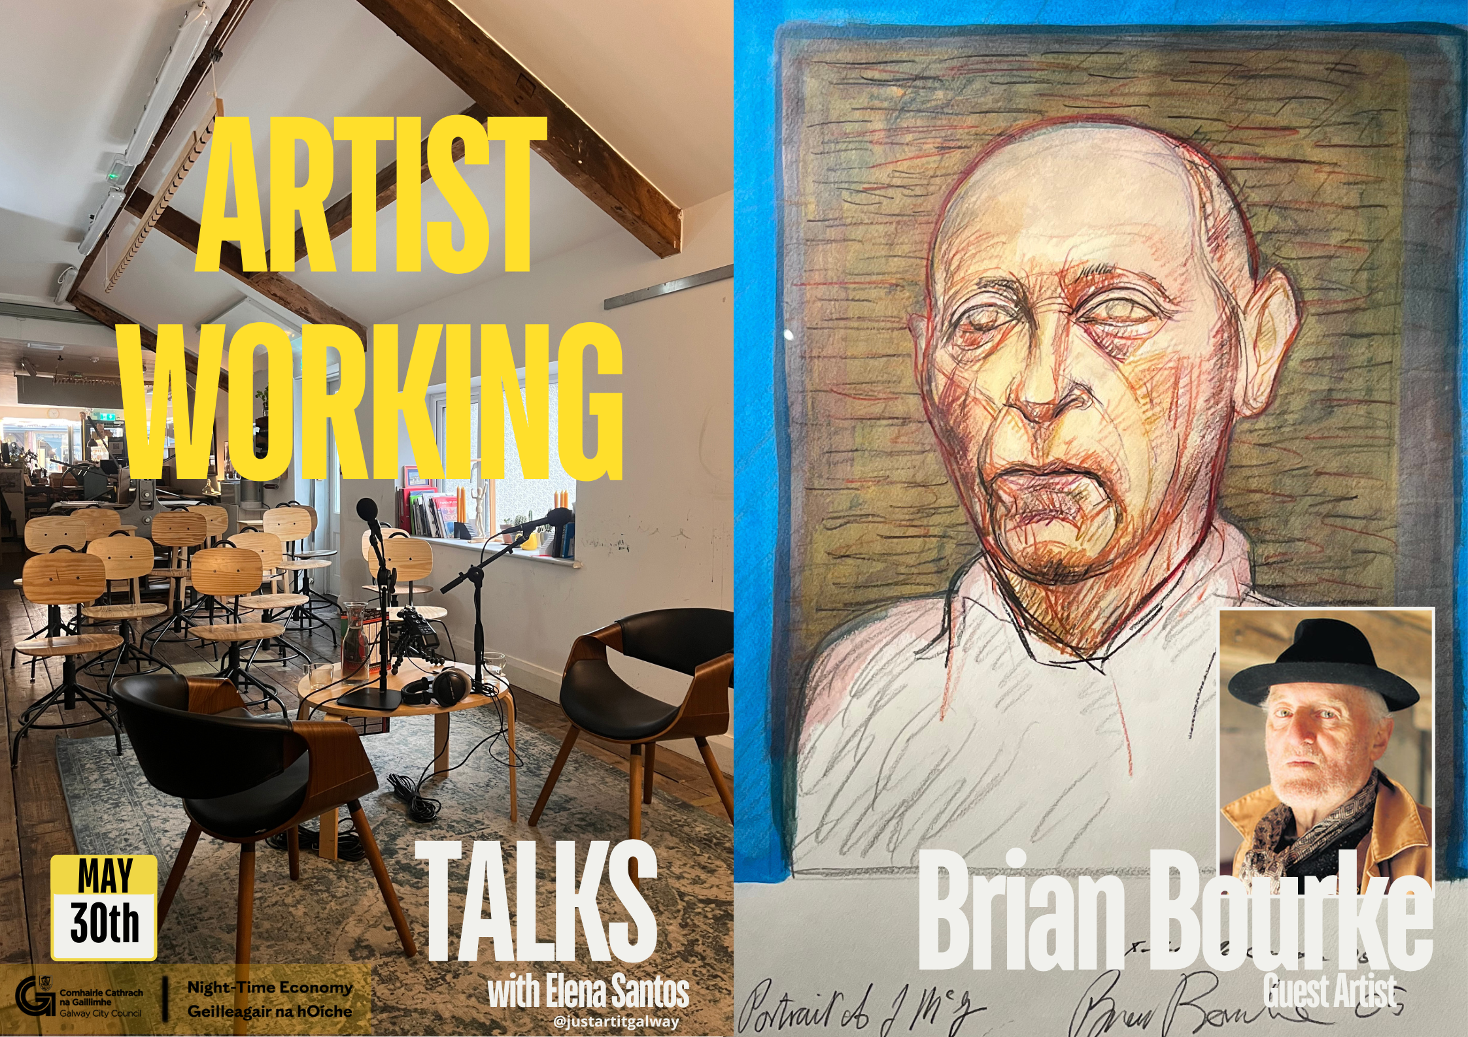
Artist Talks in Just Art It for Bealtaine
As part of the Bealtaine Festival 2025, a series of Artist talks have been held in Just Art It. This initiative, in partnership with Galway City Council Night-Time Economy continues Friday 30 May at 7pm in Just Art It, where Elena Santos of Just Art It will be in conversation with artist Brian Bourke.
This event is free, but booking is required.

More information and tickets here: justartitgalway.com

_____________________________________________________________
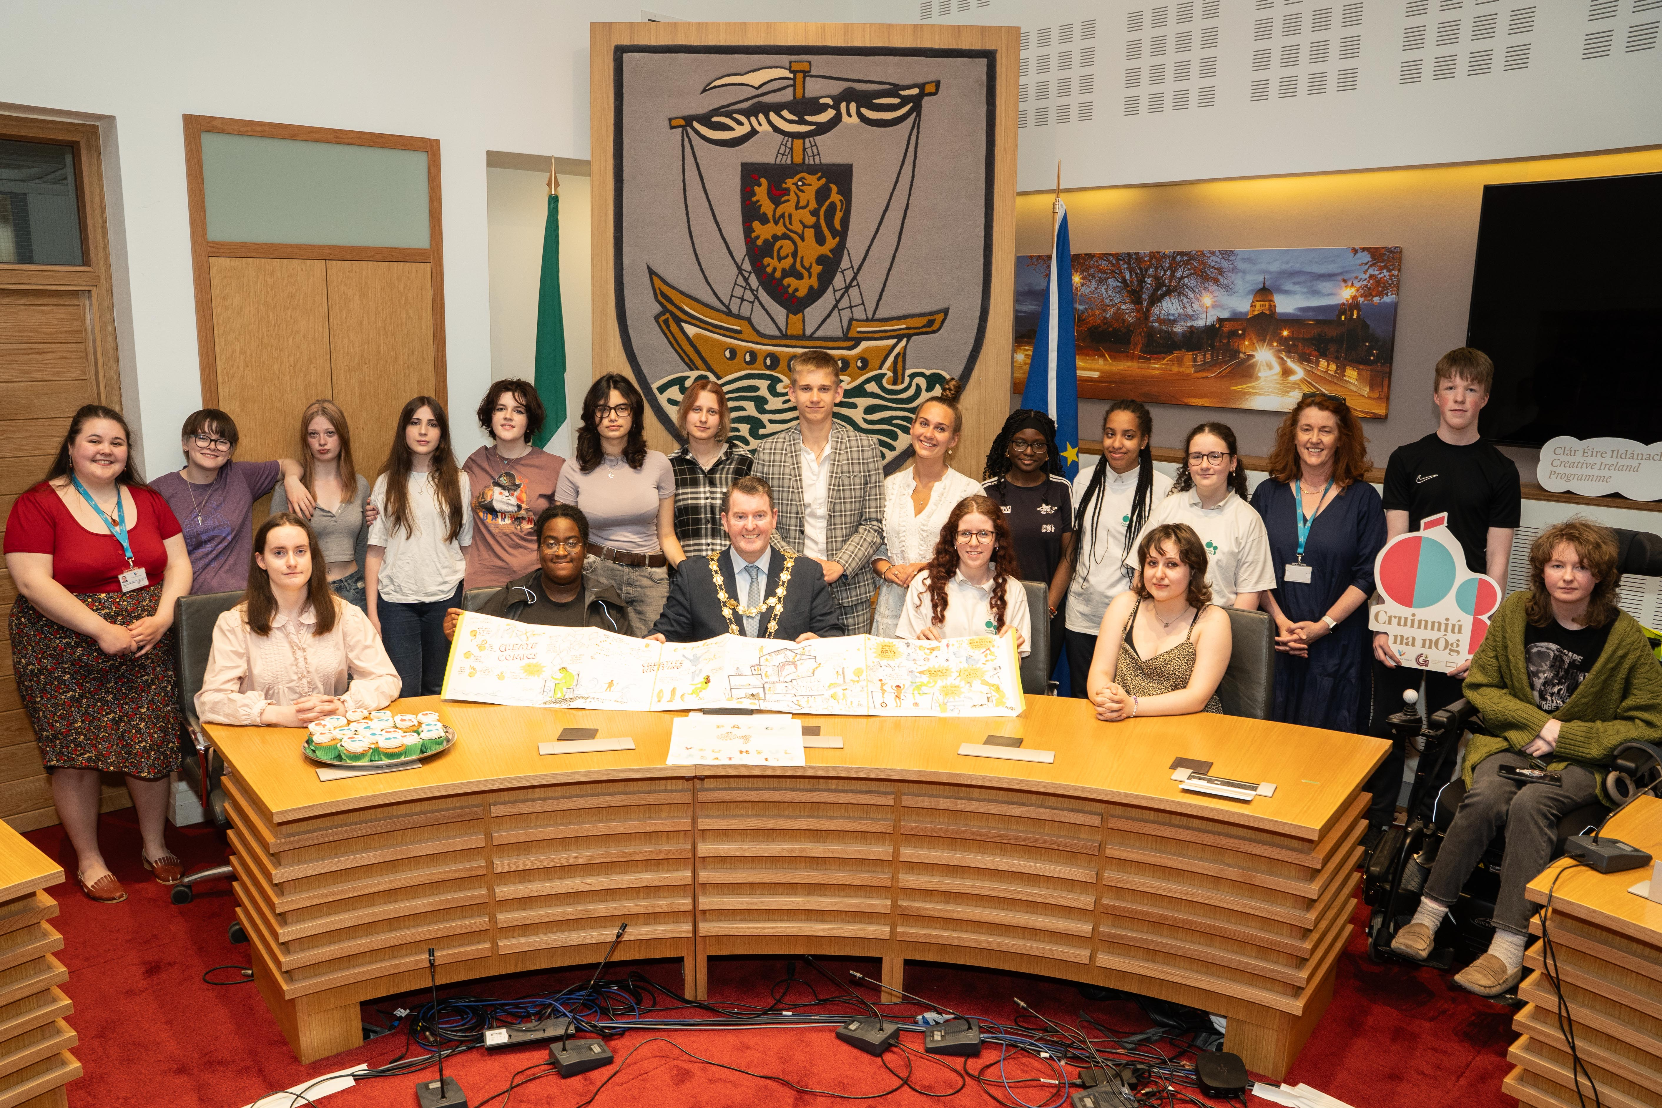
Mayor Launches Cruinniú na nÓg 2025
Mayor of Galway City, Councillor Peter Keane launched Cruinniú na nÓg 2025 on Tuesday 13 May with a presentation of poetry, art, and music at City Hall from young people involved in the Creative Youth Advisory Group.

Taking place on Saturday, June 7 from 12-9pm at Fr. Burke Park, this celebration will host over 40 free events, workshops, and performances, celebrating creativity through music, art, circus, storytelling, and more.

More information here: galwaycity.ie/news

_____________________________________________________________

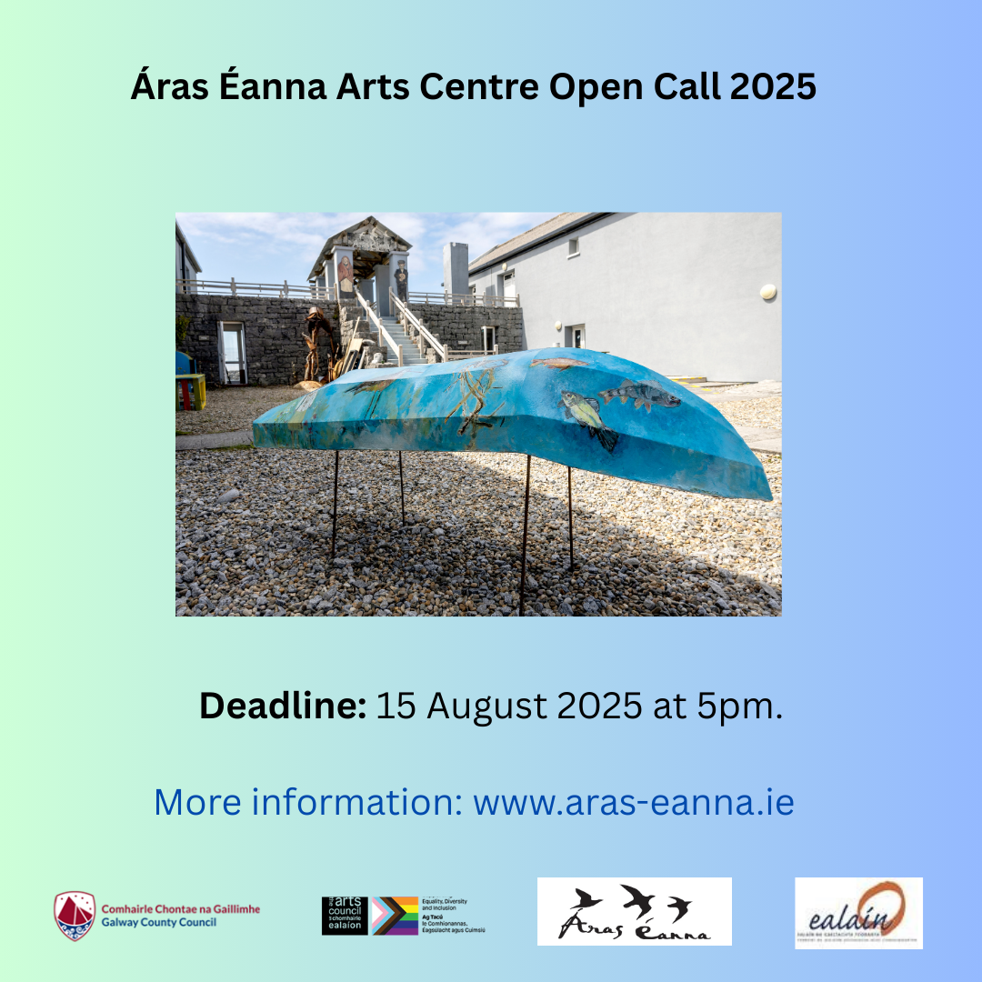
Áras Éanna Arts Centre Open Call 2026
Áras Éanna are inviting applicants to apply for residencies on Inis Oírr for 2026. The successful recipients will be offered residencies that will be allocated on dates determined by the selection board. They welcome artists at all stages of their professional life from emerging to well-established.

Closing date: Friday 15th August 2025 at 5p.m.

More information here: https://aras-eanna.ie/en/aras-eanna-arts-centre-open-call-2026/

_____________________________________________________________
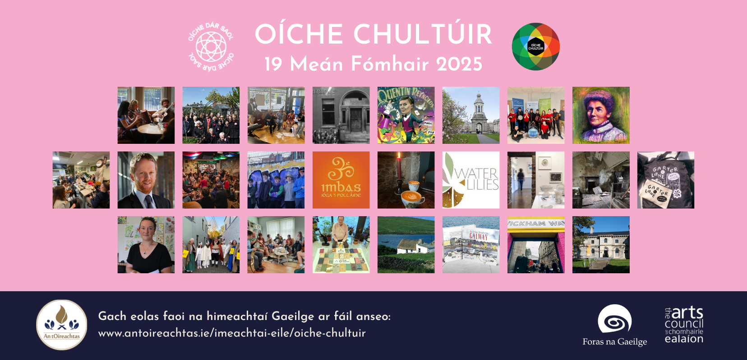
Culture Night 2025: Call for Applications
An tOireachtas, in conjunction with Oíche Chultúir, are calling for submissions of Irish Language Events on Oíche Chultúir 2025. Returning for the twentieth year, Oíche Chultúir will be held on Friday, 19 September 2025.
An tOireachtas are looking for submissions covering, but not limited to, these themes: Performing Arts; Dance‎; Literature; Heritage; Drama; Music; Arts & Crafts; Visual Arts; Talk; Tour; Film‎.
Deadline for submissions: 12 June 2025
Begin your application here.

_________________________________________________________

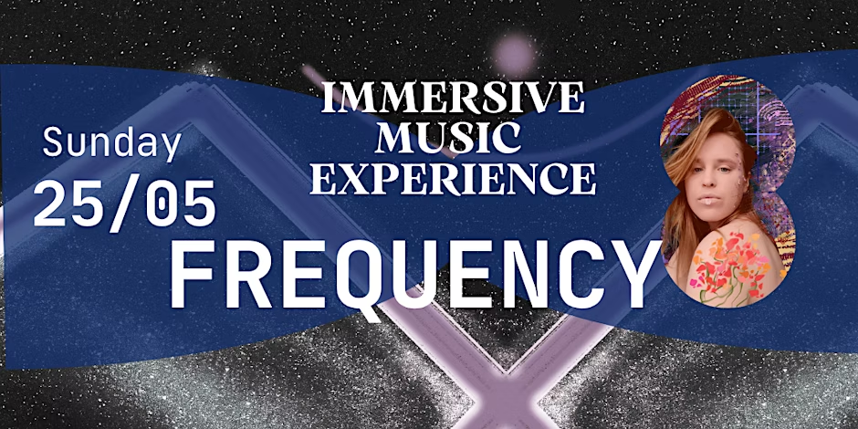
Frequency Immersive Music Experience
Join local artist Liz Stolbova (@nature_soul_ig on Instagram) for an immersive experience featuring local artists, elements of orchestral music, dance, and other forms of art in Croí Nua on Taylors Hill on Sunday 25 May from 3pm to 5.30pm.
10% of sales will go to Voices of Kids charity.
Tickets and more information here.

_________________________________________________________

Send us your Listings & News
We can share your posts! Email up to 50 words to arts@galwaycity.ie with a high-resolution landscape image. Images and text may be edited to fit.
___________________________________________________________________
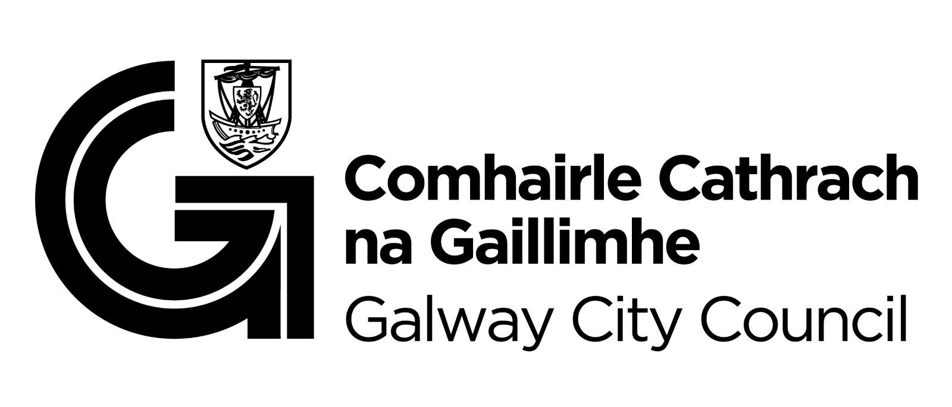
You are getting this email because you are on the Galway City Council Arts Office mailing list. Unsubscribe by emailing arts@galwaycity.ie and ask to be removed.

