Galway City Council Arts Newsletter Early July
The newsletter highlights the work of our funded arts organisations in Galway City and also includes opportunities and news for anyone interested and involved in arts and culture in Galway City.
GCC Arts Office Social Media
Facebook: www.facebook.com/ArtsOfficeGalwayCity
Instagram: @artsofficegalwaycity
_____________________________________________________________
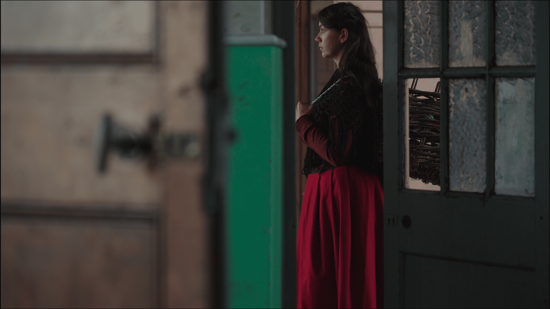
Beckett sa Chreig: Guth na mBan: An Taibhdhearc le Company SJ
Cuireann an Taibhdhearc Beckett sa Chreig: Guth na mBan i láthair, ceithre shaothar ghearra le Samuel Beckett, an dara cuid i sraith le Company SJ.

Cuireann an léiriúchán tumtha Gaeilge seo, a spreagtar ag teanga agus tírdhreach Inis Oírr, deis annamh ar fáil chun na saothair seo a fheiceáil ar shlí nach bhfacthas riamh.

Galway City Council Arts Office supports An Taibhdhearc through the Arts Organisation Grant 2025.

More information here.
_____________________________________________________________
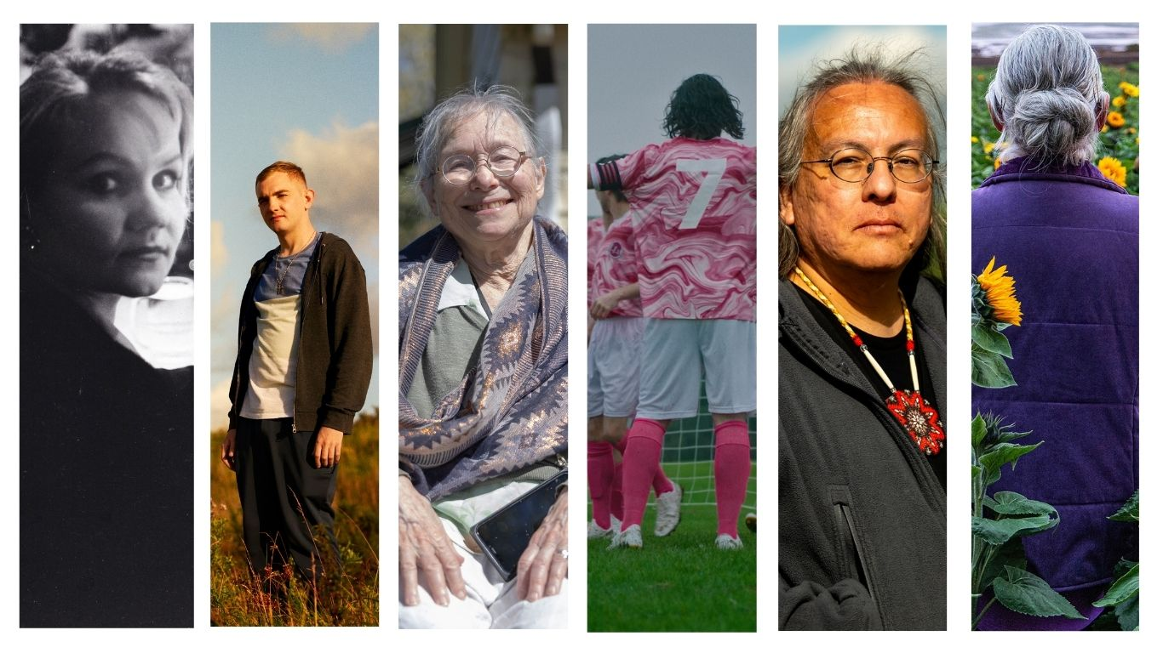
Galway Film Fleadh announces full programme for the 37th Edition
Galway Film Fleadh has announced World, International and Irish Premieres for the 37th edition of the film festival taking place from 8 – 13 July in the Town Hall Theatre and Pálás Cinema. The 37th Fleadh will feature 31 World Premieres, 11 International/European Premieres and 46 Irish Premieres from 44 countries, featuring 96 feature films in total.

Galway City Council Arts Office supports Galway Film Fleadh through the Arts Organisation Grant 2025.

More information here.

_____________________________________________________________
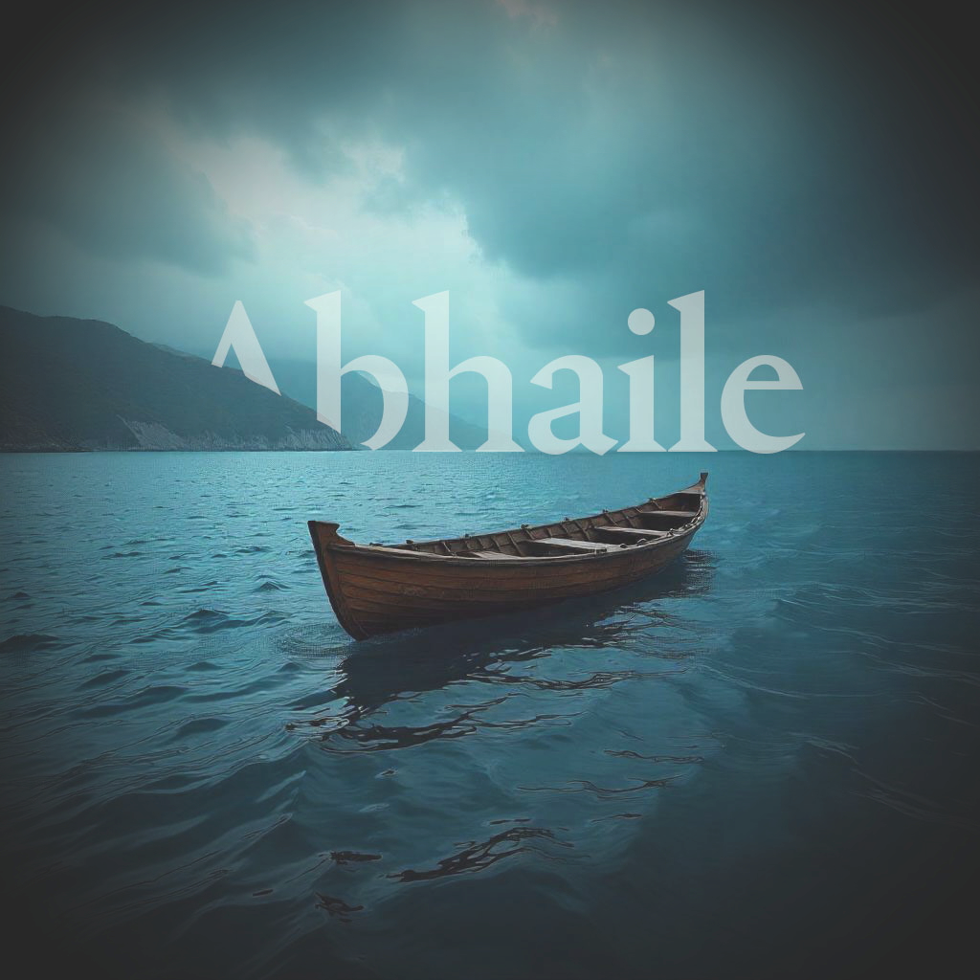
Luminosa String Orchestra announce Abhaile
Our long awaited 2025 concert has been curated around the idea of coming home. This can mean very different things to us at different times, but at the heart of Luminosa's curatorial approach is the idea of being based in Galway and having local and international talent; a confluence of artistic excellence from around the world coming together to create a memorable evening of live music making especially for Galway audiences.

The concert will take place Saturday 20th September in St.Nicholas’ Collegiate Church.

Galway City Council Arts Office supports Luminosa through the Arts Organisation Grant 2025.

More information here
_____________________________________________________________
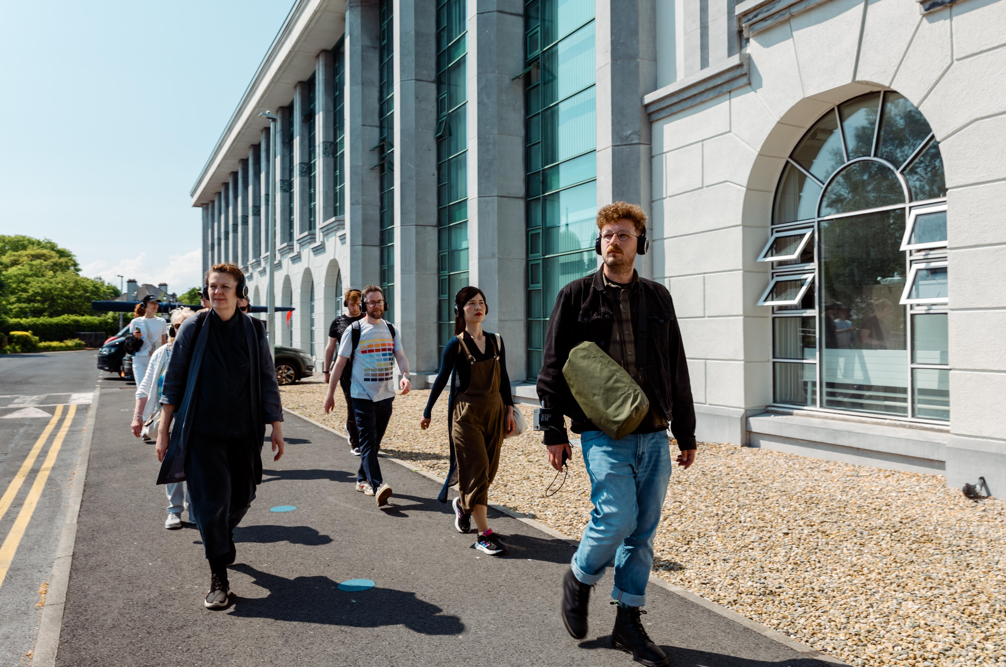
Christopher Steenson 1, Airwalk – Ambient Air Quality Sensing System, 2025, with members of the Westside community, 13 May 2025, Photograph by Tom Flanagan
Artists’ works exploring air quality and pollution to premiere at Galway’s Westside Arts Festival
Galway Arts Centre, in conjunction with Galway City Council, today announced details of the newly completed artworks created through the ‘The Air We Share’ artist-in-residence programme. The programme supports artists to work with local communities and creatively respond to scientific research on air quality and climate, conducted by local citizens and climate scientists from the University of Galway. The art projects will feature at this year’s Westside Arts Festival, which takes place from 8th to 12th July 2025.

More information here.

_____________________________________________________________
Ballybane Art Group ‘Variety’ Exhibition Opening soon
Ballybane Art Group, let by local artist Irene Naughton will launch an art exhibition in Ballybane Library on Saturday 5 July at 2.30pm.
The exhibition is titled ‘Variety’, so named for the various techniques and themes within the exhibition.
Ballybane Art Club is supported by Galway City Council through the Creative Communities Fund 2025.
_________________________________________________________

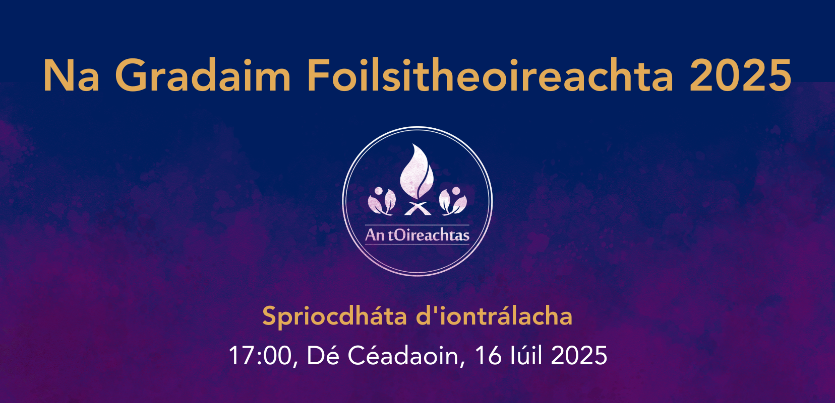
Na Gradaim Foilsitheoireachta 2025
Is comórtais iad seo atá dírithe ar fhoilsitheoirí leabhar Gaeilge agus is marc aitheantais ar scoth an chaighdeáin in earnáil na foilsitheoireachta Gaeilge é ceann de na gradaim seo a bhaint amach. Bronnfar duais ar údar na nduaisiarrachtaí agus i gcás Gradam Réics Carló, ar ealaíontóir an leabhair chomh maith leis an Teach Foilsitheoireachta.

Foirm Iontrála

_________________________________________________________

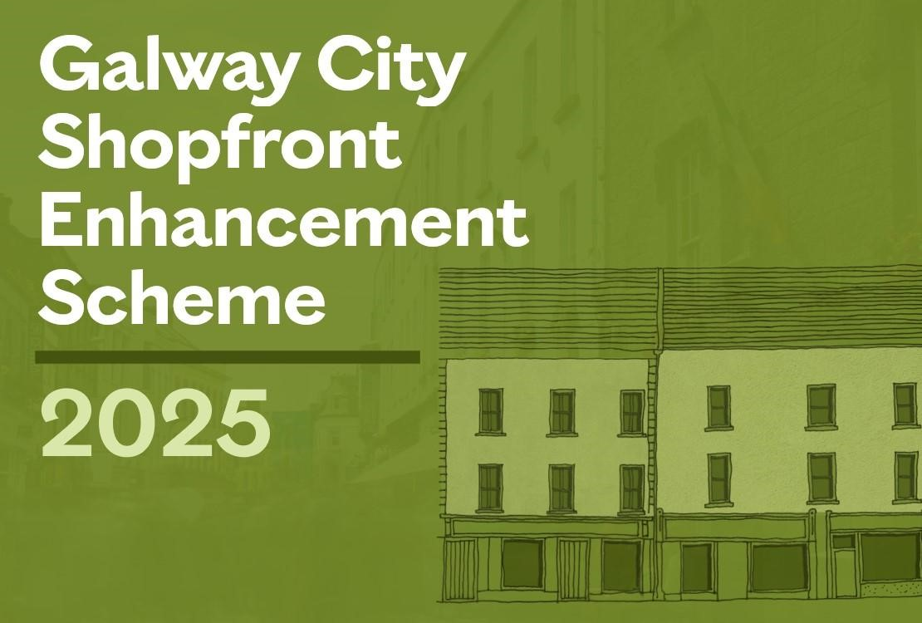
Galway City Council €200,000 Shopfront Enhancement Scheme closes soon
Applications to Galway City Council’s Shopfront Enhancement Scheme 2025, a €200,000 initiative aimed at revitalising the city’s commercial streetscapes, will close soon.

Eligible businesses are invited to apply by Friday 11 July 2025.

More information here: galwaycity.ie/shopfront

_____________________________________________________________
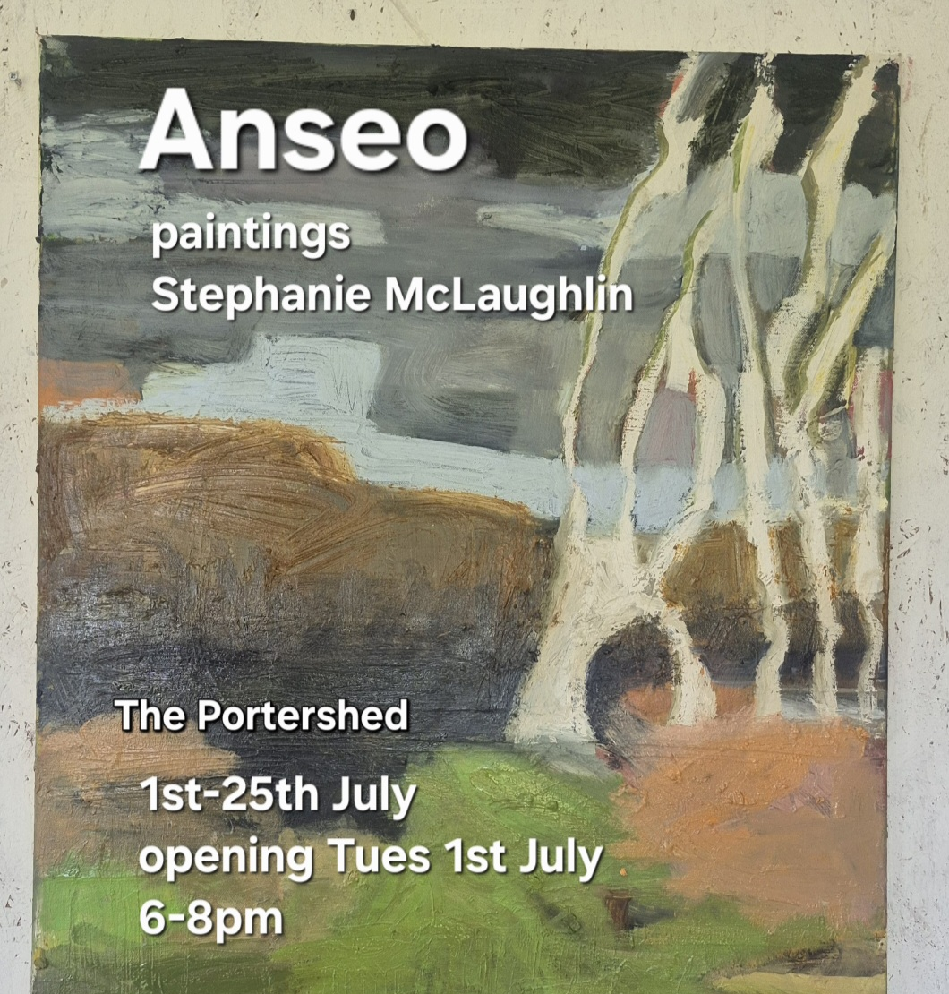
Stephanie McLaughlin presents ‘Anseo’
Local artist Stephanie McLaughlin is currently presenting an exhibition of works titled ‘Anseo’ in the Portershed. The exhibition runs from 1 July to 25 July.

More information here.

_____________________________________________________________
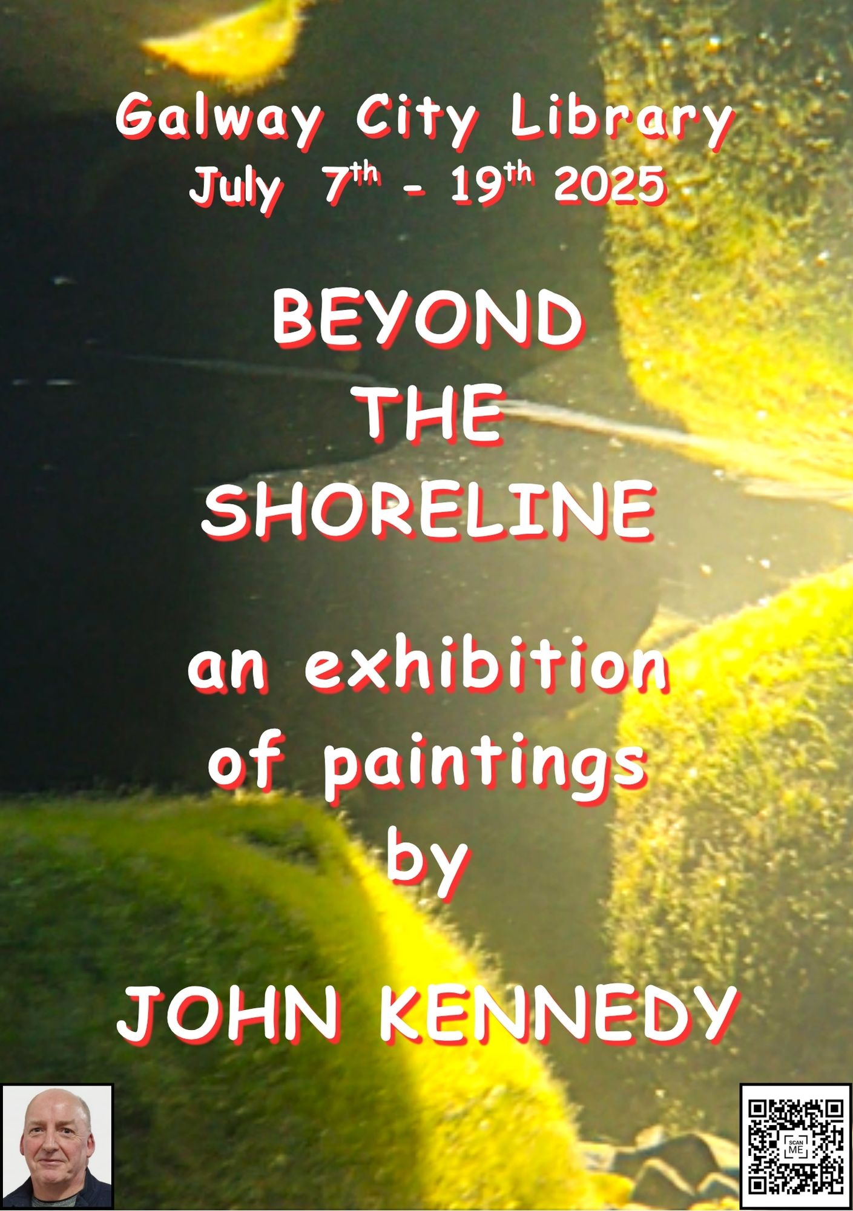
Beyond the Shoreline exhibit in Galway City Library
Oranmore based artist John Kennedy will present an exhibition of works titled “Beyond the Shoreline” in Galway City Museum. The exhibition runs from July 7 to 19 July.

More information here.

_____________________________________________________________

Expressions of Interest sought for participants of the 2025-2026 Sustainable Development Goal (SDG) Champions Programme
The Department of Climate, Energy and the Environment is seeking Expressions of Interest for participants of the 2025-2026 SDG Champions Programme.

Established in 2019, the SDG Champions Programme is a non-funded programme, developed to raise public awareness of the SDGs and to demonstrate, through best practice examples provided by the SDG Champions, that everyone in society can make a contribution to the 2030 Agenda for Sustainable Development.

The application deadline is 30 July 2025.

More information here.

_____________________________________________________________
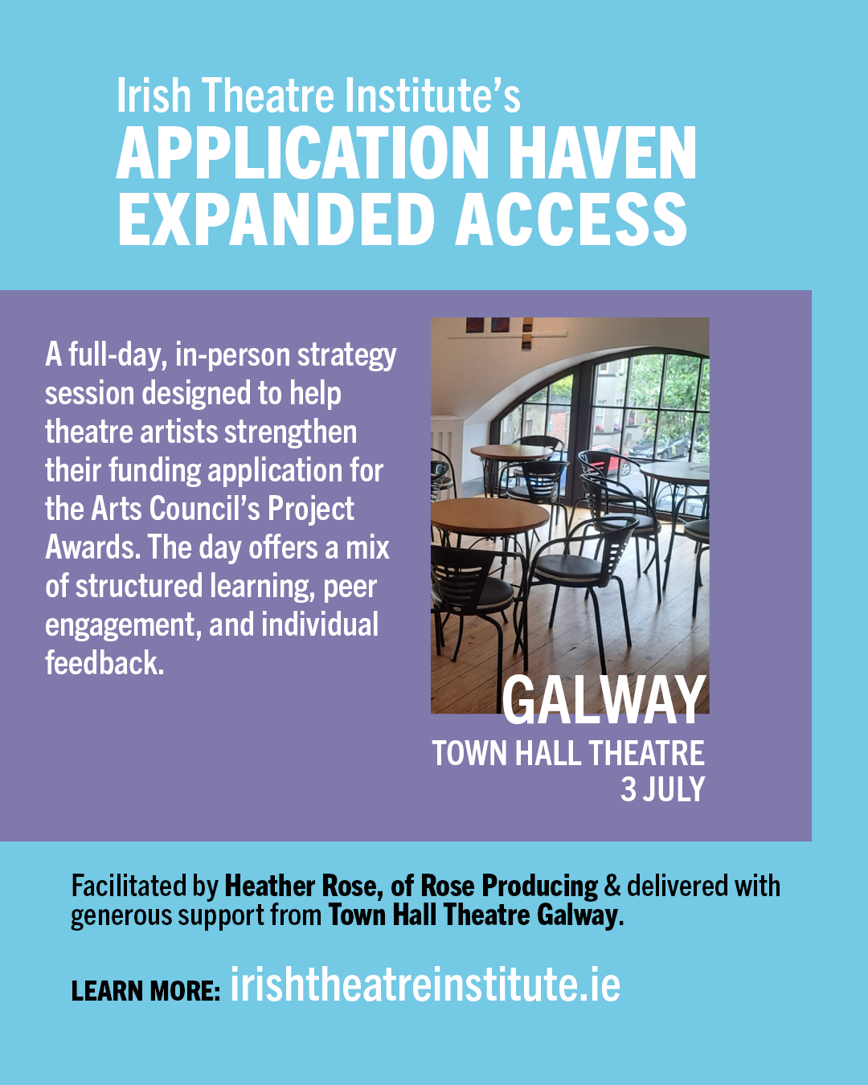
Application Haven: Expanded Access in Galway this Thursday
Join us for a full-day, in-person strategy session designed to help you strengthen your funding application for the Arts Council’s Project Awards. The day offers a mix of structured learning, peer engagement, and individual feedback.

More information here.

_____________________________________________________________
Send us your Listings & News
We can share your posts! Email up to 50 words to arts@galwaycity.ie with a high-resolution landscape image. Images and text may be edited to fit.
___________________________________________________________________
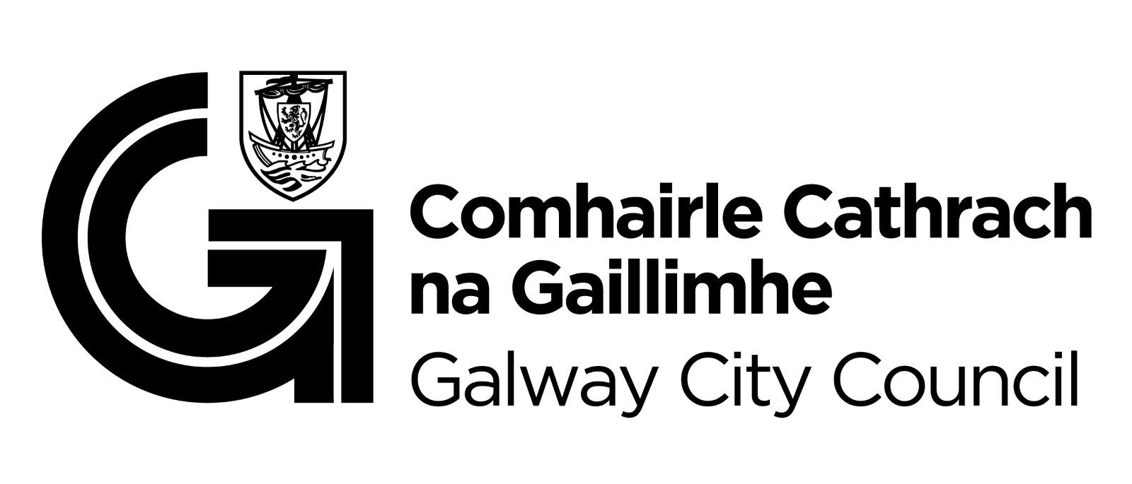
You are getting this email because you are on the Galway City Council Arts Office mailing list. Unsubscribe by emailing arts@galwaycity.ie and ask to be removed.

