**Galway City Council Arts Newsletter Late June**

The newsletter highlights the work of our [funded arts organisations](https://www.galwaycity.ie/services/arts-and-culture/arts-and-culture-services/arts-grants-2025) in Galway City and also includes opportunities and news for anyone interested and involved in arts and culture in Galway City.

**GCC Arts Office Social Media**

Facebook: [www.facebook.com/ArtsOfficeGalwayCity](https://scanner.topsec.com/?d=1122&r=show&u=https%3A%2F%2Fwww.facebook.com%2FArtsOfficeGalwayCity&t=a6b33347cd65717d4a93047cc8b1c9f7c5d8a4c9)

Instagram: [@artsofficegalwaycity](https://www.instagram.com/artsofficegalwaycity?utm_source=ig_web_button_share_sheet&igsh=ZDNlZDc0MzIxNw==)

**_____________________________________________________________**

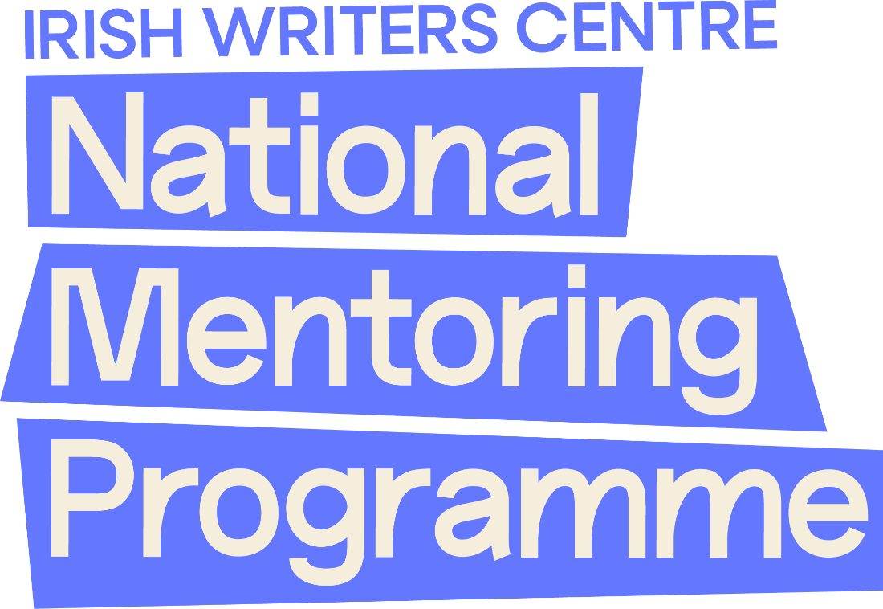

**Three Galway based writers chosen for National Mentoring programme**

Local writers, Bern Butler, Barry Neenan, and Kate McHugh have been chosen for the Irish Writers Centre’s prestigious National Mentoring Programme 2025, following an exceptional response to this year’s nationwide callout, which attracted 354 applicants. Each selected writer will receive one-to-one mentoring from an established writer, offering invaluable creative and professional guidance over the coming months.

[More information here](https://irishwriterscentre.ie/34-writers-selected-for-irish-writers-centres-national-mentoring-programme-2025/).

**_____________________________________________________________**

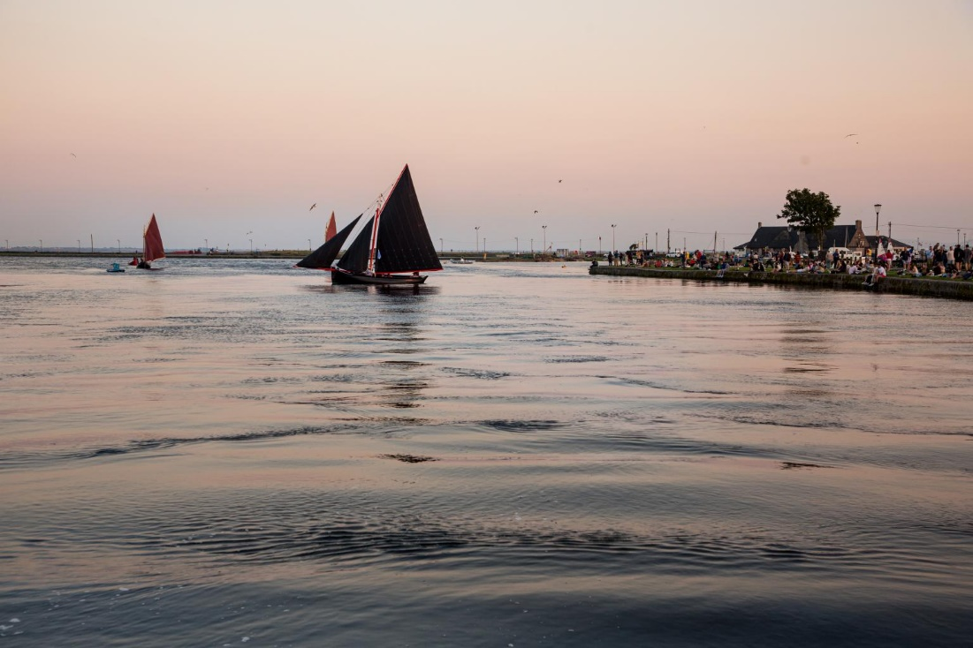

**Galway City Culture Night Open Call Now Closed**

Thank you to all who submitted a proposal for the Culture Night Open Call for Galway City. We received a great response, with many exciting activities. The Culture Night team will now review all of the applications and reach out to applicants in the coming weeks. We are sure that this year will be another fantastic year for Galway City, and we thank you for your patience while we work to put together the best programme of events possible.

In the meantime, if you have any queries, please email [culturenightgalwaycity@outlook.com](mailto:culturenightgalwaycity@outlook.com)

**_____________________________________________________________**

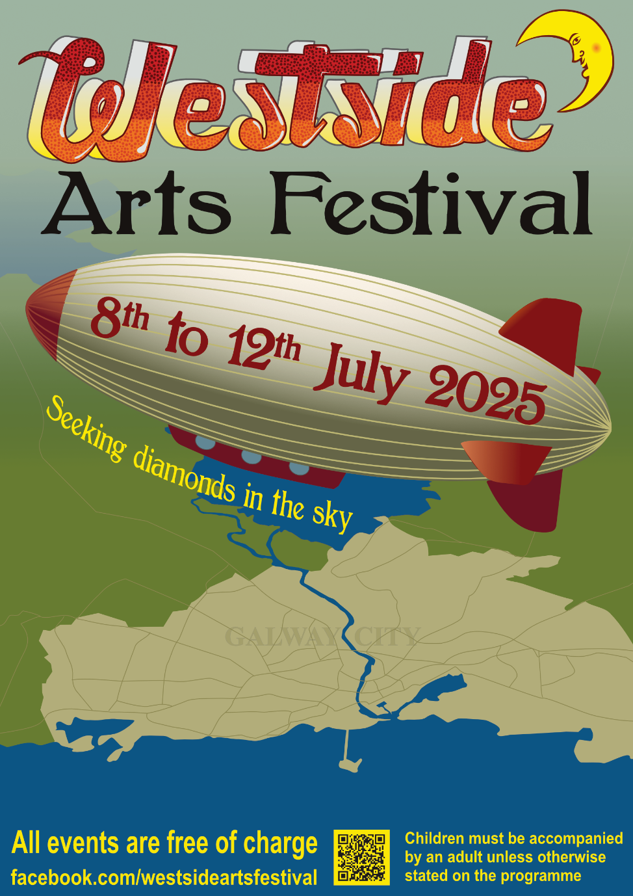

**Westside Arts Festival poster Launched**

The time of the festival is fast approaching, and the organising committee has just launched the Westside Arts Festival 2025 promotional poster. The 2025 festival takes place from Tuesday 8th to Saturday 12th July and promises a wide range of free creative events and activities. Local artists can submit a maximum of two pieces to be exhibited at the festival gallery.

Westside Arts Festival are supported by Galway City Council Arts Office.

More information here: [facebook.com/westsideartsfestival](https://www.facebook.com/westsideartsfestival/)

**_____________________________________________________________**

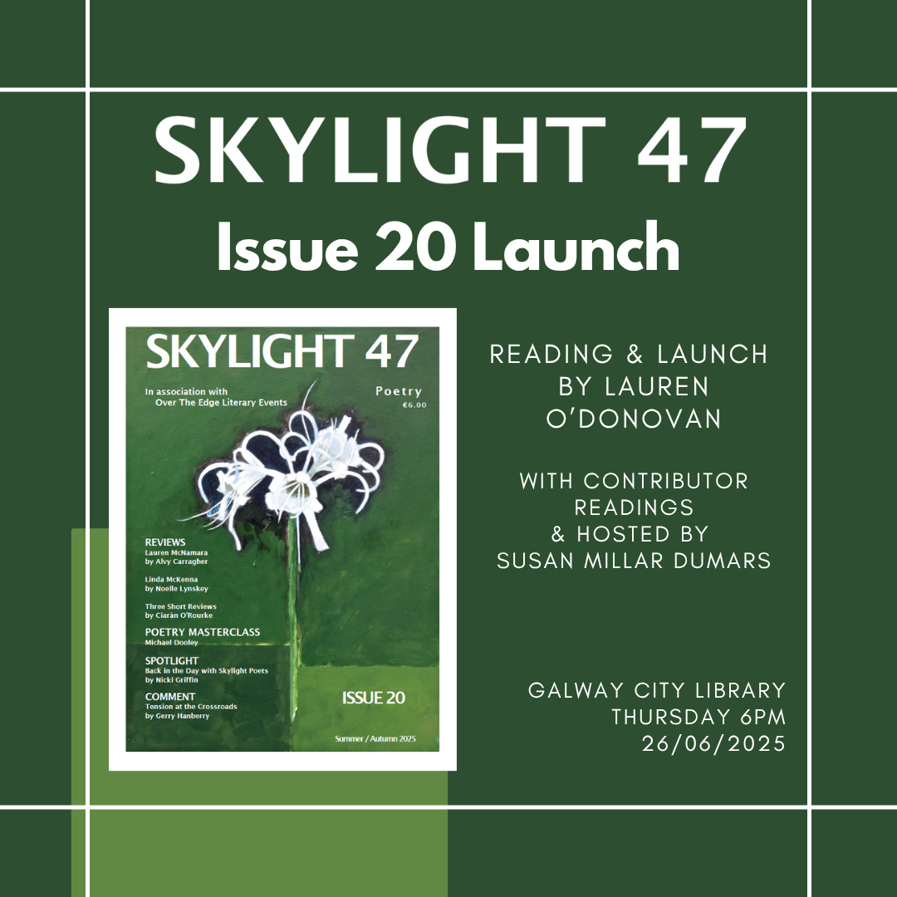

**Skylight 47 launch Issue 20**

Skylight 47 poetry magazine will hold a launch event for its special milestone issue, Issue 20, at 6PM on Thursday, June 26th in the Galway City Library. The event will be hosted by Susan Millar DuMars, and award-winning poet Lauren O'Donovan will launch the issue and perform a reading of her own work. She will be joined by contributors who will read their published poems. All are welcome to this free event.

Skylight 47 are supported by Galway City Council Arts Office through the Arts Organisation Grant 2025.

More info here: [skylight47poetry.wordpress.com](https://skylight47poetry.wordpress.com/)

**_____________________________________________________________**

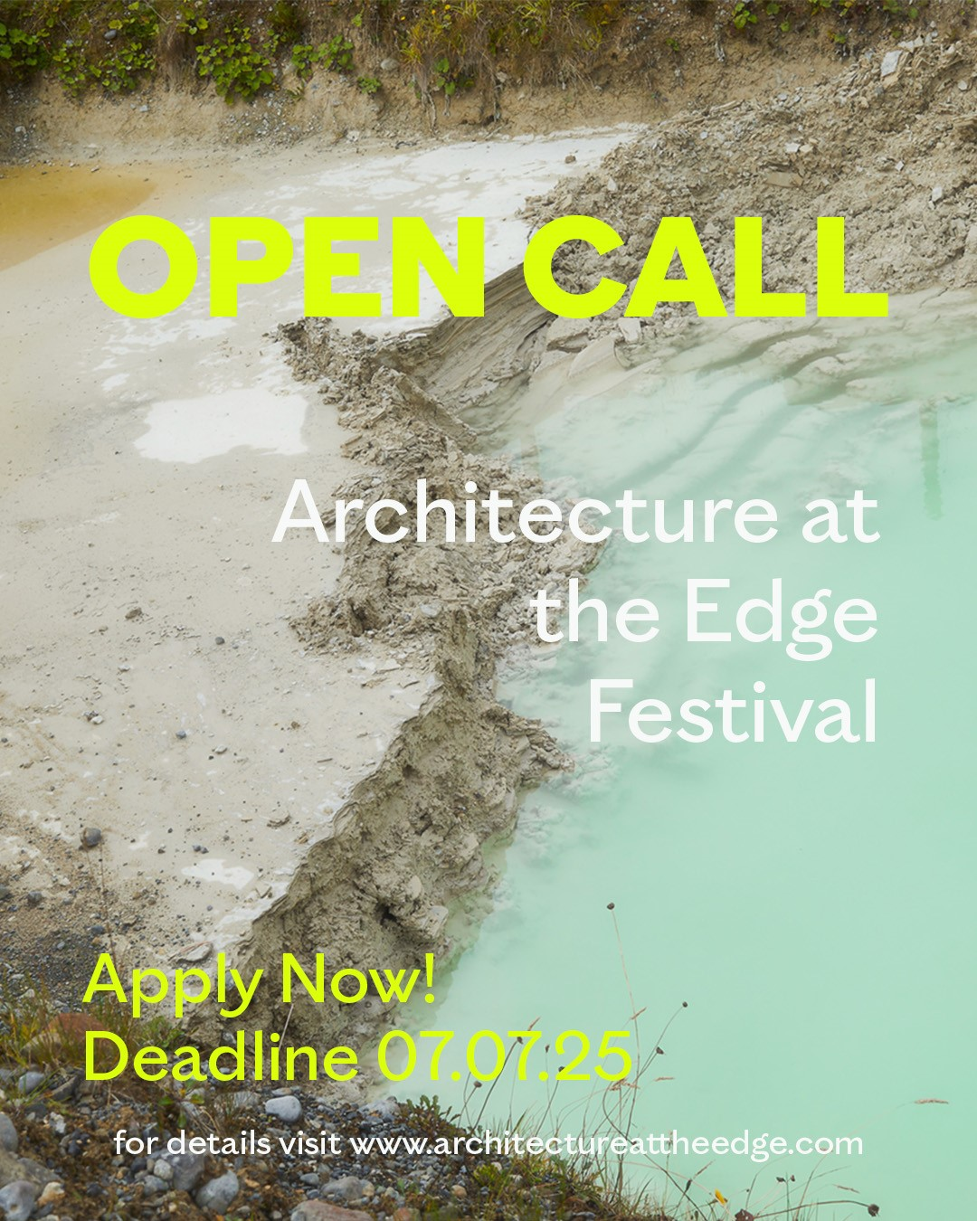

**Open Call - Architecture at the Edge Festival 2025**

Architecture at the Edge has issued an open call for entries for the next edition of the Festival which will take place between 26 September – 12 October 2025.

The topic of this year's Architecture at the Edge Festival is centred on the theme of the ‘Unseen.’

Application deadline is 7 July.

Architecture at the Edge is supported by Galway City Council Arts Office through the Arts Organisation Grant 2025.

More information here: <https://www.architectureattheedge.com/aate-open-call-2025>

**_____________________________________________________________**

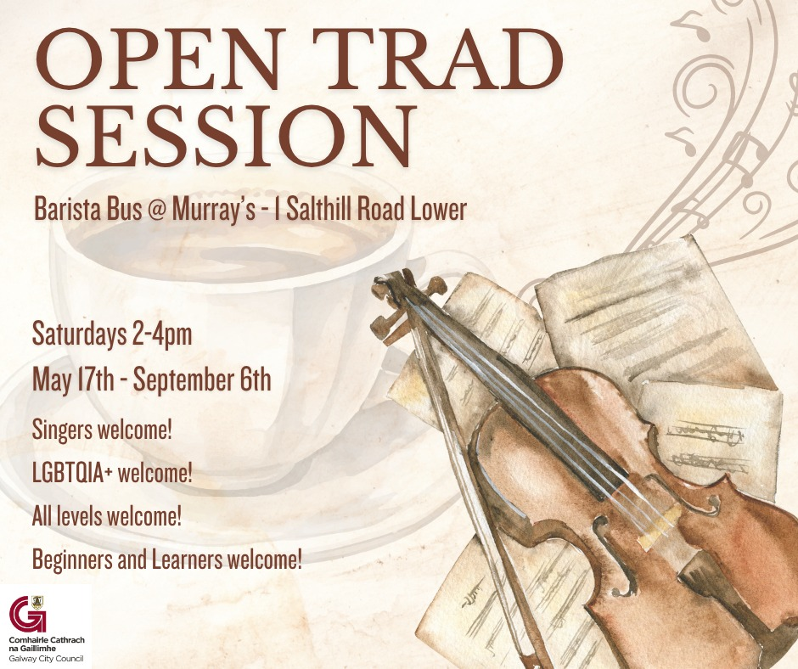

**Open Trad Sessions in Murray’s coffee house**

Open Trad Sessions run Saturdays at 2pm until 6th September at Barista Bus @ Murray’s, Galway. Free and welcoming, these sessions are ideal for adult beginners and returning musicians. Led by Tyler Holt and Gustavo Lobão. No registration needed.

This initiative is supported by Galway City Council and Creative Ireland.

More info: [@tylergabrielmusic on Instagram](https://www.instagram.com/tylergabrielmusic).

**_____________________________________________________________**

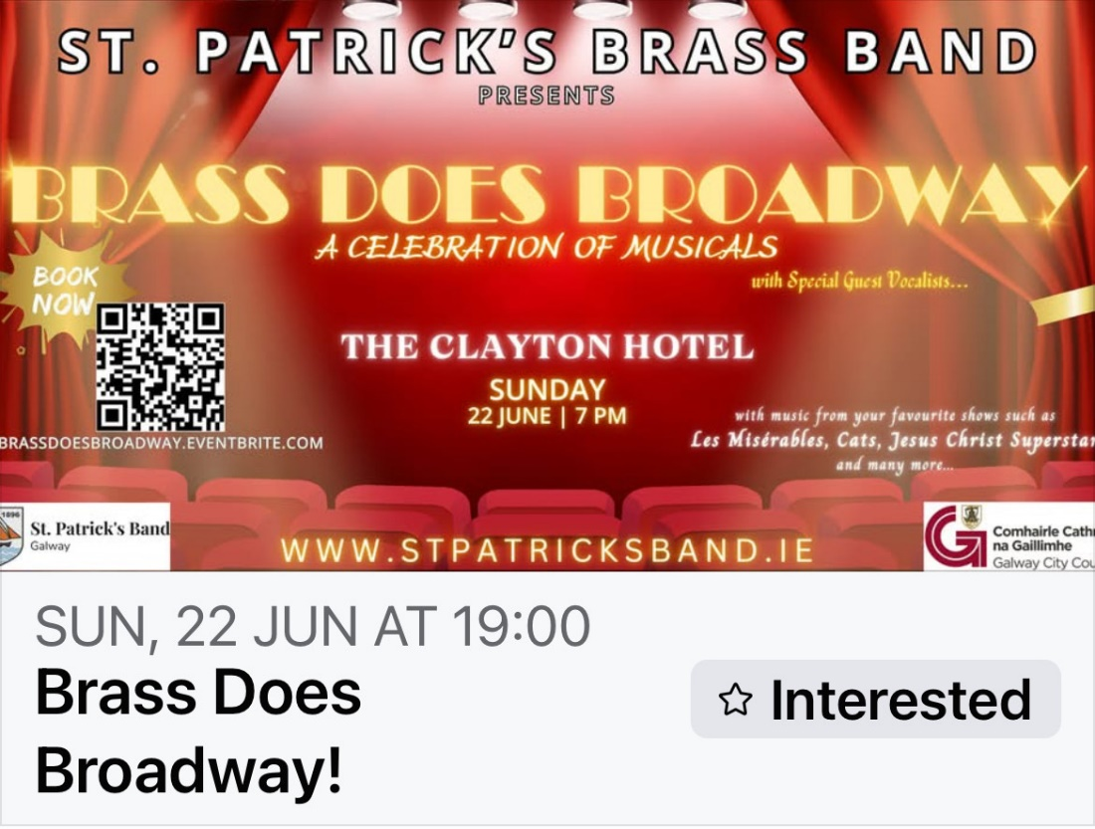

**St Patrick’s Band Concert**

St. Patrick's Brass Band Galway are delighted to present "Brass does Broadway" on Sunday 22 June in the Clayton Hotel Galway. Come join us for a spectacular night of music - full of your favourite show themes including music from Cats, Les Miserablés, Jesus Christ Superstar, Phantom of the Opera and many more!! Featuring some of Galway's best guest vocalists, it promises to be a night not to be missed!!

St. Patrick's Brass Band are supported by Galway City Council Arts Office through the 2025 Band Performance Grant.

[More information here](https://www.facebook.com/events/s/brass-does-broadway/711926478457552/).

**_____________________________________________________________**

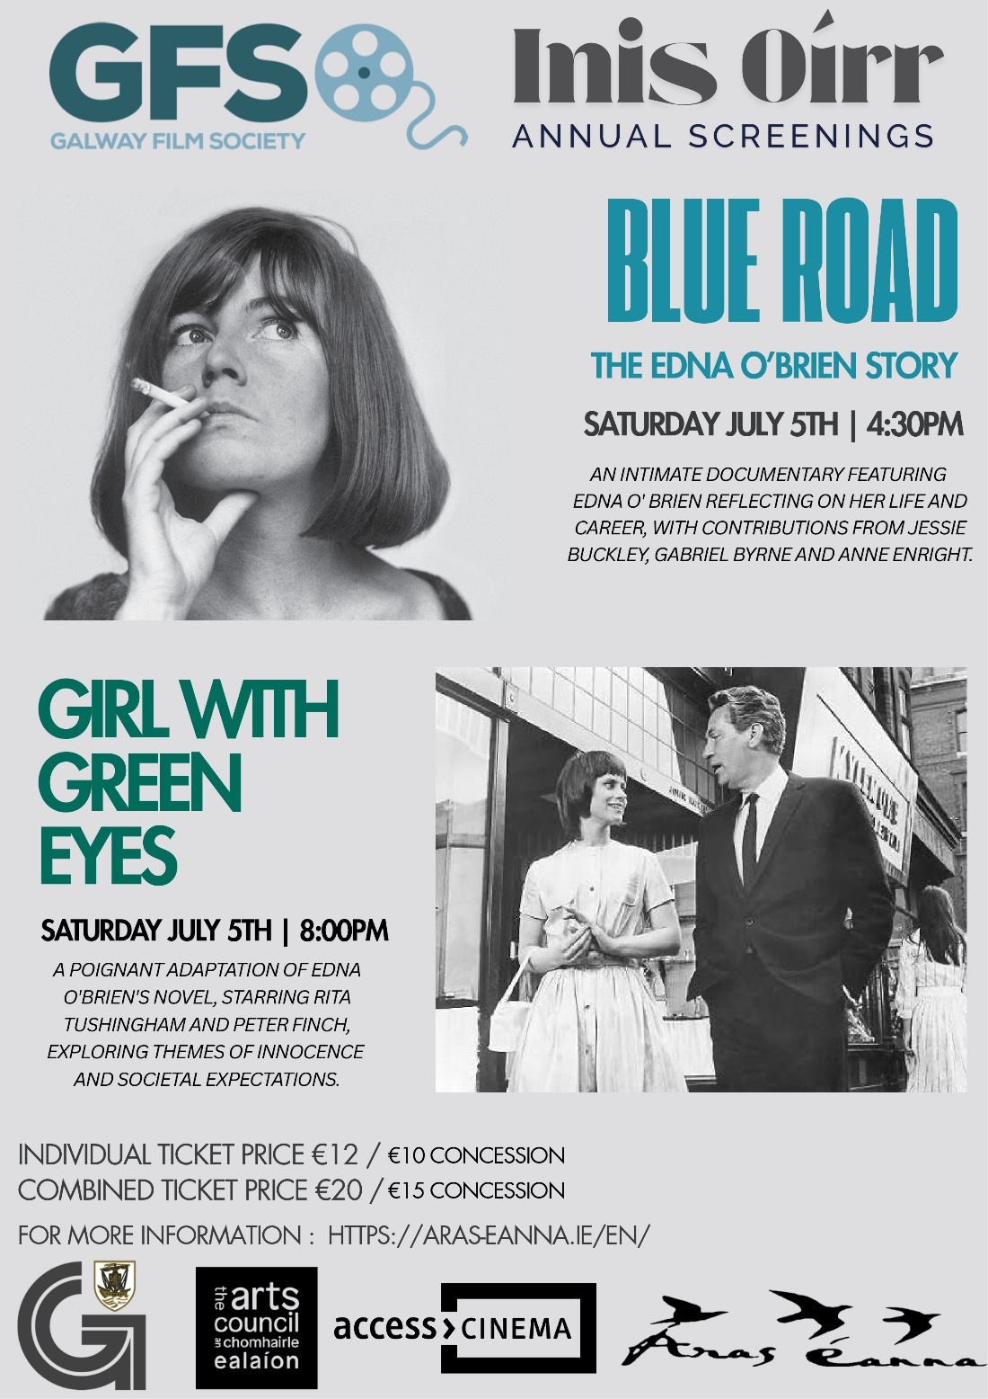

**Galway Film Society host screenings of two films**

Galway Film Society will host screenings of Blue Road, a film about the life of Edna O’Brien, and Girl With Green Eyes, a film adaptation of Enda O’Brien’s novel of the same name, in Aras Eanna on July 5.

Galway Film Society are supported by Galway City Council Arts Office through the 2025 Arts Organisation Grant.

More info here: [aras-eanna.ie](https://aras-eanna.ie/en/event/blue-road-edna-obrien-story-4pm-girl-with-green-eyes-8pm/)

**_____________________________________________________________**

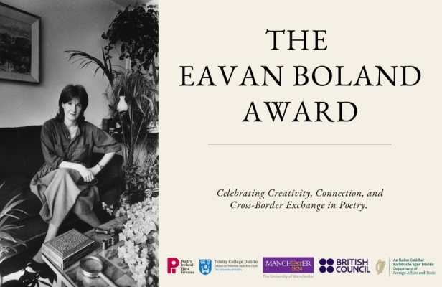

**The Eavan Boland Award 2025 – Call for Applications**

The Eavan Boland Award returns for 2025, inviting applications from early-career poets based in the UK and mid-career poets based in Ireland. The Eavan Boland Award 2025 will support two cross-residency opportunities at Trinity College Dublin School of English and The University of Manchester Centre for New Writing, supported by Poetry Ireland, Department of Foreign Affairs and Trade, Trinity College Dublin, The University of Manchester, and the British Council.

This award honours Eavan Boland’s dedication to fostering new voices and diverse perspectives in poetry and celebrates her legacy by supporting emerging and mid-career poets through residencies and mentorship.

For full Award details and application, please visit: [www.poetryireland.ie/news/eavan-boland-award-2025](https://www.poetryireland.ie/news/eavan-boland-award-2025)

**_____________________________________________________________**

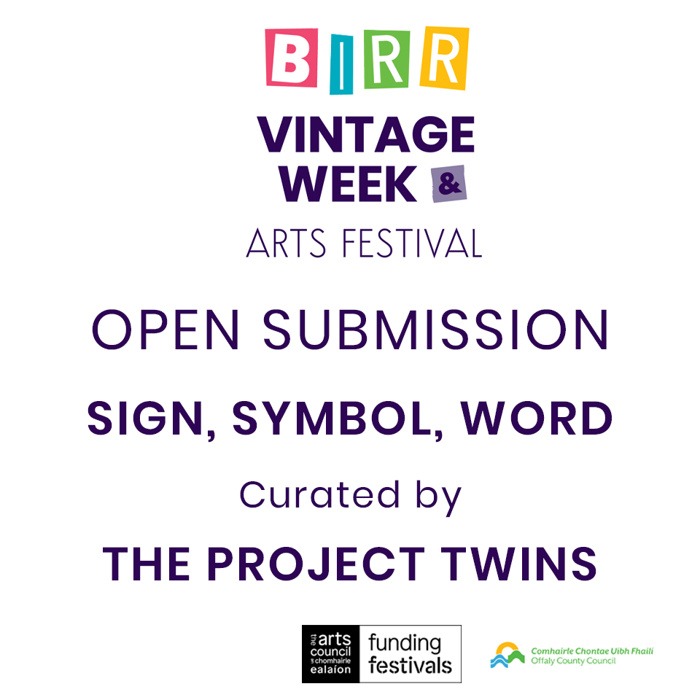

**Open call for submissions to Birr Vintage Week Arts Festival**

Birr Vintage Week & Arts Festival invite you to submit work for their Annual Open Submission Exhibition.

From stone carvings to digital code, people have always used symbols to make sense of the world. This open call invites artists to play with, disrupt, or reimagine the signs and symbols that shape our experience. How do meaning, form, and context shift when language becomes image, or image speaks like language.

Closing date for submissions: 13 July 5pm

[More information here](https://www.birrvintageweek.com/annual-open-submission-exhibition).

**_________________________________________________________**

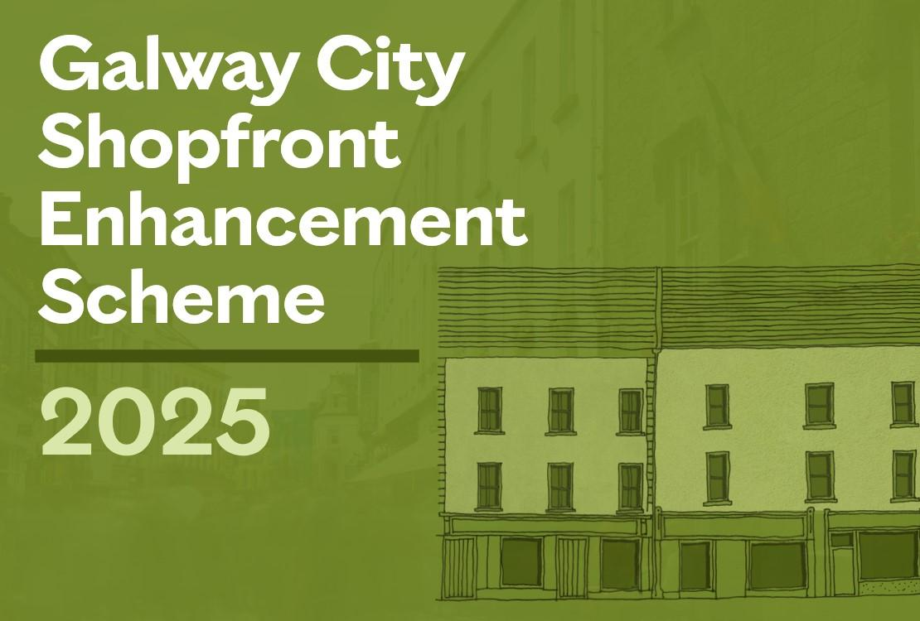

**Galway City Council Launches €200,000 Shopfront Enhancement Scheme 2025**

Galway City Council is delighted to announce the launch of the Shopfront Enhancement Scheme 2025, a €200,000 initiative aimed at revitalising the city’s commercial streetscapes. The scheme supports high-quality, culturally sensitive, and visually cohesive improvements to shopfronts, enhancing Galway’s unique character and boosting the local economy. The scheme offers financial assistance to independent retail and hospitality businesses to enhance the appearance, accessibility, and heritage value of their shopfronts. Eligible businesses are invited to apply by Friday 11 July 2025.

More information here: [galwaycity.ie/shopfront](https://www.galwaycity.ie/news/2025/galway-city-council-launches-eu200000-shopfront-enhancement-scheme-2025)

**_____________________________________________________________**

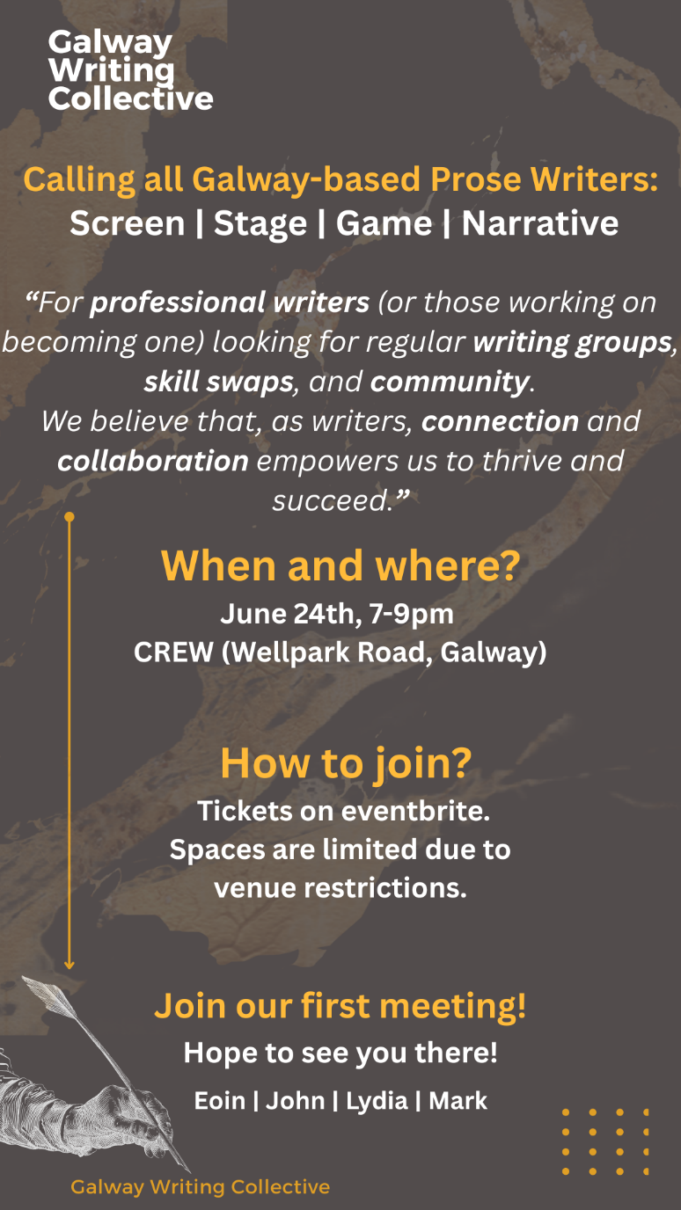

**New Galway Writing Collective Meeting — 24 June**

A new meet-up for Galway Prose writers will take place on Tuesday 24 June in the CREW hub in Wellpark. Details are in the poster above.

[Book your place here](https://www.eventbrite.ie/e/galway-writers-meet-up-tickets-1396540352789).

**_____________________________________________________________**

**Send us your Listings & News**

We can share your posts! Email up to 50 words to [arts@galwaycity.ie](mailto:arts@galwaycity.ie) with a high-resolution landscape image. Images and text may be edited to fit.

**___________________________________________________________________**

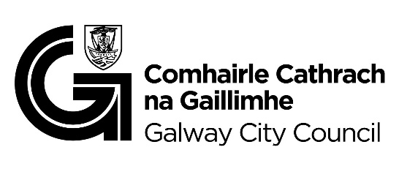

You are getting this email because you are on the Galway City Council Arts Office mailing list. Unsubscribe by emailing [arts@galwaycity.ie](mailto:arts@galwaycity.ie) and ask to be removed.