Galway City Council Arts Newsletter August
The newsletter highlights the work of our funded arts organisations in Galway City and also includes opportunities and news for anyone interested and involved in arts and culture in Galway City.
GCC Arts Office Social Media
Facebook: www.facebook.com/ArtsOfficeGalwayCity
Instagram: @artsofficegalwaycity
_____________________________________________________________
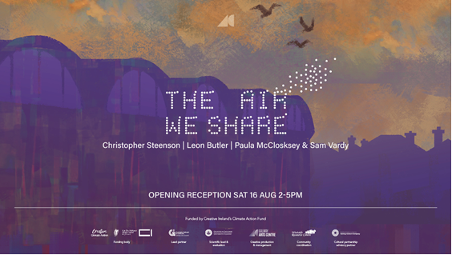
The Air We Share exhibition launch
Galway Arts Centre are pleased to announce The Air We Share, a major group exhibition of works developed through a year-long artist residency programme, exploring air quality, climate, and our shared environment through artistic collaboration and community engagement in Galway.

‘The Air We Share’ brings together a consortium of local partners, which is led by Galway City Council and includes Galway Arts Centre, the University of Galway’s Centre for Creative Technologies, the Centre for Climate and Air Pollution Studies and the Insight SFI Centre for Data Analytics, Westside Resource Centre, and Galway Culture Company.

More information here.

_____________________________________________________________

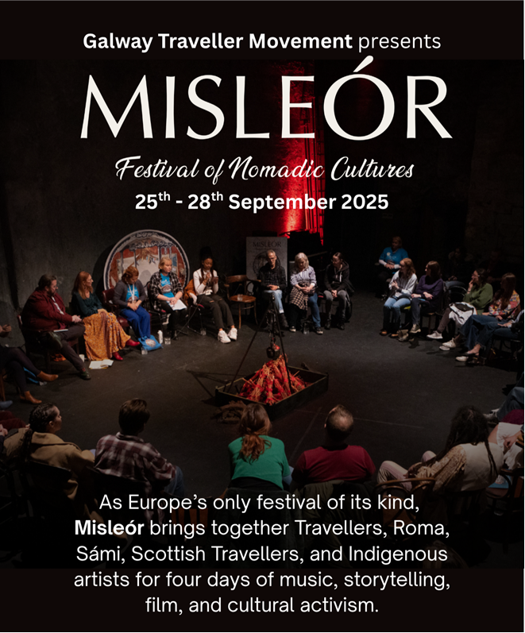
Misleór Festival of Nomadic Cultures, taking place in Galway, 25th–28th September
Now in its seventh year, Misleór celebrates the creativity, culture, and resistance of nomadic communities through music, film, talks, workshops, storytelling, with local, national and international guests.

This year’s theme, “Tending the Flame: On the Road to Justice and Reparation,” focuses on identity, resistance, memory, and the collective journey toward equity and recognition.

The full programme will be announced soon – visit misleor.ie for updates

_____________________________________________________________
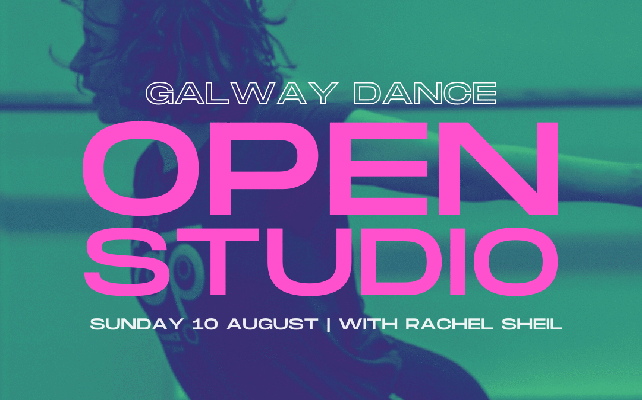
Open Studio with Rachel Sheil on Sunday 10 August
Rachel Sheil aka 'rikilikemagic' will be hosting another Open Studio at the Galway Dance studio. This is a two-hour window of time and space, facilitated and held so that you have the option to:

- Take part in an hour of gentle movement practice, complete-beginner friendly (run by Rachel 1–2pm)
- Use the studio space for your own practice
- Use the space for short rehearsal time of something you may be working on
- All of the above and more!

More information here.

Galway Dance is supported by Galway City Council Arts Office through the Arts Organisation Grant 2025.

_____________________________________________________________
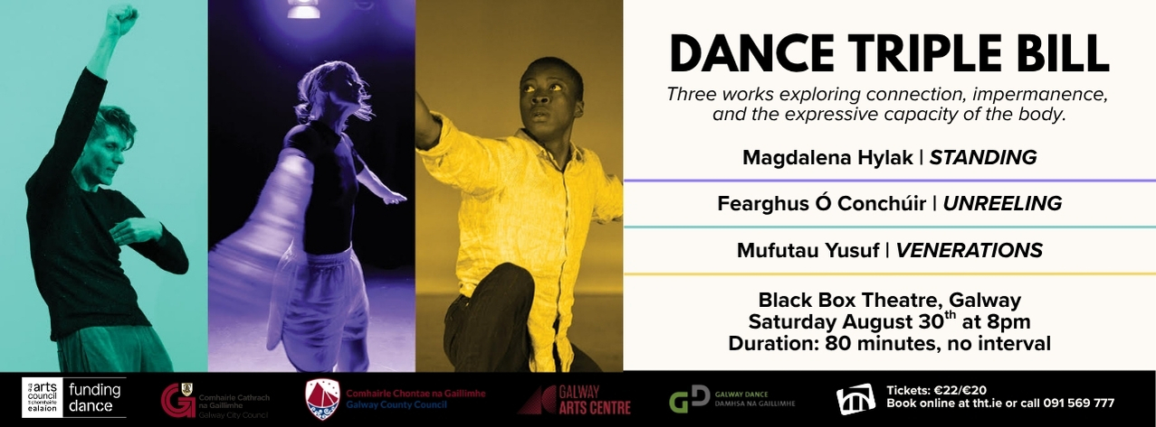
Witness three acclaimed choreographers take the stage in Galway for Dance Triple Bill!
One evening. Three powerful works exploring connection, impermanence, and the expressive capacity of the body.
Featuring Magdalena Hylak, Fearghus Ó Conchúir, and Mufutau Yusuf and curated by Magdalena Hylak, Galway Dance Artist-in-Residence. These performances embrace vulnerability and presence, inviting us to witness the quiet negotiations of the body and the profound truths it holds.

Saturday 30 August at 8pm
Black Box Theatre, Galway
Tickets: €22/€20

More information and tickets here.

Galway Dance is supported by the Galway City Council Arts Office through the Arts Organisation Grant 2025.
_____________________________________________________________
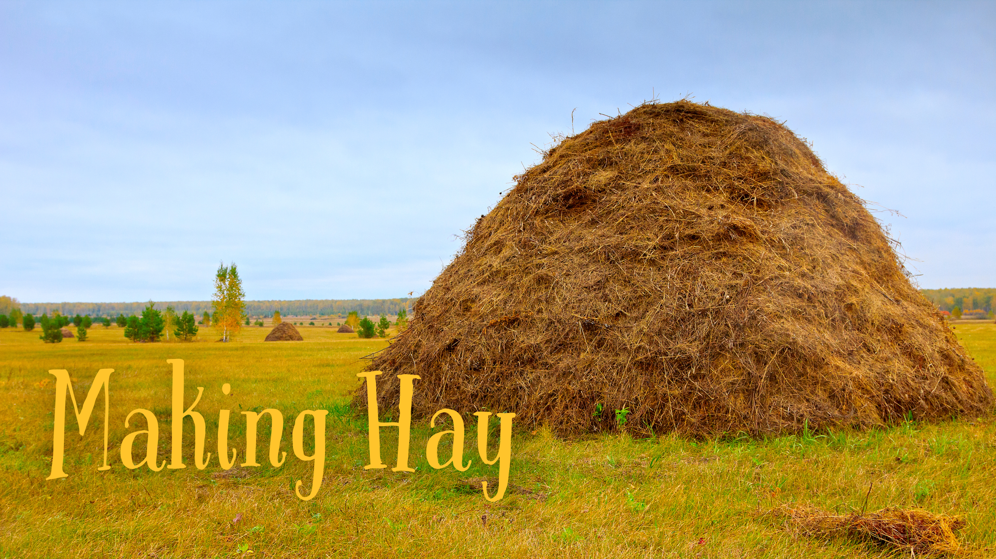
Moth & Butterfly present 'Making Hay' - a night of storytelling & improvisation
Moth and Butterfly present a night of storytelling and improvisation featuring some of Galway’s finest storytellers and performers!

Where: Rouge Restaurant, 38 Dominick St., Galway
Date: Monday, 18th August 2025
Time: Doors 7.00. Tïckets: €15 (18+)
More information and tickets here.
_____________________________________________________________
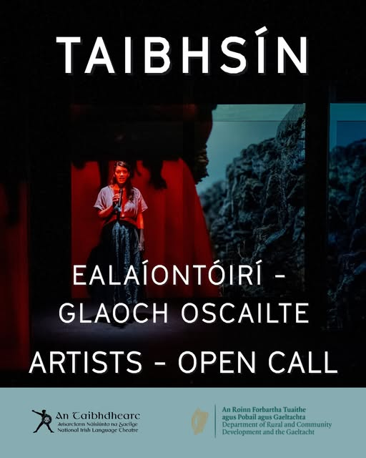
Artist Call-Out: Taibhsín Residency & Seed Bursary Opportunities at An Taibhdhearc
An Taibhdhearc, Amharclann Náisiúnta na Gaeilge, is delighted to invite applications for two artist development opportunities for writers, theatre makers and performance based artists working professionally in the Irish language.
These opportunities are open to individual professional theatre makers, writers and artists and we are happy to consider proposals from duos, provided the project is feasible within the available resources.
Closing date for applications: 21 August 2025.
More information here.
_________________________________________________________

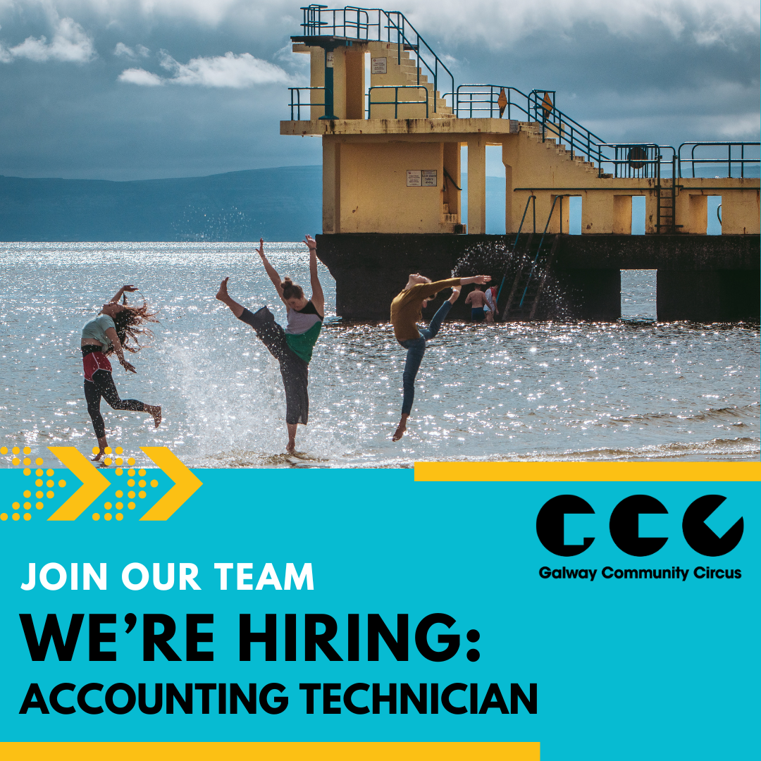
Galway Community Circus is hiring: Accounting Technician
Galway Community Circus is seeking a detail-oriented and motivated Accounting Technician to join our team on a part-time basis (3 days per week). This is a key role in supporting the financial health and sustainability of the organisation, ensuring compliance with relevant regulations and contributing to effective decision-making across the team.
More information here.
Galway Community Circus are supported by Galway City Council Arts Office through the Cultural Partnerships Fund and the Arts Organisations Grant 2025.
_________________________________________________________

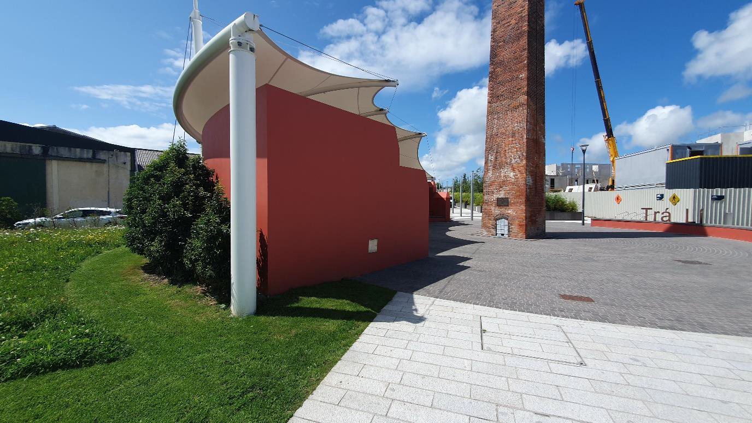
Tralee-Island of Geese Amphitheatre Artwork
Kerry County Council (KCC) is inviting Artists to provide ideas and deliver an artwork at the Island of Geese Tralee.
The actual artwork is open to interpretation (poem, story, picture, etc) and should acknowledge the past prosperity and future regeneration of the Island of Geese area.
KCC is seeking a quotation for a turnkey package (design, manufacture and installation inc. builder works and electrical works) for this art installation project. The artwork should demonstrate a connection to the history, culture, heritage or locality of the Island of Geese and its surrounds.
More information here.
_________________________________________________________

Send us your Listings & News
We can share your posts! Email up to 50 words to arts@galwaycity.ie with a high-resolution landscape image. Images and text may be edited to fit.
___________________________________________________________________
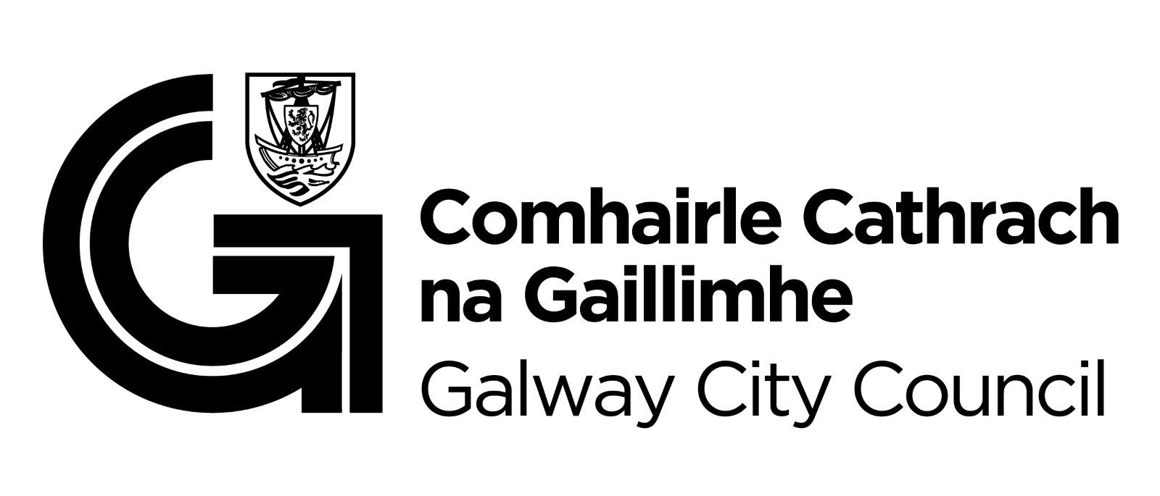
You are getting this email because you are on the Galway City Council Arts Office mailing list. Unsubscribe by emailing arts@galwaycity.ie and ask to be removed.

