**Galway City Council Arts Newsletter September**

The newsletter highlights the work of our [funded arts organisations](https://www.galwaycity.ie/services/arts-and-culture/arts-and-culture-services/arts-grants-2025) in Galway City and also includes opportunities and news for anyone interested and involved in arts and culture in Galway City.

**GCC Arts Office Social Media**

Facebook: [www.facebook.com/ArtsOfficeGalwayCity](https://scanner.topsec.com/?d=1122&r=show&u=https%3A%2F%2Fwww.facebook.com%2FArtsOfficeGalwayCity&t=a6b33347cd65717d4a93047cc8b1c9f7c5d8a4c9)

Instagram: [@artsofficegalwaycity](https://www.instagram.com/artsofficegalwaycity?utm_source=ig_web_button_share_sheet&igsh=ZDNlZDc0MzIxNw==)

**_____________________________________________________________**

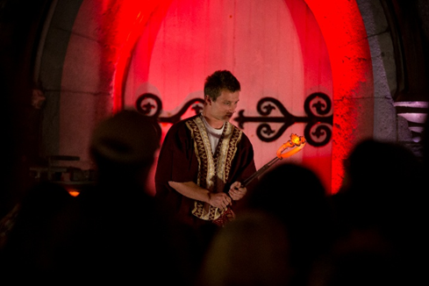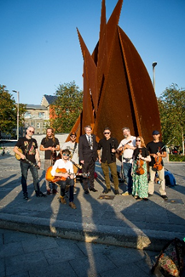

**Galway City comes alive for Culture Night with over 75 FREE events**

Friday 19th September is the date of Culture Night 2025. All are welcome!

The entire City will be alive with cultural activity, with over 75 very special and unique cultural events happening across multiple venues and in our City’s public spaces.

This programme of events is proudly developed and presented by Galway City Council Arts Office, funded by both the Arts Council and Galway City Council.

Brochures can be found across the city, and events will be posted on our social channels, and on the [Culture Night website](https://culturenight.ie/events/?_sft_location=galway-city).

**_____________________________________________________________**

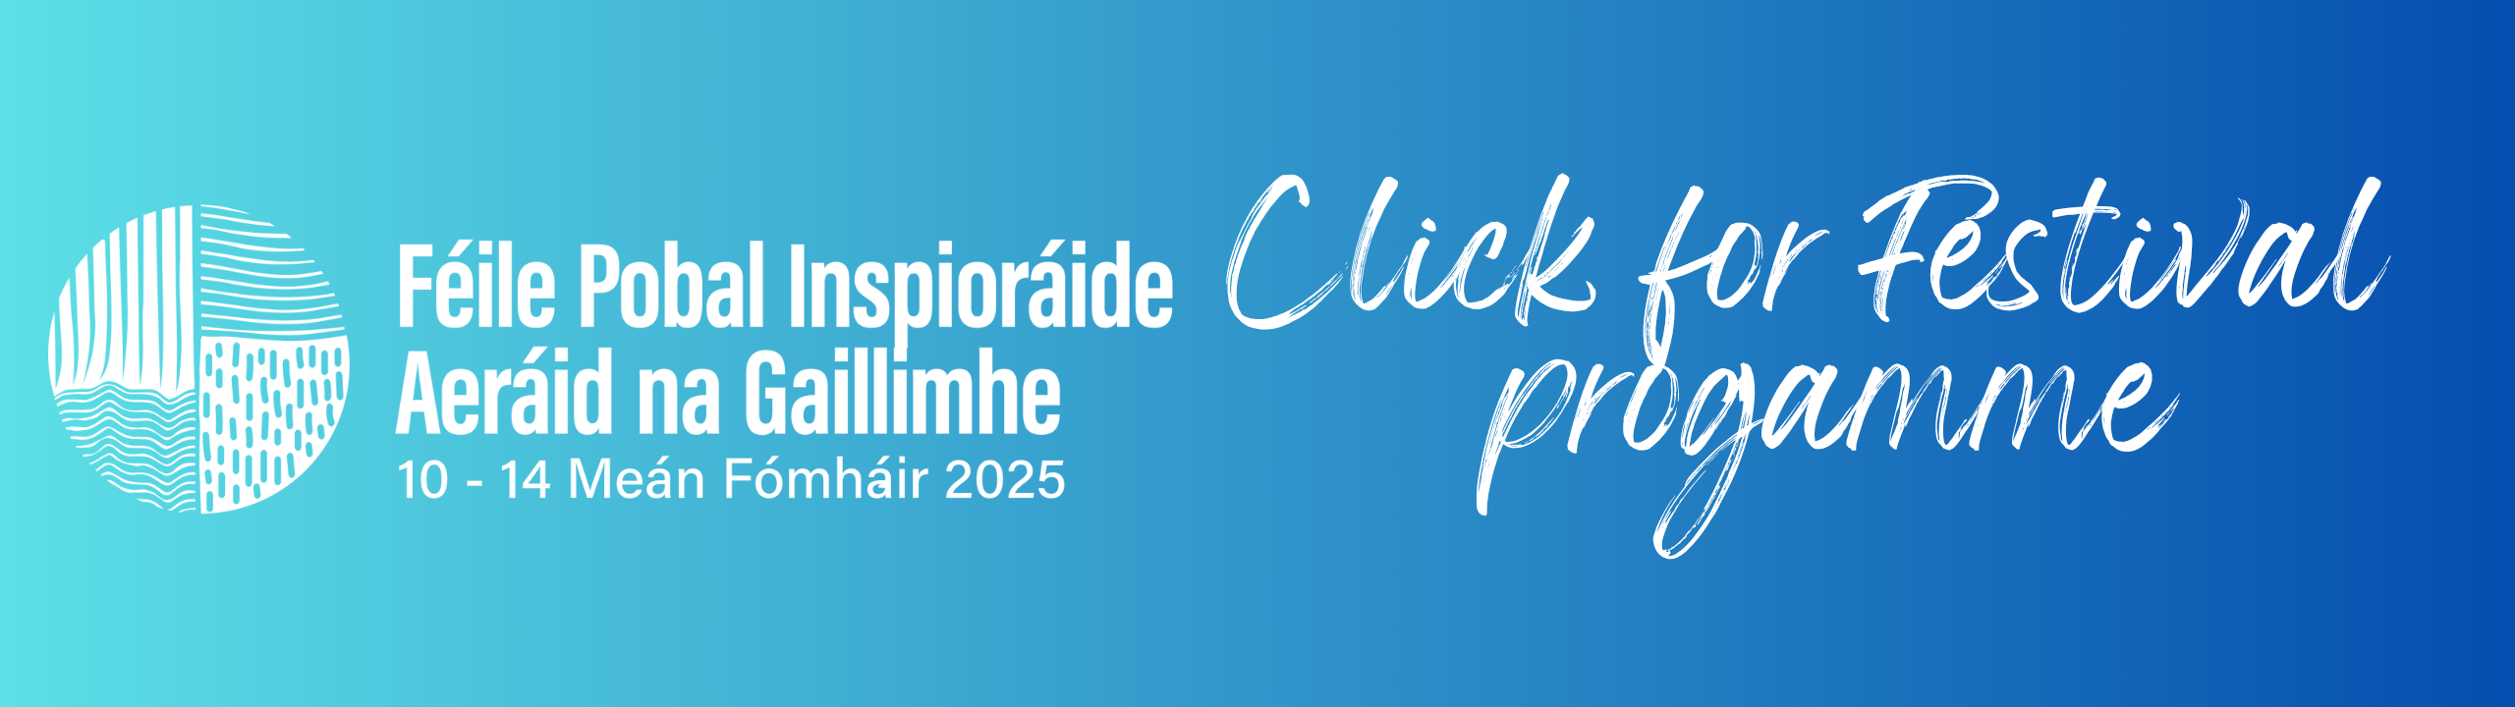

**Galway Climate Inspirations Festival 10-14 September**

This year’s Galway Climate Inspirations Festival 10-14 September is going to be worth a visit with lots of fascinating talks, live music, DJ's, food, games, active travel and all the best that Galway has to offer.

[More information here](https://galwayclimatefestival.ie/cl%C3%A1r-programme).

**_____________________________________________________________**

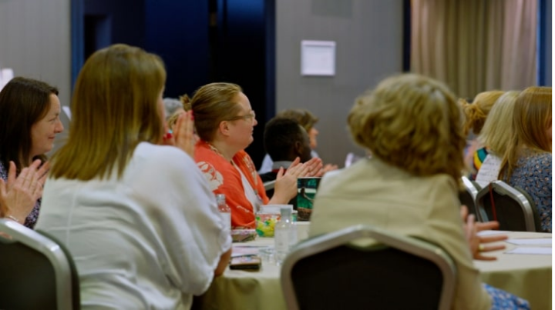

**Applications Open: Arts & Culture — Bereavement & Grief Training Course**

Applications are invited from professionals and volunteers in the arts, culture, or health sectors who support, or are interested in supporting, people of all ages experiencing dying, death, grief, and loss. The organisers, Irish Hospice Foundation, seek a diverse range of expertise and experience as this enriches the learning experience for all.

The application deadline is 17th September 2025 at 5:00pm. Notification of places will be on or before 26th September 2025.

[More information here](https://hospicefoundation.ie/our-supports-services/ihf-in-the-community/arts-and-creativity/arts-and-culture-bereavement-and-grief-training-course/).

**_____________________________________________________________**

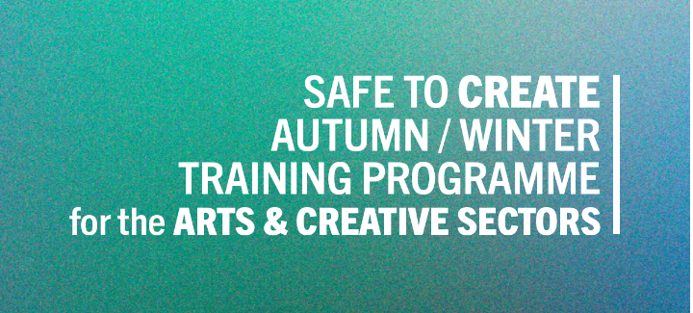

**Safe To Create’s Autumn / Winter 2025 training Programme Is Now Live!**

Safe to Create is proud to launch the Autumn/Winter 2025 Training Programme for Ireland’s arts & creative sectors. This season’s programme offers online and in-person workshops designed to give you the knowledge, skills, and tools to thrive at work.  
  
Sessions address: Dignity at Work; Safe Practice; Workplace Skills; Governance & Leadership; Equity, Diversity & Inclusion (EDI) – and more.

[More information here](https://www.safetocreate.ie/training-resources/).

**________________________________________________________________**

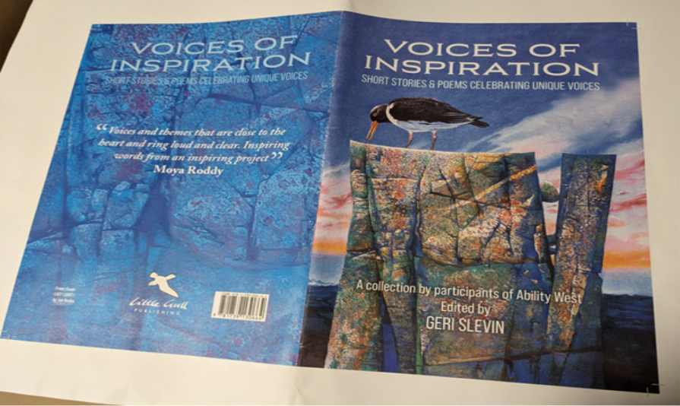

**Ability West publish a collection of stories and poems written by individuals with intellectual disabilities**

Ability West is proud to publish a collection of stories and poems written by individuals with intellectual disabilities, showcasing their creative talents and unique perspectives. This initiative promotes inclusivity, challenges stereotypes, and highlights the value of diversity in the creative community.

Launch on 19th September 11 am to 1pm Blake Suite, Maldron Hotel.

[More information here](https://www.abilitywest.ie/news-blog/blog-post-title-5e454-6nmrs-nprs3-ablpn-z9242-5hydk-klt5s-825kx-bdycz-yjrbn-daad3-hsghr-bdkly-d9hhw).

**_________________________________________________________**

**Send us your Listings & News**

We can share your posts! Email up to 50 words to [arts@galwaycity.ie](mailto:arts@galwaycity.ie) with a high-resolution landscape image. Images and text may be edited to fit.

**___________________________________________________________________**

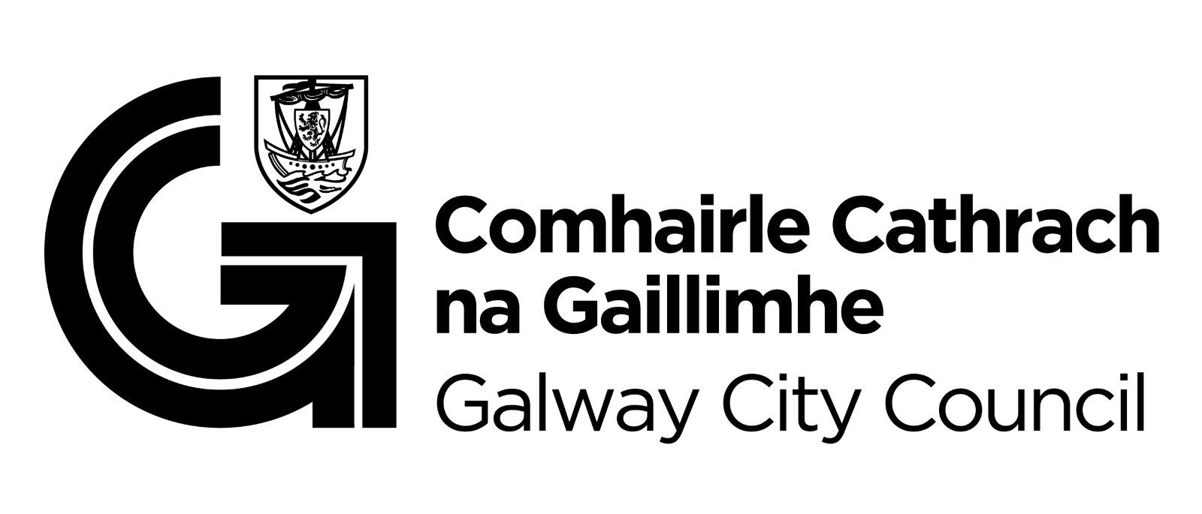

You are getting this email because you are on the Galway City Council Arts Office mailing list. Unsubscribe by emailing [arts@galwaycity.ie](mailto:arts@galwaycity.ie) and ask to be removed.