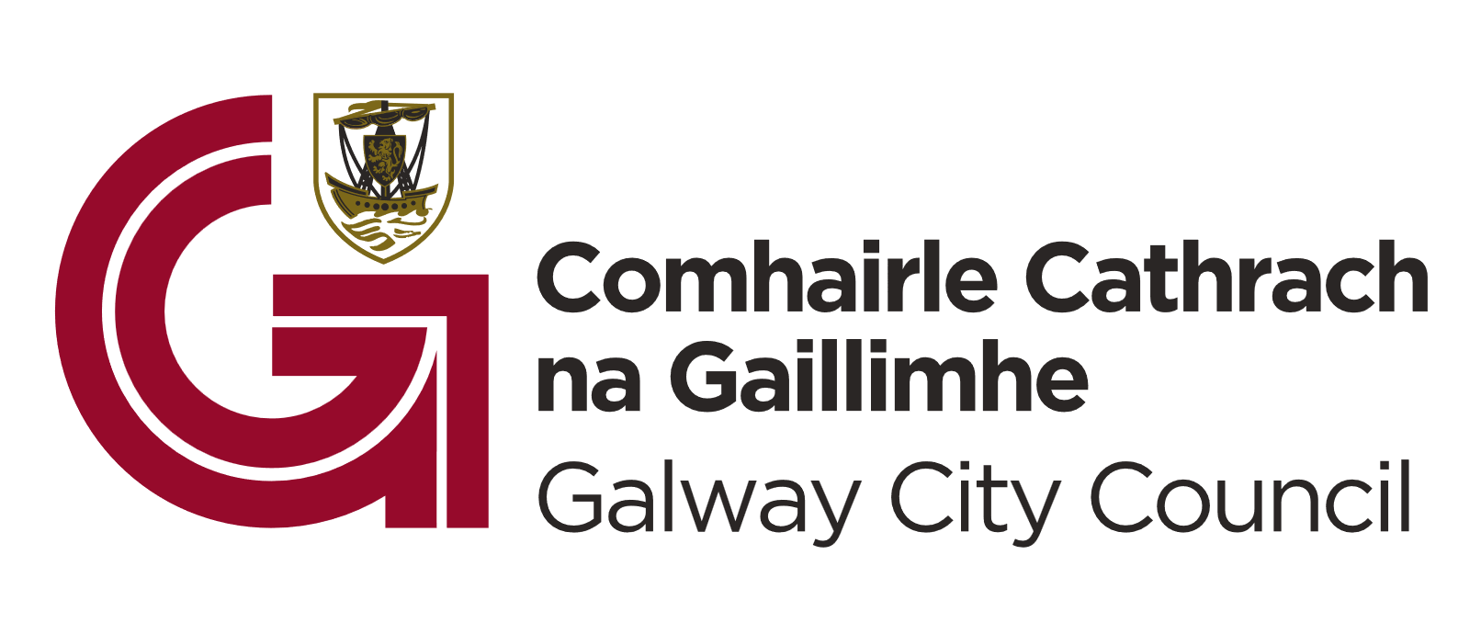
Call for Action 2026:
International Relations Office, Galway City Council

- Guidelines
Galway City Council’s International Relations Office invites proposals from organisations, institutions, and partners committed to strengthening Galway’s international presence, enhancing international collaboration, and contributing to the city’s cultural, economic, and diplomatic development.

Deadline for submissions is close of business Friday, the 6th of February 2026.
Contact keith.finnegan@galwaycity.ie for further details in advance of closing date.

Purpose
The International Relations Office seeks initiatives that:
- Promote Galway internationally and enhance the city’s reputation as a vibrant, creative, and internationally connected place.
- Develop international partnerships that support cultural exchange, education, innovation, sustainability, and economic opportunity.
- Attract international visitors, delegations, and collaborators, particularly during off-peak periods, to support year-round city vibrancy.
- Support projects with citywide impact, contributing meaningfully to Galway’s strategic international objectives.

- Application Brief
Eligibility & Expectations
Projects should:
- Demonstrate clear economic, cultural, or diplomatic benefits for Galway.
- Show strong potential to attract international engagement, investment, or exchange.
- Provide a high-quality visitor or participant experience, reflecting Galway’s values and identity.
- Include a robust delivery plan, including organisational experience and capacity.
- Offer appropriate recognition opportunities for Galway City Council as a partner.

- Assessment Criteria
Applications will be evaluated on:
- International impact and strategic relevance.
- Economic and cultural contribution to Galway.
- Inclusivity and accessibility.
- Opportunities for partnership visibility.
- Compatibility with and development of existing international relations that Galway City Council has in place.

Application Requirements
Applicants will be asked to provide:
- A detailed project description.
- A clear economic and cultural impact plan.
- A budget and financial plan, including co-funding sources.
- Additional information relevant to the project’s international dimension.

The following items are not eligible for funding:
- Purchase of equipment.
- Accommodation and/or rent of office space.
- Costs incurred before approval.
- Ongoing revenue or operating costs.
- Staffing/Teaching costs.
- Travel and Transportation.
- Insurance.

- Governance & Compliance
- All information provided must be accurate and complete.
- Organisations must have appropriate insurance, governance structures, and child protection policies where applicable.
- Galway City Council may request interviews with shortlisted applicants.
- The Council’s decision is final.
- Funding will not be provided to activities where there is an alternative statutory funding programme in place.
- The final decision on grant allocation is a function of the elected members after assessment by the Grants committee.

- Freedom of Information
Galway City Council proposes that the following information relating to this grant application competition will be made available on request:
- Name of the applicants
- Reasons an applicant did / did not qualify for grant consideration
- Name, summary of Project and Grant amount of the successful applicants
Galway City Council undertakes to use its best endeavours to hold confidential any information provided by applicants subject to its obligations under law, including the Freedom of Information Act 1998 and 2003.
Call for Action 2026:
International Relations Office, Galway City Council
APPLICATION FORM
ORGANISATION DETAILS: To be completed by all applicants

NAME OF ORGANISATION _________________________________________________

ADDRESS _________________________________________________

_________________________________________________

_________________________________________________

PHONE NUMBER _________________________________________________

EMAIL ADDRESS _________________________________________________

WEBSITE/SOCIAL MEDIA _________________________________________________

_________________________________________________

_________________________________________________

PROJECT DESCRIPTION AND IMPACT
Project title:
Briefly outline your proposed project:
Briefly define the overall goals and specific objectives of the project:
What is the expected cultural and economic impact of this project?
By what metrics would you evaluate the impact of this project while ongoing and once completed?
Please describe any opportunities for strategic partnership already identified:
BUDGET AND FINANCE
Estimated budget outline:
Please outline your budget narrative, detailing how the proposed project supports the expected expenditure:
What other potential sources of funding been identified for this project?

ADDITIONAL INFORMATION
What previous experience does your organisation have in facilitating or managing projects with economic, cultural, community, or international aspects?

If you have previously worked with Galway City Council or another public body please provide further details:
Is your organisation a member of or affiliated with any national or international trade or cultural bodies?
Does your organisation already have or agree to acquire all relevant liability and insurance for this project?

Please outline what insurance your organisation already has in place:
Does your organisation agree to acknowledge Galway City Council (and other sources of funding) on all publicity, press and marketing material produced in connection with this project?

NAME (PRINTED): _______________________________________________________

SIGNED: _______________________________________________________

POSITION: _______________________________________________________

DATE: ________________________________

