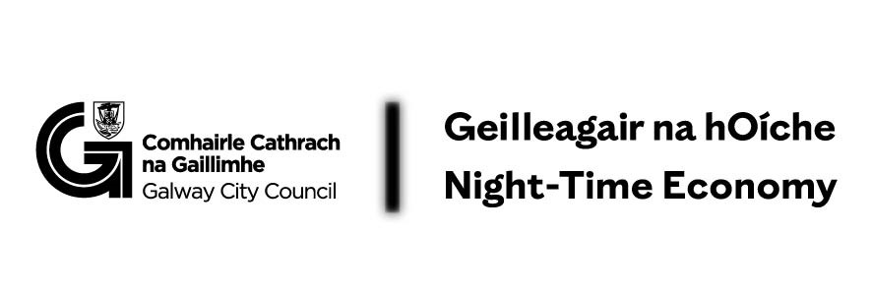

Café Lates 2026
Expression of Interest Form

Please complete this form to express your interest in participating in the Café Lates 2026 Night‑Time Economy Pilot Initiative.

1. Contact Information
Name:
Phone Number:
Email Address:

2. Business Information
Business Name:
Business Address & Eircode:
☐ I confirm that my business meets the definition of a café for the purposes of this initiative (primary offering of coffee/tea and beverages, seating available).

3. Proposed Café Lates Programme
Please describe the cultural or community‑based activity you are proposing as part of Café Lates 2026.

Programming may include (but is not limited to): acoustic music, spoken word, vinyl nights, talks, workshops, crafts, drawing/painting sessions, games evenings, or similar activities.

All events must:
- Take place on a Thursday evening
- Commence no earlier than 6.00pm
- Occur within the pilot periods: 1 April – 30 June and/or 1 August – 3 December

Proposed format (tick one or describe):
☐ Weekly Thursday series
☐ Monthly “Café Late” (last Thursday of the month)
☐ Other (please specify)
Number of events proposed:

Proposed Event Details
For each event or event series, please include:

Proposed date(s):
Proposed time(s):
Description of activity:
Ticketed / Non‑ticketed:
☐ I confirm that walk‑in customers will be accommodated, even where a workshop or ticketed element forms part of the programme.

4. Proposed Costs & Funding Requested
The Café Lates pilot provides maximum funding support of €2,000 per business (for a series of events).

Please provide a cost breakdown

Element of Work/Programme/Item | Cost (€):
TOTAL

☐ I confirm that the costs listed align with eligible expenditure as outlined in the Guidelines.

6. Priority Criteria (for monitoring purposes)
☐ My café is located off a primary thoroughfare
☐ My café did not participate in the 2024/25 Café Lates pilot

7. Declaration
☐ I confirm that I have read and understood the Café Lates 2026 Guidelines and agree to comply with all conditions if selected.

Completed forms should be emailed to:
📧 Eimear Coleman, Galway City Council, Eimear.Coleman@galwaycity.ie
🗓 Application deadline: 27 February

