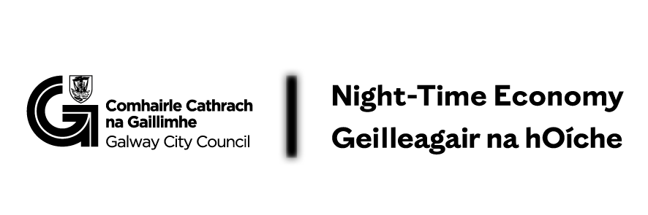
Appendix 1 - Café Lates 2026
Overview
Café Lates is a Galway City Council Night-Time Economy Pilot Initiative, supported by Galway City Council and the Department of Culture, Communications and Sport.
The initiative supports cafés to deliver Thursday evening cultural and community programming that animates the city after 6.00pm and strengthens Galway’s evening café culture.

Who Can Apply
- Cafés with seating located in Galway City Centre or Salthill
- Businesses must primarily operate as cafés (not shops or convenience stores that serve hot beverages)
If unsure about eligibility, contact:
📧 Kate Howard – kate.howard@galwaycity.ie
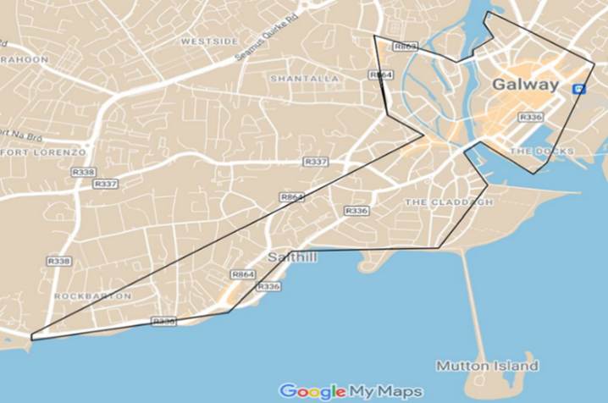

Event Requirements
- Events must take place on Thursdays from 6.00pm
- Events must occur within:
  - 1 April – 30 June, and/or
  - 1 August – 3 December
- Programmes should support an inclusive, non alcohol-focused night-time economy
- Engagement of young people aged 16+ is encouraged

Funding Support
- Maximum support: €2,500 (for a series of events, minimum of 5)
- Funding is paid retrospectively, based on approved expenditure

Eligible Costs
- services for Artist/Performer/Musician hired by the venue
- costs relating to Advertising, PR, ticketing related to the specific cultural event
- hire of specialist equipment specifically required for the cultural event
- health and safety and security costs
- event insurance costs
Ineligible Costs
- purchase of equipment
- purchase of musical instruments
- local authority rates
- staff costs for those on contract of service
- contracts of employment not relevant to the production, that is, additional staffing costs for later openings
- legal and accountancy fees
- annual insurance costs (with the exception of per event insurance)
- food and beverages

Communications & Acknowledgement
Successful applicants must:
- Actively promote events locally and online
- Provide event details 4 weeks in advance
- Acknowledge Galway City Council and the Department of Culture, Communication and Sport on all promotional material (logos provided)

Reporting & Evaluation
Successful cafés must:
- Submit an evaluation questionnaire
- Provide photographic evidence (max. 5 images)

Payment Conditions
- Payment by Electronic Fund Transfer (EFT) only
- Cash payments are not permitted
- Failure to submit required documentation will result in forfeiture of funding

Appeals
Appeals must be submitted within 5 working days to:
📧 Eimear.Coleman@galwaycity.ie

