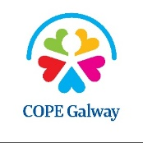
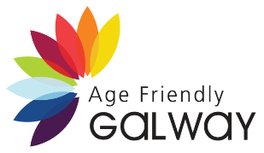
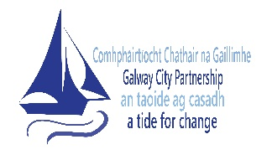
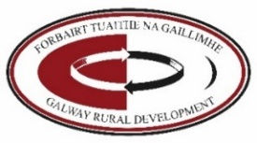
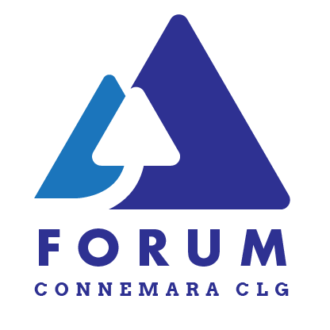
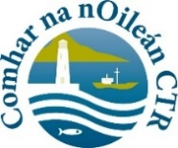
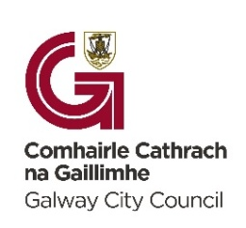
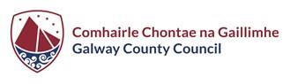

COPE Galway Media Consent Form
Positive Ageing Week (TBC, September – October 2026) is an opportunity to shine a light on the contributions of older people across our communities in Galway.
Completing and signing this form allows us to use your bio and photo in our communications. This can be for any legitimate purpose connected with Positive Ageing Week 2026. This can include exhibitions, digital media, print media, social media etc.
We may also use it in newsletters, annual reports etc.
Thank you so much for taking part in this initiative.
Name
Mobile
Email
Address
Eircode

Signature: _____________________________________________
Date: _____________________________________________

