Positive Ageing Week 2026

A chance to shine a light on the positivity of older age
We aim to highlight all the great things older people bring to our lives and communities as part of Positive Ageing Week 2026.
The focus is to celebrate the people in our communities who:
- Show healthy and active ageing;

- Contribute to their friends, family, neighbourhoods, communities, the arts, sports, heritage and environment.
It also aims to encourage others to keep active and connected. This helps contribute to a more positive ageing experience.
We want to celebrate 30 older people across Galway City and County. It is important to note that we are looking for people who may not otherwise get recognition. Positive Ageing Week is a way of recognising and thanking these older people and all they do.
Here’s what to do:
1. Do you know an older person who is active and engaged?
It could be that they:
- have strong social connections
- are physically active
- help with family and childminding
- are a family carer
Or do they help in their communities with:
- local activities
- tidy towns
- community gardens
- hobbies
- sporting organisations
- the arts and culture
2. Ask them if they would like to take part. If they agree, get in touch with us (Contact details on page 3). A biography (bio) of the person will need to be written (by themselves or someone who knows them). The bio is a short description of the person (no more than 200 words).
It could include details such as:
- How they contribute to those around them
- Their approach to healthy and active ageing
- Something about their background
- Where they grow up and where they live now
- Their interests and hobbies
- How they spend their day
- What brings them joy
- What is important to them
- What are they most proud of
- How do they contribute to their family or community
- What is their attitude to ageing
- What life/ageing advice would they like to offer
Samples: See bio examples on pages 4 and 5 and on the Cope Galway Website – click https://www.copegalway.ie/senior-support-service/positive-ageing-week/
3. They must give us written permission to use the Bio (See the Media Permission Form on page 4). This must be sent with the bio.
4. We will arrange for a professional photographer to visit each person and take their photo. This will be used in the media, local newspapers and social media during Positive Ageing Week.
Note: This is not a competition and there is no overall winner. Those who take part will be invited to a small gathering during Positive Ageing Week. They will receive their framed photographs to thank them for taking part.
Return the completed bio and Media Permission Form to Galway City Council Age Friendly programme by Friday 8 May 2026.
Email: agefriendly@galwaycity.ie
T: 091 536 358
Address: Galway City Age Friendly, Community Department, Galway City Council, College Road, Galway City, H91 X4K8
Checklist before returning bio:
Item: | Please Tick
Bio Complete in 200 words

Media permission form filled in fully with all details

Media permission form signed and dated

Example of Bios from previous years
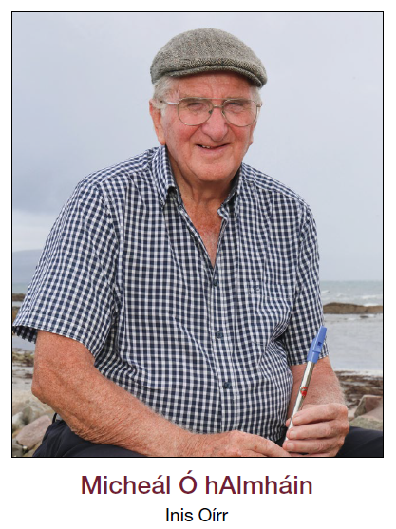
Micheál is a renowned musician and educator whose contributions to Irish traditional music and to the cultural life of the Aran Islands are profound and enduring. Many years ago, Micheál and his wife Áine left the city to raise their family on Inis Oírr. Since then, he has become a pillar of island life, inspiring generations through music, mentorship, and quiet leadership. At 80, Micheál remains remarkably active, travelling weekly between the three Aran Islands as the principal music teacher. His influence echoes in every local session, festival, and gathering where traditional music thrives.
Nationally and internationally, Micheál is respected as a leading figure in Irish music, especially through his longstanding work with Comhaltas Ceoltóirí Éireann. In 2001, he founded Craiceann, the internationally acclaimed bodhrán festival held annually on Inis Oírr. A daily sea swimmer and avid cyclist, Micheál also lives deeply connected to Ireland’s natural and spiritual heritage. As a modern-day Druid, he created An Gairdín Draíochta, a sacred community space for reflection and connection.
Whether teaching a tune or sharing stories of ancient Ireland, Micheál Ó hAlmhain continues to inspire as a true keeper of living tradition.
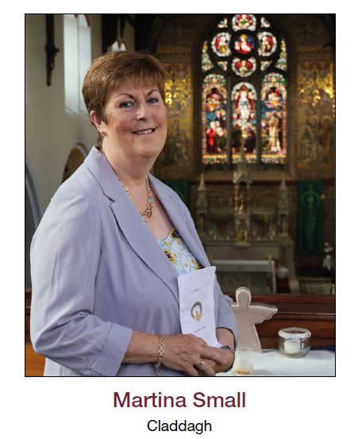
Martina lives in The Claddagh, Galway City, is in her 60s, and is the full-time family carer for her beloved husband Stephen, who developed Early Onset Dementia in his early 50s. For the past ten years, Martina has been devoted in caring for Stephen, who requires assistance with all activities of daily living. She also works part-time in administration in University Hospital Galway.
Despite the long number of years caring, the arduous nature of her full-time caring role, alongside working part-time, Martina always welcomes you with a warm, engaging smile and has a positive and zealous outlook on life. She is a long-standing member of her local Church Choir, is an integral Committee member, and enjoys attending fortnightly practice and singing at mass, which she says, “Gives me great joy and an outlet to unwind and forget about your worries.”
Martina is an accomplished baker, an avid gardener, walks daily, and enjoys weekly crosswords. Sharing some words of wisdom with her fellow carers, she says, “Self-care is vital, you have to make time for yourself, even to go for a walk, you are a better person for it when you come back.”
Martina passionately believes that “Ageing is a privilege.”

An tSeachtain um Aosú Dearfach 2026

Deis chun solas a chaitheamh ar dhearfacht na haoise níos sine
Tá sé mar aidhm againn aird a tharraingt ar na rudaí iontacha go léir a thugann daoine scothaosta dár saol agus dár bpobail mar chuid den tSeachtain um Aosú Dearfach 2026.
Is é an fócas ná ceiliúradh a dhéanamh ar na daoine inár bpobail atá:
- Léiríonn aosú folláin agus gníomhach,
- Thugann cúnamh dá gcairde, teaghlaigh, comharsanachtaí, pobail, na healaíona, spórt, oidhreacht agus timpeallacht.
Tá sé mar aidhm aige freisin daoine eile a spreagadh chun coinneáil gníomhach agus ceangailte. Cuidíonn sé seo le heispéireas níos dearfaí ag dul in aois.
Ba mhaith linn ceiliúradh a dhéanamh ar 30 duine scothaosta ar fud Chathair agus Chontae na Gaillimhe. Tá sé tábhachtach a thabhairt faoi deara go bhfuilimid ag lorg daoine nach bhfaighidh aitheantas ar shlí eile. Is bealach í an tSeachtain um Aosú Dearfach chun aitheantas a thabhairt do na daoine scothaosta seo agus buíochas a ghabháil leo.
Seo cad atá le déanamh:
1. An bhfuil aithne agat ar dhuine scothaosta atá gníomhach agus gafa?
D'fhéadfadh sé a bheith go bhfuil siad:
- naisc shóisialta láidre a bheith acu
- atá gníomhach go fisiciúil
- Cabhair le teaghlach agus le feighliúchán leanaí
- Is cúramóir teaghlaigh thú
Nó an gcuidíonn siad ina bpobail le:
- Gníomhaíochtaí Áitiúla
- bailte slachtmhara
- Gairdíní Pobail
- Caitheamh aimsire
- eagraíochtaí spóirt
- na healaíona agus an cultúr
2. Fiafraigh díobh an dteastaíonn uathu páirt a ghlacadh. Má aontaíonn siad, téigh i dteagmháil linn (Sonraí teagmhála ar leathanach 3). Beidh gá le beathaisnéis (bio) an duine a scríobh (iad féin nó duine éigin a bhfuil aithne aige air). Is cur síos gairid ar an duine é an bio (gan níos mó ná 200 focal).
D'fhéadfaí sonraí a áireamh ann, mar shampla:
- Conas a chuireann siad leis na daoine mórthimpeall orthu
- A gcur chuige i leith aosú sláintiúil agus gníomhach
- Rud éigin faoina gcúlra
- Cá bhfásann siad aníos agus cá gcónaíonn siad anois
- A gcuid spéiseanna agus caitheamh aimsire
- Conas a chaitheann siad a lá
- Cad a thugann áthas dóibh
- Cad atá tábhachtach dóibh
- Cad iad na rudaí is mó a bhfuil siad bródúil astu
- Conas a chuireann siad lena dteaghlach nó lena bpobal
- Cén dearcadh atá acu i leith dul in aois
- Cén chomhairle saoil/aosaithe ba mhaith leo a thairiscint
Samplaí: Féach samplaí beathaisnéise ar leathanaigh 4 agus 5 agus ar shuíomh Gréasáin Cope Galway – cliceáil ar https://www.copegalway.ie/senior-support-service/positive-ageing-week/
3. Ní mór dóibh cead scríofa a thabhairt dúinn an Bio a úsáid (Féach an Fhoirm Ceada Meán ar leathanach 4). Caithfear é seo a sheoladh leis an mbeathaisnéis.
4. Socróimid grianghrafadóir gairmiúil chun cuairt a thabhairt ar gach duine agus a ngrianghraf a thógáil. Bainfear úsáid as seo sna meáin, sna nuachtáin áitiúla agus sna meáin shóisialta le linn na Seachtaine um Aosú Dearfach.
Tabhair faoi deara: Ní comórtas é seo agus níl aon bhuaiteoir foriomlán ann. Tabharfar cuireadh dóibh siúd a ghlacann páirt chuig cruinniú beag le linn na Seachtaine um Aosú Dearfach. Gheobhaidh siad a gcuid grianghraf frámaithe chun buíochas a ghabháil leo as páirt a ghlacadh.
Seol an bhith chomhlánaithe agus an Fhoirm Ceada Meán ar ais chuig Clár Cairdiúil d'Aoisigh Chathair na Gaillimhe faoi dé hAoine 8 Bealtaine.
R: agefriendly@galwaycity.ie
T: 091 536 358
Seoladh: Cairdiúil don Aois, Cathair na Gaillimhe, An Roinn Pobail, Comhairle Cathrach na Gaillimhe, Bóthar an Choláiste, Cathair na Gaillimhe, H91 X4K8
Seicliosta sula gcuirtear beathaisnéis ar ais:
Mír: | Cuir tic le do thoil
Bio Comhlánaigh i 200 focal

Foirm chead na meán líonta isteach go hiomlán leis na sonraí go léir

Foirm cheada meán sínithe agus dátaithe

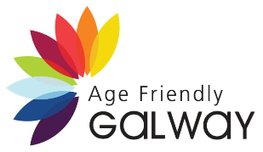
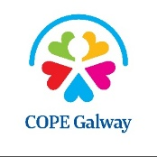



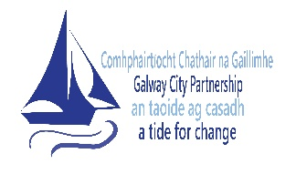


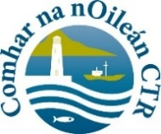
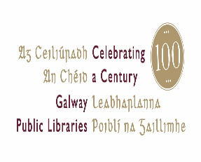

COPE Galway Media Consent Form
Is deis í an tSeachtain um Aosú Dearfach (28 Meán Fómhair – 4 Deireadh Fómhair 2026) chun solas a chaitheamh ar an méid atá déanta ag daoine scothaosta ar fud ár bpobail i nGaillimh.
Trí an fhoirm seo a chomhlánú agus a shíniú, is féidir linn do bhith agus do ghrianghraf a úsáid inár gcumarsáid. D'fhéadfadh sé seo a bheith chun aon chuspóir dlisteanach a bhaineann le Seachtain Aosaithe Dearfach 2026. D'fhéadfadh taispeántais, na meáin dhigiteacha, na meáin chlóite, na meáin shóisialta srl. D'fhéadfaimis é a úsáid freisin i nuachtlitreacha, i dtuarascálacha bliantúla srl.
Dúradh Is Maith Liom É Go raibh maith agat as páirt a ghlacadh sa tionscnamh seo.
Ainm
Soghluaiste
Ríomhphost
Seoladh
Eircode

Síniú: _____________________________________________
Dáta: _____________________________________________
Sampla de Bios ó bhlianta roimhe seo
Is ceoltóir agus oideachasóir mór le rá é Micheál, a bhfuil a chuid oibre sa cheol traidisiúnta agus i saol cultúrtha Oileán Árainn fíorthábhachtach agus buan.Blianta fada ó shin, d’fhág Micheál agus a bhean chéile Áine an chathair chun a gclann a thógáil ar Inis Oírr. Ó shin i leith, tá sé ina bhuncharachtar de shaol an oileáin, ag spreagadh glúnta trí cheol, meantóireacht agus ceannaireacht chiúin.
Ag 80 bliain d’aois, tá Micheál fós an-ghníomhach ag taisteal go seachtainiúil idir trí Oileán Árainn mar an príomh-mhúinteoir ceoil. Tá a thionchar le brath I ngach seisiún ceoil, féile agus ócáid ina mbíonn ceol traidisiúnta beo. Tá cáil náisiúnta agus idirnáisiúnta ar Mhicheál mar cheoltóir traidisiúnta, go háirithe mar gheall ar a shaothar le Comhaltas Ceoltóirí Éireann. Sa bhliain 2001, bhunaigh sé Craiceann, an fhéile bodhrán cáiliúil a reáchtáiltear gach bliain ar Inis Oírr.
Is snámhóir laethúil agus rothaí díograiseach é Micheál, a bhfuil nasc domhain aige le dúlra agus le spioradáltacht na hÉireann. Mar Dhraoi nuaaimseartha, chruthaigh sé An Gairdín Draíochta, spás pobail do mhachnamh agus do cheangal leis an nádúr. Bíodh gur ag múineadh poirt nó ag roinnt scéalta faoi Éirinn ársa a bhíonn sé, is fíor a rá gur fíorchoimeádaí den traidisiún beo é Micheál Ó hAlmhain.
Tá Martina ina cónaí sa Chladach, Cathair na Gaillimhe, tá sí ina cuid seascaidí, agus is cúramóir lánaimseartha dá fear céile Stephen í, a d’fhorbair néaltrú luath-thosaithe sna luathchaogaidí. Le deich mbliana anuas, tá Martina tiomanta do chúram a thabhairt do Stephen, a bhfuil cúnamh ag teastáil uaidh le gach gníomhaíocht laethúil. Oibríonn sí go páirtaimseartha freisin ag déanamh obair riaracháin in Ospidéal Ollscoile na Gaillimhe.
In ainneoin na mblianta fada cúraim, agus ról crua an chúramóra, chomh maith le bheith ag obair go páirtaimseartha, cuireann Martina fáilte romhat i gcónaí le meangadh gáire, agus tá dearcadh dearfach agus díograiseach aici ar an saol. Is ball fadbhunaithe í dá Cór Eaglaise áitiúil, is ball lárnach den Choiste í, agus is
maith léi freastal ar chleachtadh chuile choicís agus canadh ag an Aifreann. Deir sí “Tugann sé seo áthas mór dom agus deis chun scíth a ligean agus dearmad a dhéanamh ar aon imní atá orm.” Is báicéir cumasach í Martina, garraíodóir díograiseach, siúlóidí gach lá, agus is maith léi crosfhocail a dhéanamh chuile sheachtain. An chomhairle is mó a thugann sí do chúramóirí eile ná, “Tá cúram pearsanta ríthábhachtach, caithfidh tú am a dhéanamh duit féin, fiú le dul ag siúl, beidh tú níos fearr dá bharr nuair a fhilleann tú.”
Creideann Martina go paiseanta gur, “pribhléid é dul in aois.”

