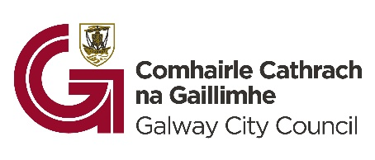
SITE NOTICE

Planning and Development Act 2000 (as amended)
Part 8 of the Planning and Development Regulations, 2001 (as amended)

Applicant: Galway City Council

Location: Eyre Square/Kennedy Park, Galway City

Development: Pursuant to the requirements of the above, notice is hereby given of a proposed development consisting of the demolition of the existing public toilet block and tourist kiosk within the pedestrian area of Eyre Square/Kennedy Park, and the construction of a new tourist information centre and public toilets, as well as the construction of a new Changing Places facility as an extension to the existing substation. The development is to include new public seating, a performance space, and associated landscape elements.

The proposal has undergone Appropriate Assessment Screening under the Habitats Directive (92/43/EEC) and screening for Environmental Impact Assessment under the EIA Directive 2011/92/EU, as amended by Directive 2014/52/EU. The authority has concluded that there is no real likelihood of significant effects on the environment arising from the proposed development and a determination has been made that an Environmental Impact Assessment Report (EIAR) is not required. The authority has also made a determination under Article 6(3) that the proposed development, either individually or in combination with other plans and projects, is not likely to have a significant effect on any European site(s). Any person may, within 4 weeks from the date of publication of this notice, apply to An Coimisiún Pleanála for a screening determination as to whether the development would be likely to have significant effects on the environment.
Plans and Particulars of the proposed development may be inspected or purchased at a fee not exceeding the reasonable cost of making a copy for a period of 4 weeks from 11/06/2026 during public opening hours at the offices of the Planning Office, Galway City Council, City Hall, College Road, Galway City, Monday - Friday 9.00am to 4.00pm.
Soft copies of plans and particulars of the proposed development can also be viewed on Galway City Council’s website – https://www.galwaycity.ie/latestnews
A submission or observation in relation to the proposed development, dealing with the proper planning and sustainable development of the area in which the development would be situated, may be made, in writing, or by e-mail to planning@galwaycity.ie, to the Planning Offices, Galway City Council, City Hall, College Road, Galway, before 4.00pm on 24/07/2026.

All comments, including names of those making comments, submitted to the council regarding this scheme will form part of the statutorily required report to be presented at a meeting of the elected members. Accordingly, they may also be included in the minutes of that meeting and may appear in the public domain. Galway City Council is subject to the provisions of freedom of information (FOI Acts 1997 (as amended) and the data protection acts 1988 (as amended).

Signed: 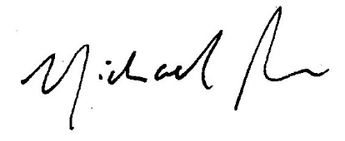 Dated: 11th June 2026

